UNITED STATES

SECURITIES AND EXCHANGE COMMISSION

Washington, D.C. 20549

SCHEDULE 14A

(Rule 14a-101)

Proxy Statement Pursuant to Section 14(a) of

the Securities Exchange Act of 1934

(Amendment No. )

Filed by the Registrant [x]

Filed by a Party other than the Registrant [ ]

Check the appropriate box:

[ ] Preliminary Proxy Statement

- ] Confidential, for Use of the Commission Only (as permitted by Rule 14a-6(e)(2)) [x] Definitive Proxy Statement
- ] Definitive Additional Materials

- ] Soliciting Material Pursuant to §240.14a-11(c) or §240.14a-12

JACK HENRY & ASSOCIATES, INC.

(Name of Registrant as Specified in its Charter)

(Name of Person(s) Filing Proxy Statement, if other than the Registrant)

Payment of Filing Fee (Check the appropriate box):

[x] No fee required.

[ ] Fee paid previously with preliminary materials.

[ ] Fee computed on table below per Exchange Act Rules 14a-6(i)(1) and 0-11.



NOTICE OF 2024 ANNUAL MEETING OF STOCKHOLDERS




 | Date and Time |  | Location |  |  | Record Date
Tuesday, |  | 2024, 11:00 | Jack Henry
Tuesday, | November 12, | 2024, 11:00 | Jack Henry | & Associates, Inc. HQ |  | September 16, 2024
 | a.m. (CST) |  | 663 Highway 60, P.O. Box 807
 |  |  | Monett, Missouri 65708

The 2024 Annual Meeting of Stockholders (the “Annual Meeting”) of Jack Henry & Associates, Inc., a Delaware corporation (the “Company”), will be held at the Company’s Headquarters, 663 Highway 60, Monett, Missouri, on Tuesday, November 12, 2024, 11:00 a.m., Central Time.

The purpose of the Annual Meeting will be the following:

- To elect nine directors to serve until the 2025 Annual Meeting of Stockholders;

- To approve, on an advisory basis, the compensation of our named executive officers;

- To approve an amendment to our certificate of incorporation to reduce stockholder voting thresholds;

- To ratify the selection of the Company’s independent registered public accounting firm; and

- To transact such other business as may properly come before the Annual Meeting and any adjournments thereof.

The close of business on September 16, 2024, has been fixed as the record date for the Annual Meeting. Only stockholders of record as of that date will be entitled to notice of and to vote at said meeting and any adjournment or postponement thereof.

Notice regarding the availability of proxy materials and this proxy statement and form of proxy are being distributed and made available on or about October 4, 2024. The accompanying form of proxy is solicited by the Board of Directors of the Company. The attached Proxy Statement contains further information with respect to the business to be transacted at the Annual Meeting.

ALL STOCKHOLDERS ARE INVITED TO ATTEND THE MEETING IN PERSON. WHETHER OR NOT YOU EXPECT TO ATTEND, PLEASE DATE AND SIGN THE ENCLOSED PROXY. IF YOU DECIDE TO ATTEND THE MEETING, YOU MAY REVOKE YOUR PROXY AND VOTE YOUR SHARES IN PERSON.

By Order of the Board of Directors
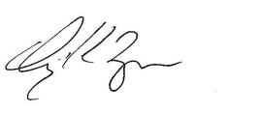

Craig K. Morgan

Secretary

TABLE OF CONTENTS

Proxy Summary

Election of Directors (Proposal 1)

Corporate Governance

Certain Relationships and Related Transactions

Delinquent Section 16(a) Reports

Audit Committee Report

Executive Officers

Human Capital & Compensation Committee Report

Compensation Discussion and Analysis

Compensation and Risk

Executive Compensation

Equity Compensation Plan Information

Pay Ratio Disclosure

Pay Versus Performance

Advisory Vote on Executive Compensation (Proposal 2)

Approval of Amendment to our Certificate of Incorporation (Proposal 3)

Ratification of Selection of Independent Registered Public Accounting Firm (Proposal 4)

Stock Ownership of Certain Beneficial Owners

Stockholder Proposals and Nominations

Financial Statements

Other Matters

Appendix A: Proposed Changes to the Company’s Certificate of Incorporation

1

4

14

22

24

25

26

28

29

51

52

61

63

63

68

69

71

73

75

75

75

80

PROXY SUMMARY

This summary highlights certain information for stockholders’ review in connection with the Annual Meeting. This summary does not contain all of the information that stockholders should consider, and stockholders are encouraged to read the entire Proxy Statement carefully before voting.

Business highlights

Associates ~7,200 | Clients | ~7,500 | FY 24 | $2.22B
Associates ~7,200 | Clients | ~7,500 | Revenue | $2.22B



20 | Consecutive
20 | Calendar Years of
20 | Increased Dividends

FY 24 Total
Paid $156M NASDAQ: JKHY
Dividends

 | • US News: Best Companies to | Formed in 1976
Workplace | Work for 2024-2025 | Formed in 1976
Workplace |  | HQ
Awards | • Newsweek: America’s | HQ
 | Greatest Workplaces 2024 | Monett, Missouri



Summary of Proposals

 | 2024 Proposals | Board | See Page
 | 2024 Proposals | Recommends | See Page
Proposal 1: | Election of Directors. |  | 4
Proposal 2: | Advisory Vote to Approve the Company’s Named Executive Officer Compensation for |  | 68
 | Fiscal 2024. |  | 68
Proposal 3: | Approval of an Amendment to the Company's Certificate of Incorporation to Reduce |  | 69
 | Stockholder Voting Thresholds. |  | 69
Proposal 4: | Ratification of the Appointment of PricewaterhouseCoopers LLP as the Company’s |  | 71
 | Independent Registered Public Accounting Firm for Fiscal 2025. |  | 71


2024 Proxy Statement | 1

Fiscal 2025 Director Nominees

8 of 9 | 3 of 9 | 60 years | 8 years
nominees are | nominees are | average | average
independent | women | age | tenure

Name | Title | Director | Independent | Committees & Roles
 |  | Since
David B. Foss | Executive Board Chair | 2017 | O
Matthew C. | Vice Chair and Lead | 2007 | ü | Audit, Human Capital & Compensation
Flanigan | Director
Thomas H. Wilson, Director |  | 2012 | ü | Audit (Chair), Governance
Jr.
Thomas A. | Director | 2012 | ü | Audit, Risk and Compliance (Chair)
Wimsett
Shruti S. Miyashiro Director |  | 2015 | ü | Human Capital & Compensation (Chair),
 |  |  |  | Risk and Compliance
Wesley A. Brown | Director | 2015 | ü | Audit
Curtis A. Campbell Director |  | 2021 | ü | Governance (Chair), Human Capital &
 |  |  |  | Compensation
Tammy S. | Director | 2024 | ü | Human Capital & Compensation, Risk
LoCascio |  |  |  | and Compliance
Lisa M. Nelson | Director | 2024 | ü | Audit, Governance

New Director Nominees

The following nominees were appointed by the Board of Directors as of July 22, 2024.

Tammy S. LoCascio

Ms. LoCascio, age 55, is Senior Executive Vice President and Chief Operating Officer of First Horizon Corporation, the holding company for First Horizon Bank. She brings extensive experience to the Board with banking strategy, technology, and operations as well as human capital management.

Lisa M. Nelson

Ms. Nelson, age 61, is President, International at Equifax, Inc. She brings to the Board deep knowledge and experience of management of technology companies, in addition to strategic acquisitions and implementation of growth initiatives.

- 2024 Proxy Statement

Executive Compensation Highlights

Say-On-Pay Advisory Vote and Advisory Vote Frequency

Each year the stockholders are given the opportunity to offer a “say-on-pay” advisory vote at the Company’s Annual Meeting of Stockholders. At last year’s Annual Meeting, 94% of the votes cast on say-on-pay were voted in favor of fiscal year 2023 executive compensation, with the stockholders also approving, on an advisory basis, continuing to hold yearly advisory votes on executive compensation.

Compensation Philosophy

Our executive compensation programs are designed to achieve the following objectives:

- Attract, retain, and motivate highly qualified executives by offering competitive compensation.

- Link performance and executive pay by tying annual cash bonus amounts to achievement of key objectives under the Company’s annual business plans, as well as specific strategic goals.

- Reward competitive performance in comparison with peers in our industry.

- Reward the creation of long-term stockholder value through long-term incentive compensation awards and encourage significant stock ownership to further align our executives’ interests with those of our stockholders.

Corporate Governance Highlights

- A majority of the Company's directors are independent in accordance with Nasdaq standards and all members of Board committees are independent.
- The Lead Director is independent.

- Executive sessions of independent directors are led by the Lead Director at each Board meeting.

- Directors are limited to service on no more than three other public company boards.

- Directors are restricted from standing for reelection after they reach 70 years old, except in exceptional circumstances as determined by the Board.

- Directors are limited to 12 total years of service for any director first elected after May 14, 2021.

2024 Proxy Statement | 3

PROPOSAL 1

ELECTION OF DIRECTORS


The Board recommends that you vote

“For”
the election of each of the nominees for election to the

Board.

Procedure

At the Annual Meeting, the stockholders will elect nine directors to hold office for one-year terms ending at the 2025 Annual Meeting of Stockholders or until their successors are elected and qualified. The Board has nominated nine of the Company's current ten directors for re-election at the Annual Meeting. Jacque R. Fiegel is not seeking re-election and her Board service will end on the date of the Annual Meeting. The Board has approved a decrease in its size from ten members to nine effective immediately prior to the Annual Meeting.

The stockholders are entitled to one vote per share on each matter submitted to vote at any meeting of the stockholders. Unless contrary instructions are given, the persons named in the enclosed Proxy Card or their substitutes will vote “FOR” the election of the nominees named below.

Each of the nominees has consented to serve as director. However, if any nominee at the time of election is unable to serve or is otherwise unavailable for election, and as a result other nominees are designated by the Board, the persons named in the enclosed Proxy Card or their substitutes intend to vote for the election of such designated nominees.

Director Qualifications and Selection

Under the Company’s Corporate Governance Guidelines, the Governance Committee is charged with the responsibility for determining the appropriate skills and characteristics required of Board members and are to consider such factors as experience, strength of character, maturity of judgment, technical skills, diversity, and age in assessing the needs of the Board. The Corporate Governance Guidelines specify that a majority of the members shall qualify as independent under applicable Nasdaq Global Select Market (“Nasdaq”) listing standards. While the term “diversity” is not specifically defined in the Corporate Governance Guidelines and there is no formal policy regarding application of the term, it has been the practice of the Governance Committee to apply the term broadly, resulting in Board composition over the years that has reflected diversity in race, gender, and age, as well as diversity in business experience and in representation of the markets served by the Company.

While the Company has a nomination policy by which stockholders may recommend to the Governance Committee certain prospective directors for consideration (See “Corporate Governance—Stockholder Recommended Director Candidates,” below), no such recommendation has been received. If such a recommendation is received in the future, it will be evaluated in the same manner as any other recommendation to the Governance Committee. The Governance Committee nomination process varies depending upon the particular expertise and skill set sought by the Governance Committee. The process can be informal, consisting of solicitation of suggestions of possible candidates from other Board members and management, contacting candidates to determine interest level, and in-person interviews to determine “fit.” The Governance Committee has also used a more formal process utilizing a recruiting firm to identify candidates,

4 2024 Proxy Statement

screening of recommendations, followed by telephone and in-person interviews, background checks, and Governance Committee evaluation and nomination. The Governance Committee expects to continue use of both formal and informal processes to identify appropriate candidates for the Board.

The Company’s Board has also adopted a “Proxy Access for Director Nominations” bylaw as part of the Company’s Amended and Restated Bylaws (the “Bylaws”). The proxy access bylaw permits a stockholder, or certain groups of stockholders, meeting the requirements contained in the proxy access bylaw to nominate and include in the Company’s proxy materials director nominees constituting up to two individuals or 20% of the Board (whichever is greater). See “Corporate Governance— Stockholder Nominated Director Candidates” below for more information.

Nominees for Election

The Board currently has ten members serving terms of office ending at the Annual Meeting. The Board has approved a decrease in its size from ten members to nine effective immediately prior to the Annual Meeting. Jacque R. Fiegel is not seeking re-election and her Board service will end on the date of the Annual Meeting. The Company is grateful for Ms. Fiegel's valuable contributions throughout her years of Board service. Ms. Fiegel served on the Governance Committee and Risk and Compliance Committee during fiscal year 2024.

The nominees for election as directors of the Company are as follows:

Name | Position with Company | Director Since
David B. Foss | Executive Board Chair | 2017
Matthew C. Flanigan | Vice Chair and Lead Director | 2007
Thomas H. Wilson, Jr. | Director | 2012
Thomas A. Wimsett | Director | 2012
Shruti S. Miyashiro | Director | 2015
Wesley A. Brown | Director | 2015
Curtis A. Campbell | Director | 2021
Tammy S. LoCascio | Director | 2024
Lisa M. Nelson | Director | 2024

The Board has determined to nominate Mr. Brown as a continuing director to serve until the 2025 Annual Meeting despite Mr. Brown reaching the age of 70, which age ordinarily prevents a director's nomination based on the mandatory retirement restrictions in the Company's Corporate Governance Guidelines. The Corporate Governance Guidelines permit the Board to waive this restriction in the case of exceptional circumstances. The Board determined that the unfortunate and untimely passing of director Laura Kelly in fiscal 2024 qualified as such an exceptional circumstance and waived the restriction for Mr. Brown, which permitted Mr. Brown's nomination for director at the Annual Meeting.

Skills Matrix

We believe that all the Company’s directors possess required common attributes such as good judgment, intelligence, strategic perspective, financial literacy, and business experience. They each exhibit a strong commitment of time and attention to their roles as directors. We also have sought certain specific skills and backgrounds in our directors to provide an array of expertise in

2024 Proxy Statement | 5

the Board. The chart below summarizes certain specific qualifications, attributes, and skills for each director nominee. A mark indicates a specific area of focus or expertise of a director on which the Board relies, but a lack of a mark does not mean that an individual does not possess that skill.

Expertise

Leadership

Finance

Financial Services Industry

Regulatory Compliance

Other Public Company Board or Governance

Technology and Innovation

Strategy and Mergers and Acquisitions

Risk Management and Cybersecurity

Board of Directors

Foss | Flanigan | Wilson | Wimsett | Miyashiro | Brown | Campbell | LoCascio | Nelson
• | • | • | • | • |  | • | • | •
• | • | • | • |  | • |  | •
• | • |  | • | • | • |  | • | •
• | • |  | • | • |  | • | • | •
• | • | • |  | • |  | •
• |  | • |  | • |  | • | • | •
• | • | • | • | • | • | • | • | •
• | • | • | • |  |  | • | • | •

Attribute and Skills Definitions

Attribute or Skill |  | Definition
Leadership |  | Experience in senior leadership roles at a large organization
Finance |  | Experience or expertise in corporate finance, financial accounting, or financial management
Financial Services Industry |  | Experience in the financial services industry, including banks, credit unions, or payments
Regulatory Compliance |  | Experience in overseeing compliance programs or engagement with government or
 |  | regulatory bodies
Other Public Company Board |  | Experience on another public company board or significant corporate governance
or Governance |  | experience
Technology and Innovation |  | Experience managing technological change or driving technological innovation within an
 |  | organization
Strategy and Mergers and |  | Experience in strategic planning, business development, or mergers and acquisitions
Acquisitions
Risk Management and |  | Experience in risk management, cybersecurity, information security, or data privacy
Cybersecurity
6 | 2024 Proxy Statement


Board Diversity Matrix

The matrix below summarizes the self-identified gender and ethnic diverse attributes of the directors on our Board.

Board Diversity Matrix (As of September 16, 2024)

Total Number of Directors |  |  | 10
 |  |  |  | Did Not
 | Female | Male | Non-Binary | Disclose
 | Female | Male | Non-Binary | Gender
Directors | 4 | 6 | - | -
Number of Directors who identify in any of the categories below
African American or Black | - | 1 | - | -
Alaskan Native or Native American | - | - | - | -
Asian | 1 | - | - | -
Hispanic or Latinx | - | - | - | -
Native Hawaiian or Pacific Islander | - | - | - | -
White | 3 | 5 | - | -
Two or More Races or Ethnicities | - | - | - | -
LGBTQ+ |  |  | -
Undisclosed |  |  | -

Board Nominee Snapshot
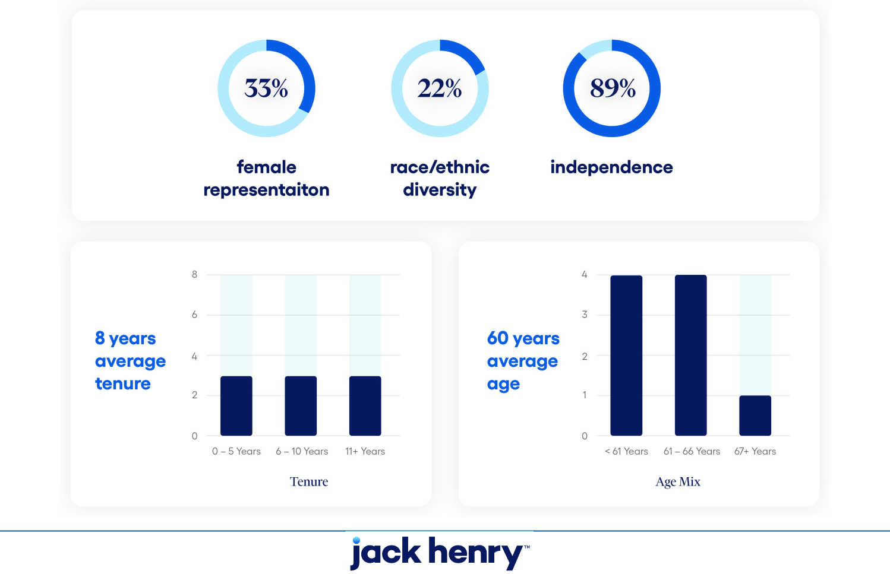

2024 Proxy Statement | 7

Nominee Information

The following information relating to the Company’s director nominees details their principal occupations, business experience, and positions during the past five years, as well as the specific experiences, qualifications, attributes, and skills that led to the conclusion that they should serve as directors of the Company:

David B. Foss Age: 63

Executive Board Chair

Mr. Foss was named Executive Board Chair on July 1, 2024 and was previously appointed Board Chair on July 1, 2021. Mr. Foss served as Chief Executive Officer of the Company from July 1, 2016 to June 30, 2024. He also served as President of the Company from 2014 until January 2022. Mr. Foss’s prior positions with the Company include: President of the Company’s ProfitStars Division from 2009 to 2014; General Manager of ProfitStars from 2006 to 2009; General Manager of the Company’s Acquisition and Business Integration unit from 2004 to 2006, during which time the Company completed 10 acquisitions; General Manager of the Complementary Solutions Group from 2000 to 2004; and President of the Open Systems Group from 1999 to 2004. He is also currently serving as a director of CNO Financial Group, Inc. (NYSE: CNO). Before joining the Company in 1999, Mr. Foss held a variety of positions in the financial services industry including senior operations management, sales management, and supervisory roles at BancTec, Advanced Computer Systems, and NCR. His long tenure in the industry and variety of leadership roles provide significant experience to the Company and its products, employees, and customers.

Vice Chair and Lead Director

Matthew C. Flanigan

Age: 62

Mr. Flanigan is former Executive Vice President, Chief Financial Officer and nine-year Board Member of Leggett & Platt, Incorporated (NYSE: LEG), having retired from those positions in 2019. Headquartered in Carthage, Missouri, Leggett & Platt is a leading manufacturer of engineered components and products found in many homes, offices, automobiles, and airplanes. Mr. Flanigan became Chief Financial Officer in 2003, was appointed Executive Vice President in 2009, and elected to Leggett & Platt’s Board of Directors in 2010. From 1999 until 2003, he served as President of the Office Furniture and Plastics Components Groups of Leggett. Prior to joining Leggett in 1997, Mr. Flanigan was employed in the banking industry for 13 years, the last 10 of which as First Vice President and Manager for Societe Generale S.A. in Dallas, the largest non-U.S. lending institution in the Southwestern United States at that time. Mr. Flanigan currently serves as a director of Performance Food Group Company (NYSE: PFGC), one of the nation’s largest food distribution businesses and a Fortune 100 company. Mr. Flanigan brings to our Board expertise in banking and finance, risk, and compliance as well as a unique perspective coming from his broad experience at a large, global manufacturer as both an executive and board member, and having served on several public company boards. Mr. Flanigan was appointed “Lead Director” by the independent directors in 2012.

8 2024 Proxy Statement

Director

Thomas H. Wilson, Jr.

Age: 63

Mr. Wilson is a Managing Partner at DecisionPoint Advisors, LLC in Charlotte, N.C., a specialized merger and acquisition advisory firm for mid-market technology companies and currently serves as a director of NN, Inc. (Nasdaq: NNBR), a diversified industrial company. Prior to joining DecisionPoint in 2008, he served as Chairman and CEO of NuTech Solutions from 2004 to 2008, a business intelligence software company that was acquired by Neteeza. From 1997 to 2004, Mr. Wilson was President of Osprey, a consulting and systems integration firm. Prior to his work at Osprey, Mr. Wilson was employed by IBM for 14 years in a variety of management and sales positions. Mr. Wilson earned a Master’s in Business Administration from Duke University and has served on the boards of various non-profit and community organizations, including North Carolina Innovative Development for Economic Advancement (NC IDEA), Junior Achievement, the Charlotte United Way, and the National Association of Corporate Directors Carolinas Chapter. Mr. Wilson brings to the Board extensive management and sales experience in technology companies, as well as expertise in technology-oriented investment banking and mergers and acquisitions.

Thomas A. Wimsett Director

Age: 60

Mr. Wimsett is the Founder and Chairman of Merchant’s PACT, a fintech, payments program management, and consulting firm he formed in 2012. He also served as Executive Chairman of ControlScan, Inc., a payment card compliance, network, and managed security services firm, from 2014 through 2020. He is a 35+ year veteran of the payments industry, the founder and former Chairman and Chief Executive Officer of Iron Triangle Payment Systems, a leading merchant payment processor, which was acquired by Vantiv (now Fidelity National Information Services, Inc.) in late 2010. Prior managerial and executive positions in the payments industry include President and CEO of National Processing Company (now owned by Bank of America Corp) from 1999 to 2002. He formerly served as Chairman and director of Town & Country Bank and Trust Company in Bardstown, Kentucky. Mr. Wimsett brings deep knowledge and experience in the payments industry to the Board, including service for more than 10 years as a director or advisory board member of the Electronic Transaction Association, an international trade association, and prior roles as a director of MasterCard’s US Board and on advisory boards for both Discover Card and Visa.

2024 Proxy Statement | 9

Shruti S. Miyashiro Director

Age: 53

Ms. Miyashiro is President and Chief Executive Officer of Digital Federal Credit Union, which she has led since 2022. Ms. Miyashiro also served as President and CEO of Orange County’s Credit Union, which she led from 2007 through 2022. Ms. Miyashiro has served in numerous leadership positions, including as a past Board Director of the Federal Home Loan Bank of San Francisco, past Board Director of CO-OP Financial Services, a large credit union services organization which serves institutions nationwide, past appointee to the Advisory Committee for the California Department of Financial Protection and Oversight, as well as numerous state and national committees for credit unions. Ms. Miyashiro brings to the Board the perspective and experience of one of the largest credit unions in the nation and a current Company customer, as well as that of a past customer from her time at Orange County’s Credit Union, which used the Company’s core software system and many of its complementary products and services during her tenure. Ms. Miyashiro earned a Master’s in Business Administration from the University of Redlands.

Wesley A. Brown Director

Age: 70

Mr. Brown currently serves as President of Bent St. Vrain & Company, LLC, a Denver-based bank consulting firm that he formed in 2015, and as director of FirstBank Holding Company, a $27 billion asset bank holding company based in Lakewood, CO. Mr. Brown served KPMG, LLP as Managing Director in its Corporate Finance subsidiary from June 2014 to his retirement in October 2015. From 2004 to 2014, Mr. Brown was a co-founder and Managing Director of St. Charles Capital, LLC in Denver, Colorado, where he also served as its first President and Compliance Officer. Mr. Brown has specialized in merger transactions and financings for financial institutions, completing over 125 transactions totaling in excess of $3.5 billion over his career. His connections with and to the community banking industry in the Rocky Mountain Region are extensive, as he has personally worked on approximately half of all Colorado bank and thrift merger transactions from 1993 through 2015. Prior to founding St. Charles Capital, he served as Managing Director of McDonald Investments, Inc. (2001-2004) and Executive Vice President of The Wallach Company (1991-2000). Mr. Brown previously served as a Director from 2005 to 2014, when he resigned due to changes in the terms and requirements of his employment by the national accounting and consulting firm KPMG. In addition to experience with finance and compliance, Mr. Brown brings a deep knowledge of the banking industry to the Board as well as unique insight to the Company’s mergers and acquisitions. Mr. Brown earned a Master’s in Business Administration with Honors from the University of Chicago.

10 2024 Proxy Statement

Curtis A. Campbell Director

Age: 52

Mr. Campbell is President of Global Consumer Tax and Chief Product Officer of H&R Block, Inc. (NYSE: HRB), where he has served since 2024. Mr. Campbell is the former CEO of TaxAct, a provider of technology-enabled tax focused financial solutions. He also previously served as President of Software at Blucora, Inc. where he ran TaxAct from 2018 until it was sold by Blucora in 2022. He continued to lead TaxAct after the sale until 2023. Prior to TaxAct, Mr. Campbell served Capital One Financial Corporation (NYSE: COF), a diversified financial services holding company, as a Managing Vice President of Consumer Auto from 2017 to 2018 and Intuit Inc. (Nasdaq: INTU), a financial technology company serving consumers and small businesses, where he served in Vice President roles leading Product Management and Strategy from 2014 to 2017. Mr. Campbell brings extensive experience with infrastructure and cloud computing as well as digital development and a keen focus on customer experience from his leadership roles at several technology companies. Mr. Campbell earned a Master’s in International Business from the University of South Carolina.

Tammy S. LoCascio Director

Age: 55

Ms. LoCascio is Senior Executive Vice President and Chief Operating Officer of First Horizon Corporation (NYSE: FHN), the holding company for First Horizon Bank, where she also previously served as Chief Human Resources Officer, and Executive Vice President of Consumer Banking. Prior to joining First Horizon in 2011, Ms. LoCascio worked in management consulting as well as held leadership roles at various regional banks. Ms. LoCascio brings extensive experience with banking strategy, technology, and operations as well as human capital management. Ms. LoCascio is engaged in the communities she serves and was named a Woman of Impact by the American Heart Association of the Mid South in 2024 and was honored as one of Memphis’ most influential women in business by the Memphis Business Journal in 2018.

Lisa M. Nelson Director

Age: 61

Ms. Nelson is President, International at Equifax, Inc. (NYSE: EFX), where she also previously served as President of Equifax Australia and New Zealand, President and General Manager of Equifax Canada, and Corporate Senior Vice President and Enterprise Alliance Leader. Prior to joining Equifax in 2011, Ms. Nelson held various executive leadership positions at Fair Isaac Corporation (NYSE: FICO) from 2004 to 2011, and from 1998 to 2003 held executive positions at EFunds Corporation, a payments services company that was acquired by Fidelity National Information Services, Inc. (NYSE: FIS) in 2007. Ms. Nelson brings to the Board a deep knowledge and experience of global management of technology companies, in addition to strategic acquisitions and implementation of growth initiatives. Ms. Nelson earned a Master’s in Business Administration from the University of St. Thomas. She currently serves on the private board of Equifax do Brazil.

2024 Proxy Statement 11

Director Independence

Eight of the nine director nominees are independent. Non-employee director nominees Flanigan, Wilson, Wimsett, Miyashiro, Brown, Campbell, LoCascio, and Nelson qualify as “independent” in accordance with the published listing requirements of Nasdaq. Ms. Fiegel is also independent, though she is not seeking re-election at the Annual Meeting. Mr. Foss does not qualify as independent because Mr. Foss is currently an employee of the Company. The Nasdaq rules have both objective and subjective tests for determining who is an “independent director.” The objective tests state, for example, that a director is not considered independent if he or she is an employee of the company, has been an employee within the prior three years, or is a partner in or executive officer of an entity to which the company made, or from which the company received, payments in any of the past three fiscal years that exceed 5% of the recipient’s consolidated gross revenue for that year. The subjective test states that an independent director must be a person who lacks a relationship that, in the opinion of the Board, would interfere with the exercise of independent judgment in carrying out the responsibilities of a director.

The Board relies upon evaluation of director independence by the Board’s Governance Committee. In assessing independence under the subjective test, the Governance Committee takes into account the standards in the objective tests and reviews additional information provided by the directors with regard to each individual’s business and personal activities as they may relate to the Company and its management. Based on all the foregoing, as required by Nasdaq rules, the Governance Committee made a subjective determination as to each of Mses. Fiegel, Miyashiro, LoCascio, and Nelson and Messrs. Flanigan, Wilson, Wimsett, Brown, and Campbell that no relationship exists, which, in the opinion of the Governance Committee, would interfere with the exercise of independent judgment in carrying out the responsibilities of a director. The Governance Committee has not established categorical standards or guidelines to make these subjective determinations but considers all relevant facts and circumstances.

In making its independence determinations, the Governance Committee considered transactions occurring since the beginning of its 2022 fiscal year between the Company and entities associated with the independent directors or members of their immediate family. The Governance Committee considered the customer relationships between the Company and each of (1) the credit union currently associated and the credit union previously associated with Ms. Miyashiro, (2) the bank associated with Ms. Fiegel, (3) the bank associated with Mr. Brown, (4) the non-financial institution entity associated with Mr. Wimsett that uses complementary solutions from the Company, and (5) the bank associated with Ms. LoCascio. For each of these customer relationships, the Governance Committee has determined that these transactions were on terms no less favorable to the Company than arrangements with other unaffiliated customers and that because of the amounts involved in relation to the total revenues of the Company and the applicable customer, the relationships did not impair the independence of Ms. Miyashiro, Ms. Fiegel, Mr. Brown, Mr. Wimsett, or Ms. LoCascio. In all cases and in all years reviewed, the amounts received by the Company from each of these institutions were less than 1% of the Company’s total revenue for the year. The Governance Committee also considered that Mr. Wimsett is Chairman, Managing Partner, and majority owner of Merchant’s PACT, which has a referral agreement with the Company pursuant to which the Company is paid a fee for referring customers to Merchant’s PACT. The Governance Committee also considered that Ms. Nelson is President, International of Equifax, Inc., which offers linked services to Company customers and has a partner agreement with the Company pursuant to which the Company is paid a fee when Company customers purchase the linked interface solution. Because the amounts produced under these relationship have been well below amounts set in the Company’s Related Party Transactions Policy and constitute far less than 1% of the Company’s total revenue for the year, the Governance Committee

12 2024 Proxy Statement

has determined the relationships do not impair the independence of Mr. Wimsett or Ms. Nelson. See “Certain Relationships and Related Transactions” below for further information.

In addition to the Board-level standards for director independence, the directors who serve on the Audit Committee each satisfy standards established by the Securities Exchange Commission (the "SEC") providing that to qualify as “independent” for the purposes of membership, members of audit committees may not accept directly or indirectly any consulting, advisory, or other compensatory fee from the Company other than their director compensation.


THE BOARD RECOMMENDS THAT YOU VOTE “FOR” THE ELECTION OF EACH OF THE NOMINEES FOR ELECTION TO THE BOARD. PROXIES RECEIVED BY THE BOARD WILL BE VOTED FOR THE ELECTION OF EACH NOMINEE UNLESS STOCKHOLDERS SPECIFY IN THEIR PROXY CARD A VOTE OF “WITHHOLD” WITH RESPECT TO A NOMINEE.

2024 Proxy Statement 13

CORPORATE GOVERNANCE

The Company and its businesses are managed under the direction of the Board. The Board generally meets a minimum of five times during the year but has complete access to management throughout the year.

Corporate Governance Guidelines

The Board has adopted Corporate Governance Guidelines that include, among others, the following subjects (the following description is a summary as of September 16, 2024 and is qualified in its entirety by the Corporate Governance Guidelines, which may be updated or amended from time to time):

 | • The majority of the Board should be independent under relevant Nasdaq standards.
Director | • Independent directors should not be compensated by the Company other than in the form of
Director | director’s fees (including any equity awards).
Independence | director’s fees (including any equity awards).
Independence | • Membership on the Audit, Human Capital & Compensation, and Governance Committees should
 | be limited to independent directors.
 | • The Board will not adopt a stockholder rights plan or reprice stock options without a stockholder
Stockholders | vote.
Stockholders | • Stockholders may communicate with the Board by submitting written comments to the Secretary
Rights
Rights | of the Company, who will screen out inappropriate communications and forward appropriate
 | comments to the directors.
 | • Non-management directors may meet in executive session from time to time with or without
 | members of management.
Meeting | • The Board should have at least four regularly scheduled meetings a year and members are invited
Requirements | to attend an annual review of business strategy conducted with senior management.
 | • Board members are expected, absent unusual circumstances, to attend all Annual Meetings of the
 | Stockholders.
 | • The Governance Committee is responsible for determining skills and characteristics of Board
 | candidates, and should consider factors such as independence, experience, strength of character,
Board Composition | mature judgment, technical skills, diversity, and age.
Board Composition | • Board members should not sit on more than three other boards of public companies.
 | • Directors may not stand for re-election after age 70, except in exceptional circumstances as
 | determined by the Board of Directors, and any director first elected after May 14, 2021, may not
 | stand for re-election after a total of 12 years of service.

14 2024 Proxy Statement

 | • Directors, executive officers, and any other Section 16 officers of the Company should own
 | minimum amounts of Company stock in relation to their base compensation and should retain and
Stock | hold 75% of all shares granted, net of taxes, until the ownership requirements are met.
Requirements and | • All directors, executives, and employees are prohibited from engaging in hedging transactions,
Restrictions | short sales, pledges, and trading in any publicly traded options involving the Company’s stock.
 | • Executives are subject to a recoupment policy providing for clawback of incentive compensation in
 | the event of a restatement of financial statements.
 | • The Board should conduct an annual self-evaluation to determine whether it and its committees
 | are functioning properly and an annual performance evaluation for each individual director.
 | • The Chief Executive Officer shall provide an annual report to the Governance Committee on
Board Operations | succession planning.
Board Operations | • The Board and its committees shall have the right at any time to retain independent counsel.
 | • When the Chair is a member of management, the independent directors shall appoint a Lead
 | Director to coordinate activities of the independent directors, help set the agenda and schedule for
 | Board meetings, and chair Board and stockholder meetings in the absence of the Chair.
Stockholder Recommended Director Candidates

The Board has also adopted a Nomination Policy with respect to the consideration of director candidates recommended by stockholders. A candidate submission from a stockholder will be considered at any time if the following information is submitted to the Secretary of the Company (the following description is qualified in its entirety by the Nomination Policy):

- The recommending stockholder’s name and address, together with the number of shares held, length of period held, and proof of ownership;
- Name, age, and address of candidate;

- Detailed resume of candidate, including education, occupation, employment, and commitments;

- Any information required to be disclosed in the solicitation of proxies for election of a director under the Securities Exchange Act of 1934 (the "Exchange Act");

- Description of arrangements or understandings between the recommending stockholder and the candidate;

- Statement describing the candidate’s reasons for seeking election to the Board and documenting candidate’s satisfaction of qualifications described in the Corporate Governance Guidelines;

- A signed statement from the candidate, confirming willingness to serve; and

- If the recommending stockholder has been a beneficial holder of more than 5% of the Company’s stock for more than a year, then it must consent to additional public disclosures by the Company with regard to the nomination.

The Secretary of the Company will promptly forward complying nominee recommendation submissions to the Chair of the Governance Committee. The Governance Committee may consider nominees submitted from a variety of sources including but not limited to stockholder

2024 Proxy Statement 15

recommendations. If a vacancy arises or the Board decides to expand its membership, the Governance Committee will evaluate potential candidates from all sources and will rank them by order of preference if more than one is identified as properly qualified. A recommendation will be made to the Board by the Governance Committee based upon qualifications, interviews, background checks, and the Company’s needs.

Stockholder Nominated Director Candidates

The Company’s Board has adopted a “Proxy Access for Director Nominations” bylaw as part of the Company’s Bylaws. The proxy access bylaw permits a stockholder, or a group of up to 20 stockholders, owning 3% or more of the Company’s outstanding common stock continuously for at least three years to nominate and include in the Company’s proxy materials director nominees constituting up to two individuals or 20% of the Board (whichever is greater), provided that the stockholder(s) and the nominee(s) satisfy the requirements specified in Article II, Section 2.12 of our Bylaws. See “Stockholder Proposals and Nominations” on page 75 for more information.

Majority Election Policy

The Company’s Bylaws and Corporate Governance Guidelines require that a director nominee only be elected if he or she receives a majority vote of the votes cast with respect to his or her election in an uncontested election. Thus, for a nominee to be elected, the number of votes cast “For” must exceed the number of votes cast as “Withhold” for the nominee. If a nominee who is currently serving as a director is not re-elected with a majority of the votes cast, then under the Corporate Governance Guidelines, he or she is required to submit a resignation to the Board. In this event, the Governance Committee will consider the tendered resignation and will make a recommendation to the Board as to whether to accept or reject the resignation. The Board must act on the tendered resignation within 90 days from the date of certification of the election results and must also promptly disclose its decision and explain its rationale.

Board Leadership Structure

The Board does not have a fixed policy regarding the separation of the offices of Board Chair and Chief Executive Officer. These offices were held by different persons from 2004 to 2012 and from 2016 to 2021. The offices were combined in one person from 2012 to 2016 and from 2021 to June 2024. On July 1, 2024, these two offices were again separated when Mr. Adelson was appointed as Chief Executive Officer and Mr. Foss continued serving as Executive Board Chair. The members of the Board believe that the Company has been well served in the past by both combined Chair/CEOs and by separate persons in these offices and believes that the Board should maintain the flexibility to combine or separate these offices in the future if deemed to be in the best interests of the Company.

The Board has adopted a governance guideline providing for an independent “Lead Director.” Under the guideline, when the Chair is a member of Company management, the independent directors will annually appoint from among themselves a Lead Director. The Lead Director will coordinate the activities of the independent directors, coordinate with the Chair to set the agenda and schedule for Board meetings, advise on materials distributed to directors, chair meetings of the Board and stockholders in the absence of the Chair, call and chair executive sessions of the independent directors, and perform other duties assigned from time to time by the Board. Mr. Flanigan has served as the Lead Director since 2012.

16 2024 Proxy Statement

The Board is committed to strong, independent Board leadership and believes that objective oversight is critical to effective governance. Eight of our nine director nominees are independent, as are all members of each of the committees of the Board. The independent directors regularly meet in executive session without Mr. Foss, the sole non-independent director.

Communication with the Board

Stockholders and all other interested parties wishing to contact our Board may write to: Board of Directors of Jack Henry &

Associates, Inc., Attn: Corporate Secretary, PO Box 807, 663 West Highway 60, Monett, MO 65708. The Company’s Secretary distributes this correspondence to the appropriate member(s) of the Board.

Risk Oversight

Pursuant to the Company’s Corporate Governance Guidelines, the Board performs its risk oversight function primarily through its Risk and Compliance, Audit, and Human Capital & Compensation Committees. The Risk and Compliance Committee has primary responsibility for overseeing, monitoring, and addressing the Company’s enterprise and operational risks. The Risk and Compliance Committee is charged with overseeing the Company’s risk management program that measures, prioritizes, monitors, and responds to risks. This oversight includes ensuring the adequacy of management’s design and implementation of information security measures. The Risk and Compliance Committee receives reports from the Company’s Chief Information Security Officer, as well as other members of management. The Audit Committee oversees risks relating to financial statements and reporting, credit, and liquidity risks. The Human Capital & Compensation Committee is charged with oversight of risks in compensation, employee benefits, and other employment related policies and practices. The Audit Committee and the Human Capital & Compensation Committee provide periodic reports regarding their risk assessments to the Risk and Compliance Committee. The Board receives regular reports from both the Risk and Compliance Committee of the consolidated risk assessments of these committees and from management. The Board assesses major risks and reviews with management options for risk mitigation. As such, the Board is informed and engaged when new risks arise.

Corporate Responsibility and Sustainability

The Company has long incorporated a commitment to corporate social responsibility into the way it does business and is committed to both doing the right thing and increasing stockholder value through increased focus and disclosure on these issues. The Board has overall oversight responsibility for matters related to corporate sustainability issues, with individual Board committees responsible for certain subcomponents. The executive leadership team is held accountable for execution through their lines of business. The Company published its most recent sustainability report in April 2024. The sustainability report is posted on our investor relations web site at http://ir.jackhenry.com under the “Sustainability” tab.

Code of Conduct

The members of the Board, as well as the executive officers and all other employees, contractors, vendors, and business partners of the Company are subject to and responsible for compliance with the Jack Henry & Associates Code of Conduct. The Code of Conduct contains policies and practices for the ethical and lawful conduct of our business, as well as procedures for confidential investigation of complaints and discipline of wrongdoers. Only the Board of Directors can amend or grant waivers from the provisions of the Code of Conduct. The Company intends to satisfy the

2024 Proxy Statement 17

disclosure requirement under Item 5.05 of Form 8-K regarding amendment to, or waiver from, a provision of the Code of Conduct by posting such information on our website at https://ir.jackhenry.com/corporate-governance/overview.

Governance Materials Available

The Company has posted its significant corporate governance documents on its website at https://ir.jackhenry.com/corporate-governance/overview. There you will find, among other things, copies of the current Corporate Governance Guidelines, the Code of Conduct, the Human Rights Commitment and Policy Statement, the Human Capital & Compensation Committee Charter, the Governance Committee Charter (with attached Nomination Policy), Audit Committee Charter, and the Risk and Compliance Committee Charter, as well as the Company’s Certificate of Incorporation and Bylaws. Other investor relations materials are also posted at http://ir.jackhenry.com, including SEC reports, financial statements, and news releases.

The Board of Directors and Its Committees

The Board held four regular meetings and two special meetings during the last fiscal year. Each director, except Laura Kelly, who passed away in March 2024, attended at least 75% of all meetings of the Board and all committees on which they served. The independent directors met in four executive sessions without management present during the last fiscal year. In accordance with our Corporate Governance Guidelines, all the then-serving directors attended the Annual Meeting of the Stockholders held on November 14, 2023.

The Governance Committee of the Board has determined that eight of the Board’s nine director nominees, Flanigan, Wilson, Wimsett, Miyashiro, Brown, Campbell, LoCascio, and Nelson are independent directors under applicable Nasdaq standards. Ms. Fiegel is also independent, though she is not seeking re-election at the Annual Meeting.

The Board has adopted stock ownership guidelines within the Corporate Governance Guidelines establishing stock ownership goals applicable to directors as well as senior management of the Company. Each non-employee director of the Company is expected to own Company shares having a value of at least five times the annual director cash retainer. Under the terms of the guidelines, new directors should be in compliance with this standard within five years after joining the Board. For this purpose, in addition to shares held outright, directors may include shares held in the person’s retirement accounts and deferral accounts, all shares held in trust for the person’s immediate family members, and all restricted stock units. As measured on June 30, 2024, all directors on such date were in compliance with these ownership guidelines or within the five-year compliance window.

The Board has the following four standing committees, each of which operates under a written charter adopted by the Board.

The Committee compositions listed below are as of September 16, 2024:

18 2024 Proxy Statement

Audit Committee

Thomas H. Wilson, Jr.

(Chair)

Matthew C. Flanigan

Thomas A. Wimsett

Wesley A. Brown

Lisa M. Nelson

Meetings in
FY2024: 14

The Audit Committee selects and oversees the independent auditor, reviews the scope and results of the annual audit, including critical audit matters, reviews critical accounting policies, reviews internal controls over financial reporting, pre-approves retention of the independent registered public accounting firm for any services, oversees our internal audit function, reviews and approves all material related party transactions, reviews regulatory examination results and addresses financial reporting risks. All members of the Audit Committee are independent. The Board has determined that Mr. Flanigan, Mr. Wilson, and Mr. Wimsett are each an “audit committee financial expert” as defined by the SEC because of their extensive accounting and financial experience. Please see the Audit Committee Report in this Proxy Statement for information about our 2024 fiscal year audit.

Human Capital & Compensation Committee

Shruti S. Miyashiro (Chair) | The Human Capital & Compensation Committee establishes and reviews the compensation,
 | perquisites, and benefits of the Company’s executive officers, evaluates the performance of
Matthew C. Flanigan | senior executive officers, makes recommendations to the Board on director compensation,
 | considers incentive compensation plans for our employees, and carries out duties assigned to
Curtis A. Campbell | the Human Capital & Compensation Committee under our equity compensation plans and
 | employee stock purchase plan. Under its charter, the Human Capital & Compensation
 | Committee has the authority to delegate certain responsibilities to subcommittees, but it may
Tammy S. LoCascio
 | not delegate any matter relating to senior executive compensation. To date, the Human
 | Capital & Compensation Committee has not delegated any of its responsibilities. All members
 | of the Human Capital & Compensation Committee are independent. Please see the Human
 | Capital & Compensation Committee Report and the Compensation Discussion and Analysis in
 | this Proxy Statement for further information about the Human Capital & Compensation
 | Committee’s process and decisions in fiscal 2024.

Meetings in
FY2024: 13

2024 Proxy Statement 19

Governance Committee

Curtis A. Campbell (Chair) |  | The Governance Committee identifies, evaluates, and recruits qualified individuals to stand
 |  | for election to the Board, recommends corporate governance policy changes, reviews
 |  | executive succession planning, and evaluates Board performance. The Governance
Thomas H. Wilson, Jr.
Thomas H. Wilson, Jr. |  | Committee will consider candidates recommended by stockholders, provided such
 |  | recommendations are made in accordance with the procedures set forth in the “Governance
Jacque R. Fiegel |  | Committee Nomination Policy” attached to its charter, discussed in greater detail in
 |  | “Stockholder Recommended Director Candidates,” above. All members of the Governance
 |  | Committee are independent. Mr. Campbell was appointed Chair of the Governance
Lisa M. Nelson
Lisa M. Nelson |  | Committee following the unfortunate and untimely passing of director Laura Kelly in March of
 | 2024.
Meetings in
FY2024: 4

Risk and Compliance Committee

Thomas A. Wimsett |  | The Risk and Compliance Committee reviews the Company’s compliance practices, reviews
(Chair) |  | enterprise risks, oversees the Company’s risk assessment and management programs,
 |  | reviews risk preparedness and mitigation, monitors regulatory compliance, and oversees
Jacque R. Fiegel
 |  | response to regulatory requirements. All members of the Risk and Compliance Committee are
Shruti S. Miyashiro |  | independent. Please see “Risk Oversight” above for further information about the Risk and
 |  | Compliance Committee’s risk management responsibilities.
Tammy S. LoCascio |  | Compliance Committee’s risk management responsibilities.
Meetings in
FY2024: 9

Compensation Committee Interlocks and Insider Participation

During our 2024 fiscal year, Ms. Miyashiro and Messrs. Flanigan, Wilson, and Brown served on the Human Capital & Compensation Committee. None of the members of the Human Capital & Compensation Committee is currently or was formerly an officer or employee of the Company. Ms. Miyashiro is President and CEO of Digital Federal Credit Union and was previously President and CEO of Orange County’s Credit Union, both of which are customers of the Company as described below in “Certain Relationships and Related Transactions.” There are no other Human Capital & Compensation Committee interlocks and no insider participation in compensation decisions that are required to be reported under the SEC’s rules and regulations.

Director Compensation

The Human Capital & Compensation Committee reviews annually the compensation for non-employee directors, as well as comparative compensation data for peer companies provided by its independent advisor. If the Human Capital & Compensation Committee determines that a change to non-employee director compensation is advisable, it provides a recommendation to the Board and the Board considers this recommendation for approval. The following table sets forth compensation paid to our non-employee directors in fiscal 2024. A director who is employed

20 2024 Proxy Statement

by the Company does not receive any separate compensation for service on the Board. The compensation paid to Mr. Foss as an employee is detailed below at “Executive Compensation.”

Name |  | Fees Earned or | Stock Awards |  | Options | Non-Equity Incentive | All Other
Name |  | Paid in Cash | Stock Awards |  | Awards | Plan Compensation | Compensation | Total
 |  | ($) | ($) (1) (2) |  | ($) | ($) | ($) | ($)
Matthew C. Flanigan |  | 165,000 | 177,475 |  | - | - | - | 342,475
Thomas H. Wilson, Jr. |  | 130,000 | 177,475 |  | - | - | - | 307,475
Jacque R. Fiegel |  | 95,000 | 177,475 |  | - | - | - | 272,475
Thomas A. Wimsett |  | 130,000 | 177,475 |  | - | - | - | 307,475
Laura G. Kelly | (3) | 82,500 | 177,475 | (4) | - | - | - | 259,975
Shruti S. Miyashiro |  | 125,000 | 177,475 |  | - | - | - | 302,475
Wesley A. Brown |  | 105,000 | 177,475 |  | - | - | - | 282,475
Curtis. A. Campbell |  | 95,000 | 177,475 | (4) | - | - | - | 272,475
Tammy S. LoCascio | (5)
Lisa M. Nelson | (5)

- These amounts reflect the aggregate grant date fair value of restricted stock units granted in the fiscal year ended June 30, 2024, in accordance with FASB ASC Topic 718. For assumptions used in determining the fair value of restricted stock units granted, see Note 10 to the Company’s 2024 consolidated financial statements in our Annual Report on Form 10-K for the year ended June 30, 2024.

- As of June 30, 2024, each director listed, other than Ms. Kelly, Ms. LoCascio, and Ms. Nelson, held an aggregate of 1,173 unvested restricted stock units.

- Director Laura Kelly passed away on March 15, 2024. A pro-rata portion of her fiscal 2024 restricted stock unit award equal to the period from her date of death through the Annual Meeting was cancelled pursuant to the terms of the award agreement.

- Includes amounts deferred pursuant to the Company’s Non-Employee Director Deferred Compensation Plan.

- Mses. LoCascio and Nelson were appointed to the Board on July 22, 2024, and received no compensation in fiscal year 2024.

Summary of Fiscal 2024 Compensation Elements

Annual Compensation Elements | Amount
Board Retainer (non-employee directors)* | $ 70,000
Lead Director* | $ 50,000
Audit Committee Retainer* | $ 20,000
Human Capital & Compensation Committee & Risk and Compliance Committee Retainer* | $ 15,000
Governance Committee Retainer* | $ 10,000
Additional Audit Committee, Human Capital & Compensation Committee, Risk and Compliance Committee Chair $ 25,000
Retainer*
Additional Governance Committee Chair Retainer* | $ 15,000
Annual Equity Award** | $ 180,000
* All retainers are paid in cash quarterly in arrears
** Equity compensation is paid annually to the non-employee directors in the form of restricted stock units.

2024 Proxy Statement 21

In fiscal 2024, the directors listed above were not eligible to participate in any non-equity incentive compensation plan from the Company or any pension plan of the Company. Non-employee directors are eligible for and may elect to participate in the Company’s Non-Employee Director Deferred Compensation Plan. In fiscal 2024, only the restricted stock unit awards to non-employee directors were eligible for deferral and two of the non-employee directors elected deferral of all or part of their award. Deferred amounts are maintained by the Company in bookkeeping accounts. Stock awards that are deferred are deemed invested in the Company’s common stock, and deemed dividends paid on deferred equity awards are invested in a Federal Rate fund. The deferred amounts are unsecured obligations of the Company. Restricted stock units that are deferred under the Company’s Non-Employee Director Deferred Compensation Plan may be settled in stock or, at the option of the Human Capital

- Compensation Committee, in cash. Earnings on deferred amounts are not included in the above table because plan earnings were not preferred or above market.

CERTAIN RELATIONSHIPS AND RELATED TRANSACTIONS

Related Party Transactions

Director Shruti S. Miyashiro is the President and Chief Executive Officer of Digital Federal Credit Union (“DFCU”). At the time of her appointment as the President and CEO of DFCU, DFCU was not a customer of the Company. On August 31, 2022, the Company completed its acquisition of Payrailz, LLC (“Payrailz”). DFCU was a customer of Payrailz at the time of the acquisition and became a customer of the Company. During the year ended June 30, 2024, cash receipts from DFCU were $2,121,925 for Payrailz complementary solutions. Prior to Ms. Miyashiro joining DFCU, the credit union had prepaid Payrailz for services. This prepaid account balance was $2,500,000 when the Company acquired Payrailz, which the Company held as deferred revenue. Several other Payrailz customers also had prepaid account balances at the time of acquisition. During fiscal 2023, DFCU’s prepaid account balance was reduced by $886,793 for services provided by the Company. The Company determined to offer the return of all remaining prepaid amounts to all Payrailz customers and move to ordinary course billing for such customers. DFCU accepted the offer and in August 2023, the Company returned $1,448,178 to DFCU, reducing the prepaid account balance to $0. The Audit Committee has reviewed the transactions with DCFU and has concluded that they were on terms no less favorable to the Company than arrangements with other unaffiliated customers.

Director Jacque R. Fiegel is Chairman of Central Oklahoma Area of Prosperity Bank, which is a customer of the Company. Total fiscal 2024 cash receipts from Prosperity Bank were $394,266, primarily for electronic payment solutions. The Audit Committee has reviewed the transactions with the bank and has concluded that they were on terms no less favorable to the Company than arrangements with other unaffiliated customers.

Director Wesley A. Brown is a director of FirstBank Holding of Lakewood, Colorado, which is a customer of the Company. Total fiscal 2024 cash receipts from this customer were $22,479, primarily for online financial management. The Audit Committee has reviewed the transactions with the bank and has concluded that they were on terms no less favorable to the Company than arrangements with other unaffiliated customers.

22 2024 Proxy Statement

Director Tammy LoCascio is Senior Executive Vice President and Chief Operating Officer of First Horizon Corporation, which is the holding company for First Horizon Bank, a customer of the Company. Total fiscal 2024 cash receipts from this customer were $1,089,871, primarily for payment processing solutions. The Audit Committee has reviewed the transactions with the bank and has concluded that they were on terms no less favorable to the Company than arrangements with other unaffiliated customers.

Director Thomas A. Wimsett is Chairman, Managing Partner, and majority owner of Merchant’s PACT, formerly known as Wimsett & Co. On July 1, 2016, a “Referral Partner Agreement” was entered into between Merchant’s PACT and the Company under which the Company may refer certain customers to Merchant’s PACT for credit and debit card consulting services with a portion of the consulting fees paid to the Company for the referrals. On July 15, 2019, Merchant’s PACT and the Company entered into an “Amended and Restated Referral Partner Agreement” which expanded the scope of the services and responsibilities of Merchant’s PACT stated in the 2016 Referral Partner Agreement. In addition to the credit and debit card consulting services, Merchant’s PACT may also engage and negotiate with certain merchant processing companies on revenue share, pricing, and terms on behalf of financial institution customers and their merchants. Under the terms of the amended agreement, all payments are made from Merchant’s PACT to the Company and Merchant’s PACT will not receive any payments from the Company. Merchant’s PACT paid the Company $50,373 in referral fees in fiscal 2024. Mr. Wimsett is also a director of Revenue Management Solutions, LLC, a non-financial institution entity that uses the Company’s enterprise payment solutions. Total fiscal 2024 cash receipts from this customer were less than $10,000.

Director Lisa M. Nelson is President, International at of Equifax, Inc., which offers linked services to Company customers and has a partner agreement with the Company pursuant to which the Company is paid a fee when Company customers purchase the linked interface solution. Total fiscal 2024 fees paid by Equifax to the Company related to this agreement were $47,782.

The Audit Committee reviewed the relationship with Ms. Fiegel and determined that because Ms. Fiegel is an employee and not an executive officer of Prosperity Bank, and the total amounts paid to the Company do not exceed the greater of $1,000,000 or two percent of Prosperity Bank’s total annual revenue, this relationship falls under the standing pre-approval granted in the Related Party Transaction Policy. The Audit Committee also reviewed the relationships with each of Mr. Brown, Mr. Wimsett, and Ms. Nelson and determined that they each did not qualify as a “Related Party Transaction” under the policy because, for Mr. Brown, he is solely a director of FirstBank Holding and the aggregate amount involved did not exceed the greater of $1,000,000 or two percent of FirstBank Holding’s total annual revenue, for Mr. Wimsett, total payments from Merchant’s PACT and from Revenue Management Solutions to the Company in fiscal 2024 did not exceed $100,000, and because for Ms. Nelson, total payments from Equifax, Inc. to the Company in fiscal 2024 did not exceed $100,000. The Audit Committee reviewed the relationships with Ms. Miyashiro relating to DFCU and with Ms. LoCascio relating to First Horizon Bank in accordance with the Company’s Related Party Transaction Policy and approved the related transactions.

The Governance Committee also considered each of the transactions described in this section and concluded that Ms. Miyashiro, Ms. Fiegel, Mr. Brown, and Ms. LoCascio to be independent directors despite the customer relationships. The Governance Committee also determined Mr. Wimsett to be independent despite the relationship between the Company and Merchant’s PACT and despite the customer relationship with Revenue Management Solutions, and Ms. Nelson to be independent despite the relationship between the Company and Equifax, Inc.

2024 Proxy Statement 23

Related Party Transaction Policy

The Board has adopted a written policy that requires all related party transactions to be reviewed and approved by the Audit Committee of the Board. The Audit Committee is charged with determining whether a related party transaction is in the best interests of, or not inconsistent with the interests of, the Company and its stockholders. In making this determination, the Audit Committee will consider such factors as whether the related party transaction is on terms no less favorable to the Company than terms generally available to unaffiliated third parties and the extent of the related party’s interest in the transaction. No director may participate in any discussion, approval, or ratification of any transaction in which he or she has an interest, except for the purpose of providing information concerning the transaction. For transactions in which the aggregate amount is expected to be less than $200,000, the Chair of the Audit Committee has been delegated the authority to pre-approve related party transactions, subject to later review by the full committee. At least annually, ongoing related party transactions will be reviewed to assess continued compliance with the policy. For purposes of the Related Party Transaction Policy, a related party transaction is a transaction or relationship in which the aggregate amount involved will or may exceed $ 100,000 in any calendar year, involves the Company as a participant, and in which any related party has or will have a direct or indirect interest (other than solely as a result of being a director or less than 10% beneficial owner of the other entity). A related party is any executive officer, director, or more than 5% beneficial owner of the Company or any immediate family member of such persons.

The policy also contains standing pre-approvals of certain transactions that are not believed to pose any material risk to the Company even if the aggregate amount exceeds $100,000 in a calendar year, including: employment arrangements with executive officers, director compensation, transactions involving competitive bids, certain banking-related services, certain Company charitable contributions, transactions where all stockholders receive proportional benefits, certain regulated transactions, and satisfaction of indemnification obligations. Standing approval is also provided for transactions with another company where the related party’s only relationship is as an employee (other than an executive officer), director, or beneficial owner of less than 10% of that entity’s shares, if the aggregate amount does not exceed the greater of $1,000,000 or 2% of that entity’s annual revenues.

DELINQUENT SECTION 16(a) REPORTS

The Company is required to identify any director, officer, or greater than 10% beneficial owner who failed to timely file with the SEC a report required under Section 16(a) of the Exchange Act relating to ownership and changes in ownership of the Company’s common stock. The required reports consist of initial statements on Form 3, statements of changes on Form 4, and annual statements on Form 5. To the Company’s knowledge, based solely on its review of the copies of such forms received by it, the Company believes that during the fiscal year ended June 30, 2024 all required Section 16(a) filings were filed timely.

24 2024 Proxy Statement

AUDIT COMMITTEE REPORT

The Audit Committee of the Company’s Board of Directors is currently composed of five independent directors. The Board has determined that Audit Committee members Matthew C. Flanigan, Thomas H. Wilson, Jr., and Thomas A. Wimsett are “audit committee financial experts” under relevant SEC standards because of their extensive accounting and financial experience. The Board and the Audit Committee believe that the Audit Committee’s current members satisfy all Nasdaq and SEC rules that govern audit committee composition.

The Audit Committee operates under a written Charter adopted by the Board. The Charter requires the Audit Committee to oversee and retain the independent registered public accounting firm, pre-approve the services and fees of the independent registered public accounting firm, regularly consider critical accounting policies of the Company, review and approve material related party transactions, receive reports from the Company’s Chief Audit Executive and General Counsel, and establish procedures for receipt and handling of complaints and anonymous submissions regarding accounting or auditing matters. The Charter also contains the commitment of the Board to provide funding and support for the operation of the Audit Committee, including funding for independent counsel for the Committee if the need arises.

The role of the Audit Committee is to assist the Board in its oversight of the Company’s financial reporting process. Management has the primary duty for the financial statements and the reporting process, including the systems of internal controls. The independent registered public accounting firm is responsible for auditing the Company’s financial statements and expressing an opinion as to their conformity to accounting principles generally accepted in the United States.

In the performance of its oversight function, the Audit Committee has reviewed and discussed with management and the independent registered public accounting firm the Company’s audited financial statements. The Audit Committee also has discussed with the independent registered public accounting firm the matters required to be discussed by the applicable requirement of the Public Company Accounting Oversight Board (“PCAOB”) and the SEC. In addition, the Audit Committee has received from the independent registered public accounting firm the written disclosures and letter required by applicable requirements of the PCAOB regarding the independent registered public accounting firm’s communications with the Audit Committee concerning independence and has discussed with the independent registered accounting firm its independence.

The Audit Committee discussed with the Company’s independent registered public accounting firm the overall scope and plans for their audit. The Audit Committee meets with the internal auditors and the independent registered public accounting firm, with and without management present, to discuss the results of their examinations, their evaluations of the Company’s internal controls and the overall quality of the Company’s financial reporting. These meetings without management present are held at least once each year, and such meeting was held in the fiscal year just ended.

In reliance on the reviews and discussion referred to above, the Audit Committee recommended to the Board, and the Board has approved, that the Company’s audited financial statements be included in the Company’s 2024 Annual Report to Stockholders and Annual Report on Form 10-K for the year ended June 30, 2024 for filing with the SEC.

Audit Committee*

Thomas H. Wilson, Jr., Chair

Matthew C. Flanigan

Thomas A. Wimsett

Wesley A. Brown

*Lisa M. Nelson, a current member of our Audit Committee, was appointed as a member of the Audit Committee after our Annual Report on Form 10-K for the fiscal year ended June 30, 2024 was prepared and accordingly did not participate in the review, discussions, and recommendation for the Audit Committee Report.

2024 Proxy Statement 25

EXECUTIVE OFFICERS

The executive officers of the Company, as well as biographical information for non-director executive officers, are as follows:

Name | Position with Company | Officer Since
David B. Foss | Executive Board Chair | 2014
Gregory R. Adelson | President and Chief Executive Officer | 2018
Mimi L. Carsley | Chief Financial Officer and Treasurer | 2022
Shanon G. McLachlan | Senior Vice President and Chief Operating Officer | 2024
Craig K. Morgan | General Counsel and Secretary | 2016
Renee A. Swearingen | Senior Vice President, Chief Accounting Officer and Assistant Treasurer | 2022
Gregory R. Adelson | President and Chief Executive Officer

Age: 60

Mr. Adelson has served as Chief Executive Officer since July 2024 and as President since January 2022. He served as Chief Operating Officer from November 2019 until his appointment as Chief Executive Officer in July 2024. Mr. Adelson joined the

Company in 2011 as Group President of iPay Solutions, the Company’s online bill pay business unit. He was later promoted to General Manager of JHA Payment Solutions in 2014 and became an executive officer of the Company in 2018. Prior to joining

the Company, Mr. Adelson had several executive roles with payment processing companies, including Chief Operating Officer at National Processing Company and President at ChoicePay.

Mimi L. Carsley Chief Financial Officer and Treasurer

Age: 55

Ms. Carsley was appointed Chief Financial Officer and Treasurer in September 2022. Prior to joining the Company, Ms. Carsley
served in various roles for Blucora, Inc. (Nasdaq: BCOR), a provider of technology-enabled tax focused financial solutions, including as Treasurer and Senior Vice President of FP&A and Procurement from 2020 to 2022, as Interim Chief Financial
Officer in 2020, and as a Financial Consultant contractor from 2018 to 2020. Ms. Carsley also served as Treasurer and

Executive Vice President of Corporate Development at LPL Financial Holdings, Inc. (Nasdaq: LPLA), a provider of investment and business solutions for independent financial advisors, from 2015 to 2017. Prior to this, Ms. Carsley spent more than a

decade at Microsoft Corporation (Nasdaq: MSFT) in several roles, culminating in the position of Senior Director Strategy, Entertainment and Devices Division.

26 2024 Proxy Statement

Craig K. Morgan General Counsel and Secretary

Age: 48

Mr. Morgan was named General Counsel and Secretary in November 2016. He oversees the legal and corporate responsibility
functions of the Company. Mr. Morgan had previously served as Managing Corporate Counsel and has served in multiple roles in the Legal Department since joining the Company in 2004. Prior to joining the Company, Mr. Morgan worked in research and
development in the biotechnology industry.

Shanon G. McLachlan Senior Vice President and Chief Operating Officer

Age: 57

Mr. McLachlan was appointed Senior Vice President and Chief Operating Officer on July 1, 2024. Mr. McLachlan is responsible for all business lines, operations, and infrastructure of the Company. Prior to his current role, he served as Vice President of the
Company and as President of Credit Union Solutions (previously Symitar), a position he held starting in 2019. He joined Jack
Henry in 2015 and served as Senior Managing Director of ProfitStars from 2015 to 2019. Prior to joining Jack Henry, Mr.

McLachlan held various leadership positions at a core systems company where he supported both banks and credit unions.

Renee A. Swearingen Senior Vice President, Chief Accounting Officer, and Assistant Treasurer

Age: 56

Ms. Swearingen was appointed Senior Vice President and Chief Accounting Officer in May 2022. She oversees the accounting, finance, tax, external reporting, procurement, and facilities functions of the Company. She joined the Company in 1996 and

served in various roles within the Company’s financial function including as Controller of the Company from 2001 to 2022 and as the Vice President of Finance and Procurement for the Company from 2021 to 2022. Prior to joining the Company, Ms.

Swearingen was a practicing CPA at FORVIS, a large public accounting firm.

2024 Proxy Statement 27

HUMAN CAPITAL & COMPENSATION COMMITTEE REPORT

The Human Capital & Compensation Committee of the Company has reviewed and discussed the following Compensation Discussion and Analysis required by Item 402(b) of Regulation S-K with management and, based on such review and discussions, the Human Capital & Compensation Committee recommended to the Board that the following Compensation Discussion and Analysis be included in this Proxy Statement.

Human Capital & Compensation Committee*

Shruti S. Miyashiro, Chair

Matthew C. Flanigan

Thomas H. Wilson, Jr.

Wesley A. Brown

- Curtis A. Campbell and Tammy S. LoCascio were appointed as members of the Human Capital & Compensation Committee effective August 23, 2024, and, as a result, neither Mr. Campbell nor Ms. LoCascio participated in the review, discussions, and recommendation with respect to the above Compensation Discussion and Analysis. Thomas H. Wilson, Jr. and Wesley A. Brown, former members of the Human Capital & Compensation Committee who participated in such review, discussions, and recommendation, were removed as members of the committee on August 23, 2024.

28 2024 Proxy Statement

COMPENSATION DISCUSSION AND ANALYSIS

You will have the opportunity to cast an advisory vote on Jack Henry’s executive compensation at this year’s Annual Meeting (our “say on pay” vote), included as Proposal 2 in this proxy statement (page 68). We encourage you to review this section prior to casting your “say on pay” advisory vote.

At the Company’s Annual Meeting of Stockholders held in November 2023, 94% of the votes cast on say-on-pay at that meeting were voted in favor of the proposal. The Human Capital & Compensation Committee (the “HC&C Committee”) believes this vote strongly affirms the stockholders’ support of the Company’s approach to executive compensation, and the HC&C Committee did not significantly change its basic approach to compensation of the named executive officers (“Named Executives”) in fiscal 2024. The HC&C Committee believes that stockholder input on executive compensation is crucial and will continue to consider the outcome of the Company’s say-on-pay votes when making future compensation decisions for the Named Executives.

This Compensation Discussion and Analysis is designed to provide information regarding the philosophy and objectives underlying our compensation policies, the processes we follow in setting compensation, the components we utilize in compensating our top executives, and the resulting compensation outcomes. This discussion is focused on the following “Named Executives” as of June 30, 2024.

Named Executive | Title
David B. Foss* | Chief Executive Officer
Gregory R. Adelson** | President and Chief Operating Officer
Mimi L. Carsley | Chief Financial Officer and Treasurer
Craig K. Morgan | General Counsel and Secretary
Stacey E. Zengel*** | Senior Vice President and President of Jack Henry Bank Solutions

*Mr. Foss served as Chief Executive Officer and Board Chair through all of fiscal 2024. He stepped down as Chief Executive Officer and took the title of Executive Board Chair effective July 1, 2024.

**Mr. Adelson served as President and Chief Operating Officer through all of fiscal 2024. He was appointed Chief Executive Officer and President effective July 1, 2024.
***Mr. Zengel retired from the Company effective June 30, 2024.

Specific information about the compensation of the Named Executives is set forth in the Summary Compensation Table and other compensation tables beginning on page 52, which should be read in conjunction with this discussion.

2024 Proxy Statement 29

Executive Summary

Jack Henry’s executive compensation programs are designed to align the interests of the Jack Henry executives with those of our stockholders. This goal is accomplished by emphasizing the principle of pay for performance through the achievement of short- and long-term performance goals and rewarding the creation of long-term stockholder value while encouraging a culture of stock ownership. The decisions made by the HC&C Committee in establishing financial, business, and personal targets for executive officer compensation reflect a clear expression of these principles. The following chart provides an overview of the fiscal 2024 compensation components for our Named Executives:

Fiscal 2024 Compensation Components

Component |  | Metrics | Performance/ Vesting | More Information
Component |  | Metrics | Period | More Information
 |  | Fixed and recurring cash compensation set at market competitive
Base Salary |  | levels to attract and retain highly qualified and effective |  | Page 36
Base Salary |  | executives. |  | Page 36
Annual Incentive Cash |  | Variable cash compensation tied 75% to annual adjusted
Annual Incentive Cash |  | operating income versus budget target and 25% tied to | One year | Page 36
Bonus |  | achievement of strategic goals. | One year | Page 36
 |  | Performance shares cliff vest based on Jack Henry’s (1) relative
 |  | total shareholder return against our Compensation Peer Group
 | Performance share | plus our two reference peers (60%), (2) three-year compound
 | Performance share | annual growth rate for organic revenue (20%), and (3) three-year | Three years | Page 42
 | awards (60%) | non-GAAP adjusted operating margin expansion (20%). | Three years | Page 42
Long-Term Incentive | Restricted stock | Time-based restricted stock units vest in equal annual | Three years | Page 46
Compensation | unit awards (40%) | installments based on continued service. | Three years | Page 46

In the aggregate, the relative portions of the above compensation components that made up the pay mix in fiscal 2024 for Mr.

Foss, our Chief Executive Officer, and the other Named Executives as a a group are as follows:
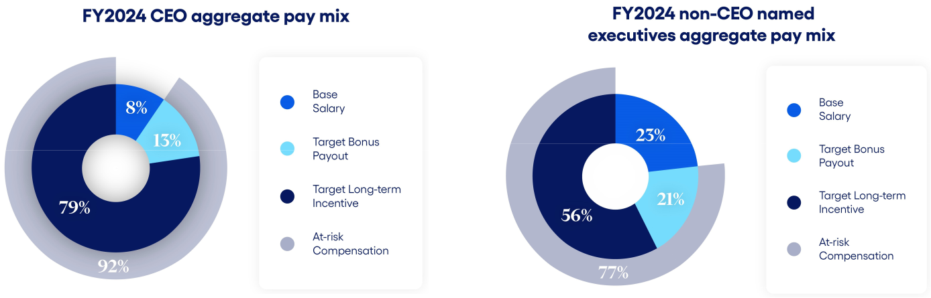

30 2024 Proxy Statement

The fiscal 2024 pay mix established by the HC&C Committee places the greatest emphasis on performance-based and at-risk pay while balancing the need for retention, and particularly emphasized long-term performance by the Company. The pay mix was intended to ensure that the Named Executives remained highly focused on the long-term success of the Company.

Total Shareholder Return, Organic Revenue Growth, Non-GAAP Adjusted Operating Margin Expansion, and Results of Fiscal 2022 Performance Share Awards

In fiscal 2022, the HC&C Committee made three separate performance share grants to our then named executive officers (“2022 Named Executives”) based on three separate measures of comparative performance. One was based on relative total shareholder return ("TSR"), one was based on the Company’s compound annual growth rate (“CAGR”) for non-GAAP adjusted revenue (“Organic Revenue Growth”), and one was based on the Company's non-GAAP adjusted operating margin expansion (“Operating Margin Expansion”).

TSR is calculated as (i) the sum of change in stock price plus dividends over the measurement period, divided by (ii) the beginning stock price. This calculation assumes reinvestment of dividends. Our TSR performance has a meaningful and direct impact on the compensation earned by our 2022 Named Executives. The TSR performance share grant comprised approximately 60% of the total performance share grant target value. The TSR performance share grant in fiscal 2022 vested at the end of three years based on TSR over the three-year period in comparison to the companies in the S&P Software & Services Index (the “S&P 1500 S&S”) plus any members of the fiscal 2022 Compensation Peer Group not otherwise included in the S&P 1500 S&S (together, the “2022 TSR Peer Group”). The Company produced a TSR of 4.98% over the three-year period ending June 30, 2024, using the average closing price of the last 30 calendar days of fiscal 2024. This TSR resulted in an achievement of the 60th percentile against the fiscal 2022 TSR Peer Group, which correlated to a final payout of 133.33% of the 2022 Named Executive’s target TSR performance shares.
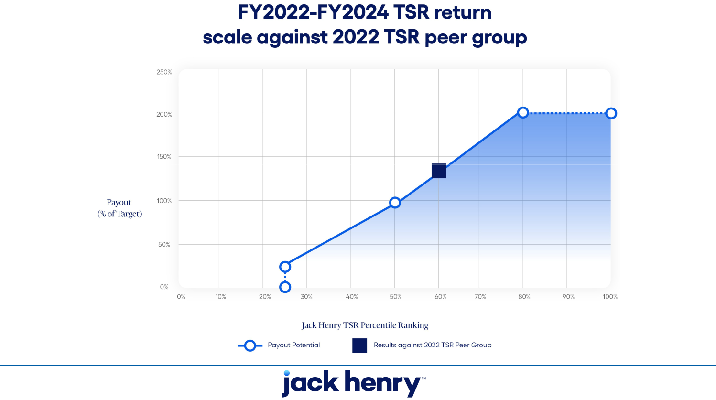

2024 Proxy Statement 31

The Organic Revenue Growth performance share grant comprised approximately 20% of the total fiscal 2022 performance share grant target value and vested at the end of three years based on the Company’s Organic Revenue Growth CAGR, which is adjusted for the impact of deconversion fees and acquisitions and divestitures during the performance period, against a threshold, target, and maximum percentage goal set by the HC&C Committee based on the annual budget of the Company and available forecasts, with the purpose of setting meaningful and challenging targets. The Company produced an Organic Revenue Growth CAGR of 7.6% over the three-year period ending June 30, 2024, resulting in a final payout of 106.7% of the 2022 Named Executive’s target Organic Revenue Growth performance shares.
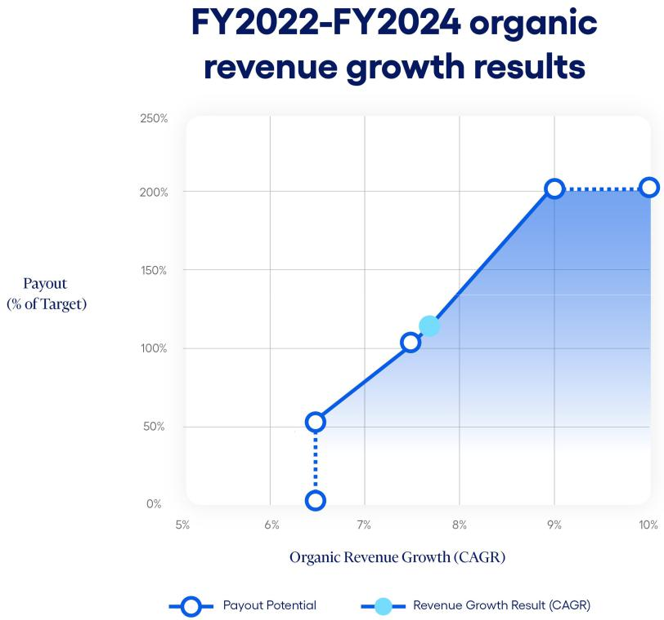

The Operating Margin Expansion performance share grant comprised approximately 20% of the total fiscal 2022 performance share grant target value and vested at the end of three years based on the Company’s Operating Margin Expansion, which is adjusted for the impact of deconversion fees and acquisitions and divestitures during the performance period, against a threshold, target, and maximum percentage goal set by the HC&C Committee based on the annual budget of the Company and available forecasts, with the purpose of setting meaningful and challenging targets. The Company produced an Operating Margin Expansion of 0.5% over the three-year period ending June 30, 2024, resulting in a final payout of 0% of the 2022 Named Executive’s target Operating Margin Expansion performance shares. This result demonstrates that the targets set by the HC&C Committee are challenging and in keeping with the Company’s desire to focus on performance-based and at-risk pay.

32 2024 Proxy Statement

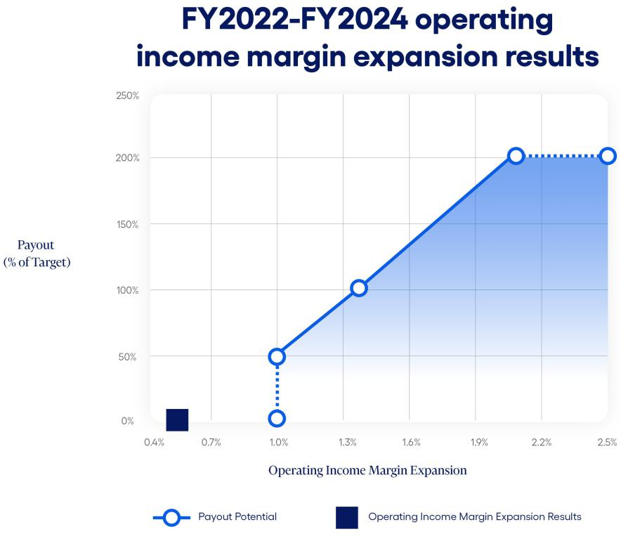

Compensation Philosophy and Objectives

Jack Henry’s compensation philosophy is to offer compensation programs to our executives that:

- Attract and retain highly qualified and motivated executives;

- Encourage esprit de corps and reward outstanding performance;

- Focus executives on achieving consistent earnings growth;

- Encourage continuation of the Company’s entrepreneurial spirit; and

- Reward the creation of stockholder value.

In meeting these objectives, the HC&C Committee strives for the interests of management and stockholders to be the same. To this end, key financial performance measures include adjusted operating income, Organic Revenue Growth, Operating Margin Expansion, and TSR. These measures emphasize a focus on revenue growth, operating efficiencies to yield strong margins, and returns to stockholders in excess of our peers.

The HC&C Committee designs and maintains compensation programs consistent with our executive compensation philosophy to achieve the following objectives:

- To attract, retain, and motivate highly qualified executives by offering compensation programs that are competitive with programs offered by similar companies, including those in our Compensation Peer Group.
- To link performance and executive pay by tying annual cash bonus amounts to achievement of key objectives under the Company’s annual business plans, as well as specific strategic goals.

- To reward competitive performance in comparison with peers in our industry.

2024 Proxy Statement 33

- To reward the creation of long-term stockholder value through long-term incentive compensation awards and encourage significant stock ownership by senior management to further align executive interests to those of our stockholders.

In pursuit of these objectives, the HC&C Committee believes that the compensation packages provided to the Named Executives should include both cash and equity-based compensation, with an emphasis on at-risk and performance-based pay.

Compensation Element | Purpose
Base salary | • Attract and retain highly qualified executives
 | • Support pay-for-performance orientation
 | • Focus executives on executing the annual operating plan and key
Annual incentive cash bonus | financial and non-financial measures of success as established by the
Annual incentive cash bonus | Board
 | • Align interests of executives and stockholders
Long-term incentive | • Support a stock ownership culture
Long-term incentive | • Drive long-term value creation
compensation | • Encourage retention of executives
 | • Attract and retain highly qualified executives
Broad-based benefits | • Named Executives at Jack Henry participate in the same benefit
Broad-based benefits | programs available to our full-time employees
Termination provisions | • Align management and stockholder interests to review attractive
Termination provisions | business alternatives

Process for Establishing Compensation

The HC&C Committee has overall responsibility for making decisions regarding the compensation of the Named Executives. In determining appropriate compensation levels for the Named Executives, the HC&C Committee meets and deliberates outside the presence of the Named Executives and other members of the executive management team. With respect to the compensation levels for the Named Executives other than the Chief Executive Officer, the HC&C Committee considers input and recommendations from the Chief Executive Officer. Performance reviews of the Named Executives are based on objective and subjective evaluations of individual performance as well as their performance in the preceding fiscal year in achieving Company performance objectives. While our Chief Executive Officer makes recommendations concerning salary adjustments, cash bonus programs, and award amounts for the other Named Executives, the HC&C Committee exercises its discretion and sole authority to set the compensation of each of the Named Executives.

In designing compensation programs and determining compensation levels for the Named Executives for fiscal 2024, the HC&C Committee was assisted by an independent compensation consultant firm. The HC&C Committee engaged Meridian Compensation Partners, LLC (“Meridian”), an independent executive compensation and corporate governance consulting firm, to serve as its independent advisor and compensation consultant with respect to compensation programs for fiscal 2024. The Chair of the HC&C Committee worked directly with Meridian to determine the scope of the work needed to assist the HC&C Committee in its decision-making processes. The engagement of the consulting firm included provision of benchmark comparative data for the Named Executives with respect to base salaries, annual cash bonuses, and long term incentives, in addition to incentive plan design and governance-related matters affecting executive compensation. Meridian was also engaged to provide analysis and advice to the HC&C

34 2024 Proxy Statement

Committee with respect to the compensation of the Company’s independent directors. The HC&C Committee Chair approves any additional work performed by Meridian on behalf of management. The HC&C Committee has assessed the independence of Meridian and determined that no conflict of interest exists under the rules established by the SEC and Nasdaq. The HC&C Committee reviews the independence of its advisors annually.

In making compensation decisions, the HC&C Committee compared each element of total direct compensation against a peer group of publicly traded companies in the software, payments, and data processing industries against which the HC&C Committee believes we compete in the market for executive talent. We collectively refer to this group as the “Compensation Peer Group.” In selecting companies for the Compensation Peer Group, the HC&C Committee has considered multiple criteria, including industry, annual revenue, and market capitalization. For fiscal 2024, the Compensation Peer Group was comprised of the following companies:

ACI Worldwide, Inc. |  | Black Knight, Inc.* |  | Broadridge Financial Solutions, Inc.
Corpay, Inc. |  | DocuSign, Inc. |  | Euronet Worldwide, Inc.
ExlService Holdings, Inc. |  | FactSet Research Systems Inc. |  | Fair Isaac Corporation
Genpact Limited |  | Morningstar, Inc. |  | PTC Inc.
Splunk Inc.* |  | SS&C Technologies Holdings, Inc. |  | Tyler Technologies, Inc.
Verint Systems Inc. |  | WEX, Inc.

*Black Knight, Inc. was included as part of the fiscal 2024 Compensation Peer Group for benchmarking, but was acquired in the first quarter of fiscal 2024. Splunk Inc. was included as part of the fiscal 2024 Compensation Peer Group for benchmarking, but was acquired in the third quarter of fiscal 2024.

The Compensation Peer Group is reviewed annually and, as appropriate, updated by the HC&C Committee to make sure that members of the group are consistent with the Company’s industry and financial scope and comparable in terms of size and labor pool. For comparison purposes, the Company’s annual revenue, net income, and market capitalization were within a reasonable range of the median of the members of the Compensation Peer Group.

In addition to the Compensation Peer Group, two companies, Fiserv, Inc. and Fidelity National Information Services, Inc. (together, the “Reference Peers”), were identified whose business models more closely align with the Company, but who both have larger revenue and market capitalization. The HC&C Committee used data from both our Compensation Peer Group and our Reference Peers to inform our executive compensation program design and to track current market trends, but only the Compensation Peer Group was used in compensation benchmarking assessments.

To benchmark each element of total compensation for our Named Executives, Meridian provided data from two key sources: (1) public filings for the companies in our Compensation Peer Group and (2) an executive compensation survey reflective of our industry and the general industry. In reviewing compensation survey data, the HC&C Committee considered data for companies with annual revenues similar to the Company.

In setting fiscal 2024 compensation, the HC&C Committee reviewed competitive market data for the Compensation Peer Group at the 25th, 50th, and 75th percentiles for base salary, target bonus, target cash compensation, long-term incentive compensation, and target total compensation. In setting total cash compensation and long-term incentive compensation, the HC&C Committee

2024 Proxy Statement 35

recognized that there are certain limitations in the market data available for the Compensation Peer Group. Thus, in addition to considering levels of compensation suggested by market data, the HC&C Committee also considered other relevant factors including performance against pre-identified objectives under business plans for the preceding fiscal year, individual performance reviews, change in job duties, and internal equity for compensation levels among our executives.

The allocation between cash, non-cash, short-term, and long-term incentive compensation is measured against the practices of our Compensation Peer Group and Reference Peers and reflects the HC&C Committee’s determination of the appropriate compensation mix among base pay, target annual cash incentives, and long-term equity incentives to encourage retention and performance. Actual cash and equity incentive awards are determined by the performance of the Company and the individual, depending on the type of award, compared to established goals.

Base Salary

Although we believe a significant portion of executive compensation should be based on “at-risk” compensation to align pay and performance, the HC&C Committee also believes that competitive base salaries are necessary to attract and retain a highly qualified and effective executive team. In June and July 2023, the HC&C Committee considered competitive data provided by Meridian. Based on this data as well as individual and corporate performance and changes in executive duties, the HC&C Committee increased the base salaries of the Named Executives in the following amounts. Fiscal 2024 base salary changes did not go into effect for Named Executives until January 2024.

Named Executive | Fiscal 2023 Base Salary | Fiscal 2024 Base Salary | Increase
Named Executive | ($) | ($)
David B. Foss | 865,000 | 865,000 | — %
Gregory R. Adelson | 575,000 | 586,500 | 2.0 %
Mimi L. Carsley | 475,000 | 517,750 | 9.0 %
Craig K. Morgan | 430,000 | 438,600 | 2.0 %
Stacey E. Zengel | 383,000 | 390,660 | 2.0 %

Annual Incentive Cash Bonuses

Annual Incentive Plan

It is our practice to provide our Named Executives with the opportunity to earn annual incentive cash bonus compensation through programs that reward attainment of key objectives under corporate annual business plans. The objectives that underlie our annual incentive compensation programs may vary between fiscal years and between the Named Executives, but generally include objectives that reward attainment by the Company of targeted adjusted operating income as well as strategic executive goals. In setting the fiscal 2024 bonus amounts a Named Executive is eligible to earn for achieving specified objectives, the HC&C Committee considered published survey data and targeted bonus and target total cash compensation levels at or near the 50th percentile of the Compensation Peer Group. Bonus opportunities for achieving objectives are generally established as a percentage of an executive’s base salary and the percentages increase with job scope and complexity. Executives have the opportunity to earn reduced bonus amounts if a minimum level (threshold) of performance against an objective is achieved and can

36 2024 Proxy Statement

also earn increased bonus amounts for performance in excess of the level of targeted performance (subject to a maximum of 200% of the established target amount).

The decision as to whether to offer an annual incentive cash bonus program to our Named Executives for any fiscal year, the type and funding of any program offered, and the objectives that underlie any program, are subject to the discretion of the HC&C Committee and its assessment of general and industry specific conditions existing during the applicable period. In determining the amount that a Named Executive is eligible to earn under an incentive cash bonus program, the HC&C Committee may also exercise negative discretion to reduce an award based on its assessment of the executive’s contribution and accountability for the objectives that are the subject of the bonus, the internal equity of the executive’s bonus opportunity as compared to bonus opportunities for our other executives, and any other factors the HC&C Committee considers relevant.

To provide an appropriate structure for cash bonus incentives, the Company’s stockholders previously approved the 2017 Annual Incentive Plan. Cash bonus incentives for fiscal 2024 were structured under the 2017 Annual Incentive Plan.

The fiscal 2024 incentive cash bonus plan established for the Named Executives was based 75% upon achievement of the Company’s annual adjusted budget operating income target and 25% upon the achievement of strategic executive goals set for the Named Executives as a group by the HC&C Committee. The achievement of these strategic executive goals is based on the HC&C Committee’s holistic determination of the performance of all strategic executive goals in the aggregate, with one payout factor determined based on the HC&C Committee assessment between 0% and 200% of target. In addition, the strategic executive goals portion of the plan is subject to an individual modifier for each specific Named Executive based on the HC&C Committee’s evaluation. This individual modifier can increase or decrease the strategic executive goal outcome 25% up or down for that Named Executive. The entire incentive cash bonus payout is limited to 200% of target for each Named Executive, even if the combined operating income target achievement and the strategic executive goal achievement, with applicable individual modifier, exceeds 200%. However, the fiscal 2024 annual incentive plan provided that no part of the incentive cash bonus was payable unless the Company’s performance on the adjusted operating income measurement was at or above the minimum threshold for achievement.

2024 Proxy Statement 37

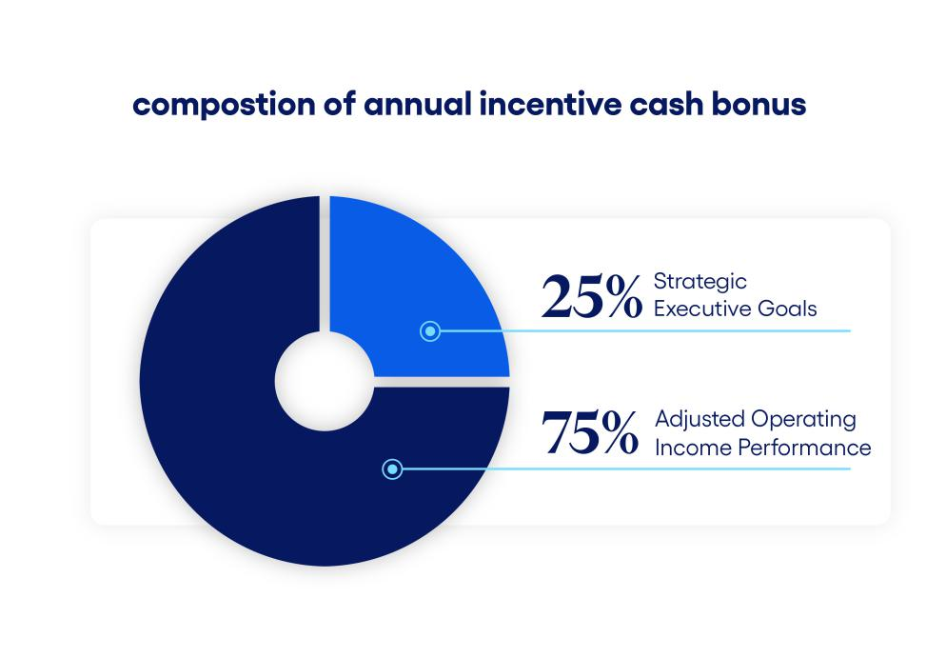

The adjusted operating income performance target for the Named Executives in fiscal 2024, which achievement composes 75% of the targeted annual incentive cash bonus, was established from the annual budget of the Company as approved by the Board of $494.5 million of adjusted operating income. The annual budget was developed by management with input from the Board in a thorough process that builds upon departmental forecasts and considers historical performance, industry dynamics, and macro-economic trends. This $494.5 million of adjusted operating income was reached by adjusting the approved GAAP operating income target of $505.7 million to remove $13.1 million of anticipated operating income from deconversion fees during the fiscal year and adding back $1.9 million of anticipated operating income loss for the first two months of fiscal 2024 from an acquisition made two months into fiscal 2023, consistent with the Company’s non-GAAP adjustment practices in financial earnings releases.

The HC&C Committee designed the fiscal 2024 annual incentive cash bonus plan to require that the adjusted operating income after all bonuses are paid be no less than $ 494.5 million. Based on $28.5 million of anticipated amounts to be expensed as target corporate bonuses that are dependent on achievement of certain operating income performance levels in the fiscal year, and accounting for the average strategic executive goal achievement including individual modifiers in fiscal 2024 of greater than 100% as described below, the 100% payout target for adjusted operating income before bonus payments was $523.2 million. For purposes of the determining payouts under the annual incentive cash bonus plan, the HC&C Committee adjusts operating income to remove the impact of deconversion fees, acquisitions and divestitures, sales of assets, and, as approved by the HC&C Committee, any other one-time non-GAAP adjustments that management makes in the Company’s earnings releases for the relevant periods.

Because annual bonuses may only be paid out to the extent post-bonus adjusted operating income exceeds the $494.5 million threshold, the threshold for adjusted operating income pre-bonus is a function of total bonus pool size, rather than a set percentage of target. For fiscal 2024, the pre-bonus adjusted operating income threshold was 94.6% of target, below which no bonus was payable, with a target amount at 100% and up to a maximum at 110%. Bonus payouts for

38 2024 Proxy Statement

adjusted operating income achievement ranged from 0% of target at threshold performance to 200% of targeted bonus at maximum performance, with additional breakpoints between threshold and target and between target and maximum.

The adjusted operating income results used for the performance target were calculated by adjusting the actual operating income results for fiscal 2024 of $489.4 million to remove operating income related to non-GAAP adjustments as applied by management in financial earnings releases and as approved by the HC&C Committee. These adjustments included removing deconversion fees during the fiscal year of $13.1 million and adding back actual operating loss for the fiscal 2023 acquisition for the two months without a comparable period in fiscal 2024 of $2.2 million, $16.4 million related to expenses incurred under the voluntary employee departure incentive payment program, a voluntary separation program offered by the Company to certain eligible employees during fiscal 2024, and amounts expensed as corporate bonuses at June 30, 2024 of $29.2 million, which were dependent upon achievement of certain operating income performance levels in the fiscal year. This outcome of $524.1 million of pre-bonus adjusted operating income in fiscal 2024, or 100.2% of target, resulted in a 100.7% payout of target for the Named Executives.
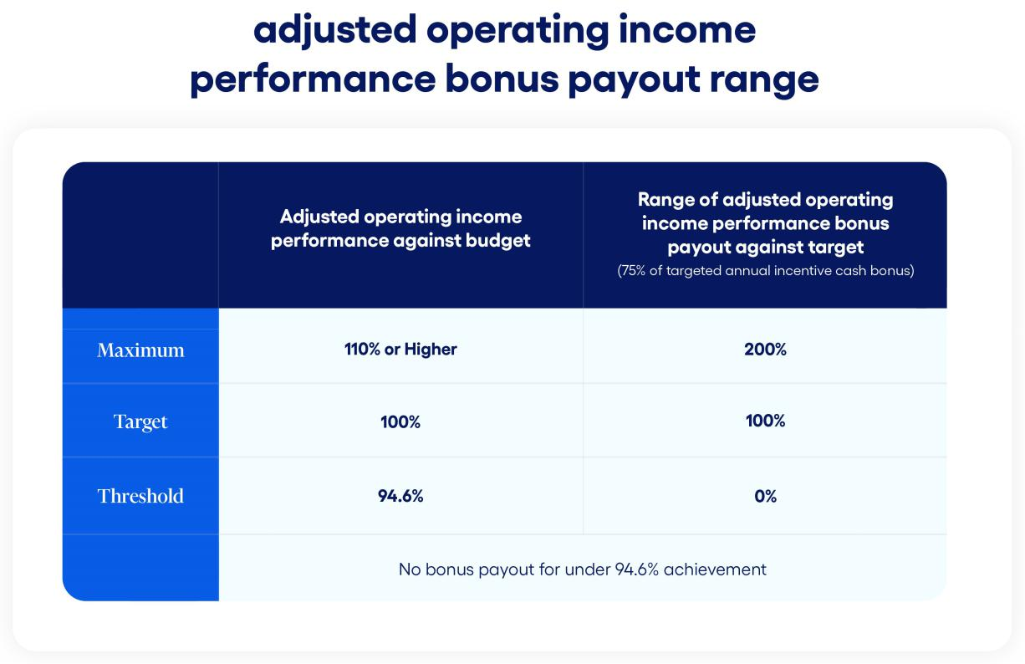

The strategic executive goals, which compose 25% of the targeted annual incentive cash bonus, were set by the HC&C Committee based on the Company’s business strategies and objectives. For fiscal 2024, the HC&C Committee adopted six strategic goals for the Named Executives, which included achieving specified customer and employee satisfaction ratings, delivery of important corporate initiatives, milestones and product delivery timelines, implementation of programs and systems, implementing process and control improvements, and achieving customer sales targets. These strategic goals are keys to financial and business success for the Company and thus contribute to producing income and stockholder returns over the long-term. The HC&C Committee grades the strategic payout based on a holistic determination of all goals in the aggregate, with

2024 Proxy Statement 39

one payout factor determined based on the HC&C Committee’s assessment. Based on exceeding benchmark scores for customer and employee satisfaction ratings, meeting or exceeding implementation schedules for identified initiatives and products, execution on process and control improvements, and positive customer sales results, the HC&C Committee determined that the six strategic executive goals earned a payout of 115% of target.

Potential bonus payouts related to the strategic executive goals range from 0% to 200%. The maximum bonus was intended to be payable only upon truly superior performance. The HC&C Committee intended for this bonus plan to provide a strong incentive for management to meet and exceed budgetary income and identified strategic goals in fiscal 2024.

The strategic executive goals payout factor applies to all Named Executives, but is also subject to an individual modifier of up to 25% increase or decrease as determined by the HC&C Committee. The individual modifier is applicable in situations of significant under- or over-performance by an individual. In fiscal 2024, the HC&C Committee applied a 25% positive individual modifier to Ms. Carsley’s strategic executive goal payout factor, resulting in a 143.8% strategic executive goal attainment percentage for Ms. Carsley. This individual modifier was applied to recognize the individual performance and accomplishments of Ms. Carsley during fiscal 2024, including specifically the improvements and achievements Ms. Carsley directed within the Company’s finance department. The HC&C Committee did not apply a positive or negative individual modifier to any other Named Executive.

The full fiscal 2024 incentive bonuses paid, including amounts paid for achievement of individual performance goals, were as follows:

 |  | Performance on Incentive Measures |  |  | Annual Incentive Payout - FY2024
 | Target Annual | Adjusted Operating | Strategic Executive
Named Executive | Incentive (as % | Income Performance | Goals Performance (25% |  | % of Target | Amount ($)
Named Executive | of base) | (75% of Bonus) | of Bonus) (1) |  | % of Target | Amount ($)
David B. Foss | 150% | 100.7% | 115% |  | 104.3% | 1,352,968
Gregory R. Adelson | 100% | 100.7% | 115% |  | 104.3% | 611,573
Mini L. Carsley | 100% | 100.7% | 143.8% |  | 111.5% | 577,097
Craig K. Morgan | 90% | 100.7% | 115% |  | 104.3% | 411,615
Stacey E. Zengel | 50% | 100.7% | 115% |  | 104.3% | 203,680

- The HC&C Committee applied a 25% positive individual modifier to Ms. Carsley’s strategic executive goal payout factor.

The HC&C Committee continues to believe that annual cash bonus opportunities are highly effective motivators for management employees and are instrumental in obtaining excellent performance in comparison with the Company’s competitors in both strong and weak economic environments.

The HC&C Committee will in future years continue to thoroughly review the effects of the bonus plan on results achieved and will make any changes to the bonus plan deemed necessary.

40 2024 Proxy Statement

Long-Term Incentive Compensation

We believe that equity awards have been instrumental in building the Company, retaining talent, and encouraging management to take a long-term view with regard to strategic decisions they face. Equity awards also help focus executive and employee attention on managing the Company from the perspective of an owner with an equity stake in the business. The HC&C Committee has the authority to grant restricted stock awards of various types and to determine the terms of the restrictions on granted shares. Starting in fiscal 2020, the long-term incentive awards have consisted of a mix of performance shares and time-based restricted stock units. In fiscal 2024, the HC&C Committee allocated the long-term incentive award value at approximately 60% performance shares and 40% time-based restricted stock units. The HC&C Committee determined this mix was appropriate to ensure our Named Executives are aligned with stockholders through stock ownership and also to encourage retention.
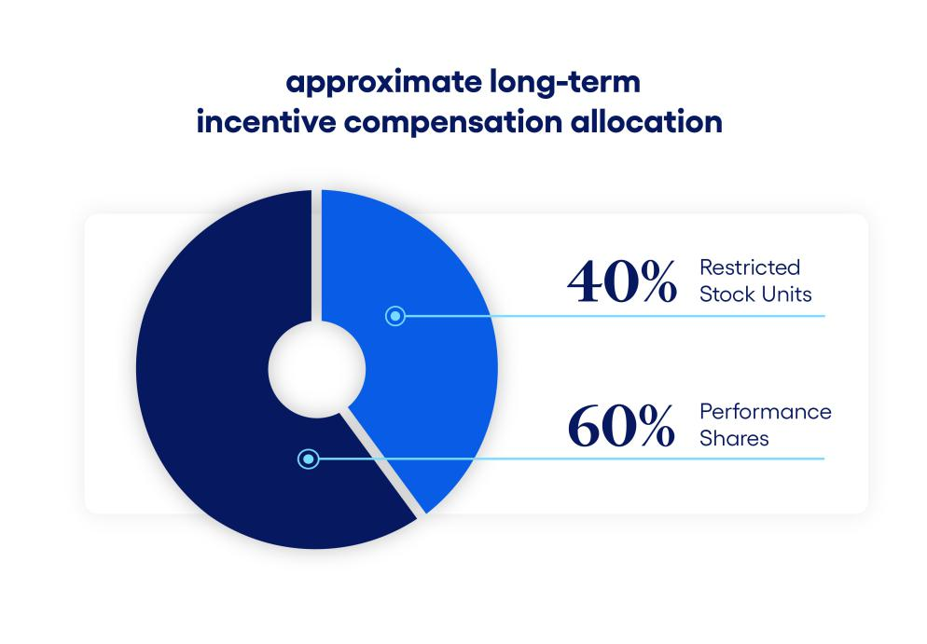

The fiscal 2024 total grant amounts for long-term incentive compensation were determined with reference to comparable aggregate grants of long-term incentive compensation by other members of the Compensation Peer Group and published survey data and were roughly targeted at the 50th percentile of the Compensation Peer Group. The aggregate target value was then divided with approximately 60% applied to performance share awards and approximately 40% applied to time-based restricted stock unit awards.

In determining the level of award for a Named Executive, the HC&C Committee also considers relevant factors such as achievement of previously identified objectives, the executive’s performance, the current equity ownership and equity awards held by the individual executive, and the internal equity of the level of award granted to the executive compared to awards granted to other executives. In reviewing the award levels for our Named Executives, the HC&C Committee believes it is appropriate to consider the Company’s performance against key objectives under its corporate business plan for the preceding fiscal year, including objectives related to revenue and earnings targets, and whether the Company’s performance during the

2024 Proxy Statement 41

preceding fiscal year benefited stockholders as measured by the market price of the Company’s common stock. In administering the equity compensation programs, the HC&C Committee considers the dilutive effect of the Company’s aggregate equity awards during any fiscal year.

Performance Shares

A portion of the grants to the Named Executives for fiscal 2024 were structured as performance shares that vest only on the achievement of Company performance goals and thus strongly reflect the principle of pay-for-performance. A grant of performance shares is a contractual right to receive stock and/or cash in the future if vesting conditions are met. In fiscal 2024, the HC&C Committee decided to utilize three separate measures of comparative performance to determine the vesting amount of performance shares. These three specific grants of performance shares in fiscal 2024 to the Named Executives vest at the end of a three-year performance period based on the following: (1) the total shareholder return over the three-year period in comparison to the companies in the Compensation Peer Group plus the Reference Peers (“TSR Peer Group”) (comprising approximately 60% of the total performance shares grant value), (2) the Company’s compound organic annual revenue growth rate (“CAGR”) for revenue over the three-year period against a target Organic Revenue Growth CAGR, where Organic Revenue Growth removes the impact of deconversion fees, acquisitions and divestitures, and, as approved by the HC&C Committee, any other one-time non-GAAP adjustments that management makes in the Company’s earnings releases for the relevant periods (comprising approximately 20% of the total performance shares grant value), and (3) the expansion of the Company’s non-GAAP adjusted operating margin over the three-year period against a target non-GAAP adjusted operating margin expansion, where non-GAAP operating margin removes the impact of deconversion fees, acquisitions and divestitures, sales of assets, and, as approved by the HC&C Committee, any other one-time non-GAAP adjustments that management makes in the Company’s earnings releases for the relevant periods (comprising approximately 20% of the total performance shares grant value).

For the purpose of the TSR grants, TSR was defined as ending stock price minus beginning stock price (adjusted for splits and similar changes) plus dividends per share paid over the performance period, all divided by the beginning stock price. A target amount of stock was set for each Named Executive that may be earned if TSR at the end of the three-year period is at the 50th percentile in comparison to the TSR Peer Group. Vesting ranges from 25% of target performance shares at the 25th percentile to the maximum amount of the grant (200% of target) at or above the 80th percentile relative to the TSR Peer Group. No shares will vest if performance is below the 25th percentile threshold.

42 2024 Proxy Statement

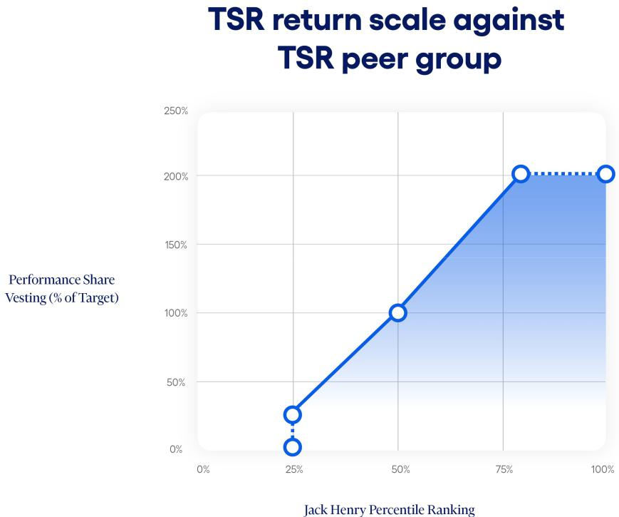

For purposes of the three-year Organic Revenue Growth CAGR grants, the following principles apply:

- non-GAAP adjusted revenue is calculated by adjusting GAAP revenue for deconversion fee revenue, acquisitions and divestitures, and, as approved by the HC&C Committee, any other one-time non-GAAP adjustments that management makes in the Company’s earning releases, for the relevant periods;
- three-year Organic Revenue Growth is calculated by (a) the quotient equal to the Company’s non-GAAP adjusted revenue for the final fiscal year of the performance period and dividing it by the Company’s non-GAAP adjusted revenue for the fiscal year ending immediately prior to the beginning of the performance period, (b) raised to an exponent of one-third, and (c) subtracting one; and
- an acquisition or divestiture by the Company during the performance period will result in an adjustment to the goal, base year results, and/or final year results, as appropriate, by the HC&C Committee to ensure the grant results are not materially benefited nor penalized by the acquisition or divestiture.

The HC&C Committee set a threshold, target, and maximum three-year Organic Revenue Growth CAGR percentage goal based on the annual budget of the Company and available forecasts and with the purpose of setting meaningful and challenging targets, with vesting for performance shares ranging from 50% of target at threshold performance, 100% of target at target performance, and 200% of target at maximum performance and above. For the fiscal 2024 three-year Organic Revenue Growth CAGR grants, threshold was set at 6.5%, target was set at 7.0%, and maximum was set at 8.5%. No performance shares vest for achievement below threshold.

2024 Proxy Statement 43

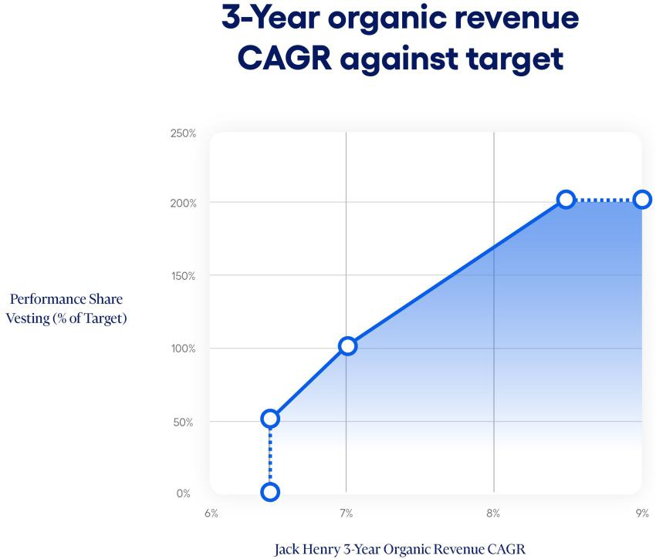

For purposes of the three-year non-GAAP adjusted operating margin expansion grants, the following principles apply:

- non-GAAP adjusted revenue is calculated by adjusting GAAP revenue for deconversion fee revenue, acquisitions and divestitures, and, as approved by the HC&C Committee, any other one-time non-GAAP adjustments that management makes in the Company's earnings releases, for the relevant periods;
- non-GAAP adjusted operating income is calculated by adjusting GAAP operating income for operating income from deconversion fees and operating income/loss from acquisitions, divestitures, sales of assets, and, as approved by the HC&C Committee, any other one-time non-GAAP adjustments that management makes in the Company's earnings releases, for the relevant periods;
- three-year non-GAAP adjusted operating margin expansion is calculated by (a) an amount equal to non-GAAP adjusted operating income for the final fiscal year of the performance period divided by non-GAAP adjusted revenue for the final fiscal year of the performance period, less (b) an amount equal to non-GAAP adjusted operating income for the fiscal year ending immediately prior to the beginning of the performance period divided by non-GAAP adjusted revenue for the fiscal year ending immediately prior to the beginning of the performance period; and

- an acquisition or divestiture by the Company during the performance period will result in an adjustment to the goal, base year results, and/or final year results, as appropriate, by the HC&C Committee to ensure the grant results are not materially benefited nor penalized by the acquisition or divestiture.

The HC&C Committee set a threshold, target, and maximum three-year non-GAAP adjusted operating margin expansion percentage goal based on the annual budget of the Company and available forecasts and with the purpose of setting meaningful and challenging targets, with vesting for performance shares ranging from 50% of target at threshold performance, 100% of target at target performance, and 200% of target at maximum performance and above. For the

44 2024 Proxy Statement

fiscal 2024 three-year non-GAAP adjusted operating margin expansion grants, threshold was set at 0.3%, target was set at 0.7%, and maximum was set at 1.0%. No performance shares vest for achievement below threshold.
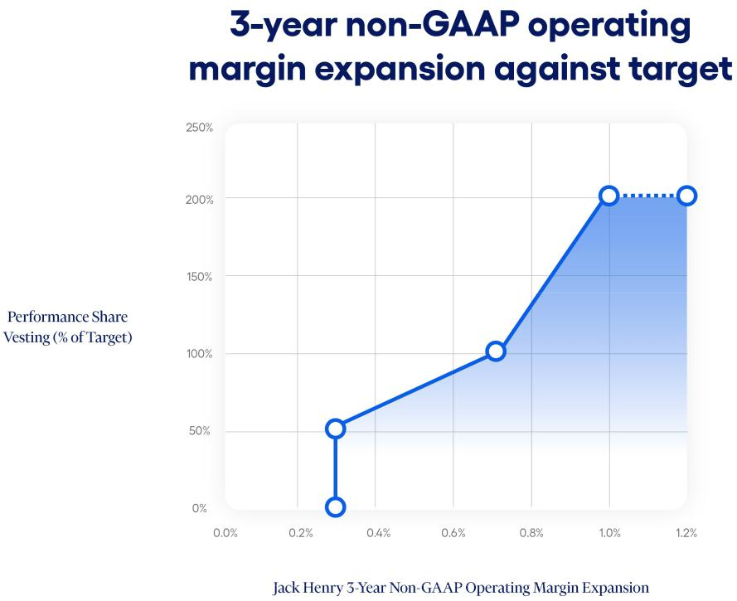

The fiscal 2024 awards were structured to provide incentives for long-term performance and retention. Retention is encouraged by grant terms which immediately forfeit all awards that have not vested in the event that the grantee’s employment with the Company is terminated for any reason other than in the event of death, incapacity, retirement, or in connection with any change in control.

The use of performance shares allows for flexibility in addressing the orderly retirement of grantees. The fiscal 2024 performance share awards contain terms which allow for the pro-rata vesting of awards upon retirement based on full months of service following the date of grant. For this purpose, retirement is defined as termination with the stated purpose of retirement, for which the grantee has provided the Company at least six months’ prior notice and occurs (1) on or after the age of 55 and following a minimum number of years of employment with the Company such that the grantee’s age plus the number of full years of employment with the Company equals or exceeds 72, or (2) on or after age 65. With respect to a retirement during the term, at the end of the three-year term of the grant, the award will be calculated, and a pro-rata portion will be settled to the grantee based on completed full months of service. For example, if an eligible grantee retires 18 months after the grant date, he or she would be credited with 18 months of service and would be entitled to one-half of any amount that vests on performance measured at the end of the three-year grant. Death or incapacity of a grantee is addressed in the same manner, with pro-rata vesting based on completed months of service. Upon a change in control of the Company and a qualified termination of the grantee, the target number of performance shares (or, with respect to TSR grants, if higher, the number of shares that would have vested based on actual TSR achievement if the change in control date were the measuring date for TSR measurement) vest and will be settled, regardless of the performance measures achieved.

2024 Proxy Statement 45

Restricted Stock Units

In fiscal 2024, the long-term incentive compensation included restricted stock unit grants to the Named Executives. The fiscal 2024 restricted stock unit awards were structured to provide incentives for long-term performance and retention. The shares vest one-third on each of the three subsequent anniversaries. Retention is encouraged by grant terms which immediately forfeit all awards that have not vested in the event that the grantee’s employment with the Company is terminated for any reason, other than in the event of retirement or in connection with a change in control.

The fiscal 2024 restricted stock unit awards contain terms which allow for continued vesting in accordance with the vesting schedule of all unvested awards upon retirement. For this purpose, retirement is defined as termination with the express reason of retirement, for which the grantee has provided the Company at least six months’ prior notice and occurs (1) on or after the age of 55 and following a minimum number of years of employment with the Company such that the grantee’s age plus the number of full years of employment with the Company equals or exceeds 72, or (2) on or after age 65. The grantee must also remain actively employed as a full-time employee for six months following the date of the award to qualify for such continued vesting. Further, the grantee must abide by certain restrictive covenants, including non-competition, non-solicit, and non-disparagement covenants. Any breach of such restrictive covenants will result in a forfeiture of all remaining non-settled awards. Upon a change in control of the Company and a qualified termination of the grantee, all unvested restricted stock units vest in full and will be settled.

Broad-Based Benefits Programs

The Company offers certain broad-based benefits programs including benefits such as health, dental, disability and life insurance, health care savings accounts, employee stock purchase plan, paid vacation time, and Company matching contributions to a 401(k) Retirement Savings Plan. Benefits are provided to all employees in accordance with practices within the marketplace and are a necessary element of compensation in attracting and retaining employees. We do not offer pensions or supplemental executive retirements plans for our Named Executives.

Termination Benefits Agreements and Executive Severance Plan

On June 30, 2024, each of the Named Executives was a participant in the Executive Severance Plan (the “Severance Plan”) that is discussed in this Proxy Statement under the caption “Agreements with Executive Officers and Potential Payments upon Termination or Change in Control” on page 57. The Severance Plan provides that each Named Executive who experiences a qualifying termination not in connection with a change in control receives severance payments. The amount of such severance payments for the Chief Executive Officer is equal to two times the Chief Executive Officer’s annual base salary, paid ratably over two years, and, for the other Named Executives, one and a half times the Named Executive’s annual base salary, paid ratably over one and a half years. The Named Executives also receive a prorated amount of the annual bonus the Named Executive would have received for the current performance year had the Named Executive remained employed through the end of such performance year, paid in a single lump sum at the same time as annual bonus payments are made to active annual bonus participants for such performance year. The Named Executives would also receive an amount equal to the cost of health benefit continuation premiums for 18 months, paid in a lump sum. The treatment of equity awards held by the terminated Named Executive would not be impacted by the Severance Plan, but would be controlled by the terms set out in those individual awards.

46 2024 Proxy Statement

The Severance Plan also provides that each Named Executive who experiences a qualifying termination in connection with a change in control receives severance payments. The amount of such severance payments for the Chief Executive Officer is equal to two times the annual base salary and two times the target annual bonus, and, for other Named Executives, one and a half times the annual base salary and one and a half the target annual bonus, also paid in a lump sum. The Named Executives will also receive a lump sum prorated amount of target annual bonus for the year in which the termination occurs and an amount equal to the cost of health benefit continuation premiums for 18 months. Equity awards held by the terminated Named Executive, other than those awards that already contain provisions governing the treatment of the awards in the event of a change in control termination (which will be controlled by the terms of such awards), will fully vest upon a qualifying termination in connection with a change in control, with any performance-based awards vesting as if target-level achievement were met. All Severance Plan payments are conditional upon the terminated executive’s execution and nonrevocation of a release of claims against the Company and adherence to certain restrictive covenants set forth in the Severance Plan.

The benefits provided were determined primarily by reference to comparative data provided to the HC&C Committee by its independent advisor. The benefits are believed by the HC&C Committee to be sufficient to provide the desired incentive and security to retain crucial personnel in a time of disruption and to help attract and retain top executive talent. The change in control benefits provided in the Severance Plan reflect the concern of the Board that any future threatened or actual change in control, such as an acquisition or merger, could cause disruption and harm to the Company in the event of the resulting loss of any of its key executives.

No severance payments are eligible to be paid under the Severance Plan unless a Named Executive’s employment is terminated by the Company without “Cause” or by the Named Executive for “Good Reason” (both as defined in the Severance Plan). The HC&C Committee believes that agreements such as the Severance Plan should not include provisions that would obligate an acquirer of the Company to make large cash payouts to our Named Executives simply because a change in control has occurred. Because of this concern, the occurrence of a change in control event alone will not trigger any cash payment obligations to our Named Executives under the Severance Plan. Change in control severance payment obligations only arise if the Named Executive’s employment is terminated by the Company without “Cause” or by the Named Executive for “Good Reason” within the period commencing 90 days prior to and for two years following a change in control (i.e., “double trigger”). The Company does not provide, nor has it ever provided, excise tax gross-up payments to any employee in the event of a change in control and termination.

The Severance Plan has no set term and will continue until terminated by the HC&C Committee. However, unless a Severance Plan participant consents, generally, the Severance Plan may not be terminated or amended in a manner that is materially adverse to a participant without 12-months’ notice to each participant. As set forth in the Severance Plan, certain exceptions apply where an amendment or termination is in connection with a change in control. The Severance Plan specifies that it does not confer on the executives any right to continued employment and shall not interfere with the right of the Company to terminate the executives at any time.

Deferred Compensation Plan

Under the Company’s non-qualified Deferred Compensation Plan, our Named Executives may voluntarily defer a portion of their compensation to one or more future years. While the plan allows

2024 Proxy Statement 47

the Company to offer deferral of all types of compensation, including salary, bonus, and equity grants, to date the Company has only offered a program to defer receipt of equity compensation upon vesting of performance shares and restricted stock units. Amounts deferred are deemed invested in investments selected by the participant from a limited number of choices. The Deferred Compensation Plan is intended to promote retention by providing a long-term savings opportunity on a tax-efficient basis. Performance shares or restricted stock units that are deferred under the Company’s Deferred Compensation Plan may be settled in stock or, at the option of the HC&C Committee, in cash. Ms. Carsley participated in the Deferred Compensation Plan in fiscal 2024.

Perquisites

Perquisites represent a minor component of executive compensation. When appropriate, we provide perquisites that we believe are reasonable and competitive. The Company has entered into an aircraft time-sharing agreement with each Named Executive, which permits the Named Executives to lease the Company’s corporate-owned aircraft for personal use on a non-exclusive, time-sharing basis. Pursuant to the time-sharing agreement, the Named Executive would reimburse the Company an amount not more than (a) twice the cost of fuel plus (b) other actual expenses for his or her personal use of the Company’s corporate-owned aircraft, which amount approximates the Company’s incremental costs for the flight. Any difference between the Company's incremental costs for the flight and the amount reimbursed for the flight is considered a perquisite. No time-sharing arrangements were used in fiscal 2024 and there were no amounts reimbursed.

Stock Ownership Guidelines

The Board established stock ownership guidelines for the Named Executives, other members of management, and the non-employee directors of the Company. These guidelines require each covered individual to hold a number of shares of the Company’s common stock with an aggregate market value that equates to a specified multiple of the employee’s base salary or, in the case of directors, of their annual base retainer. The stock ownership guidelines for the Named Executives are as follows:

Named Executive | Title | Ownership Requirement as a
Named Executive | Title | Multiplier of Base Salary
David B. Foss | Board Chair and Chief Executive Officer | 6x
Gregory R. Adelson | President and Chief Operating Officer | 3x
Mimi L. Carsley | Chief Financial Officer and Treasurer | 3x
Craig K. Morgan | General Counsel and Secretary | 1x
Stacey E. Zengel | Senior Vice President and President of Jack Henry Banking | 1x
Stacey E. Zengel | Solutions | 1x

The value of each person’s share holdings for purposes of the guidelines includes Company shares owned outright, as well as all shares held in the person’s retirement accounts and deferral accounts, all shares held in trust for the person’s immediate family members, and all restricted stock units. Stock options and performance shares are not counted for purposes of measuring compliance with the stock ownership guidelines. The HC&C Committee recognizes that executive officers or employees who were recently promoted to executive officer positions and newly

48 2024 Proxy Statement

elected directors may require some period of time to achieve the guideline amounts. The guidelines, therefore, contemplate a five-year transition period for acquiring a number of shares with the specified market value. The guidelines also require that until the applicable ownership level is achieved, the individual should retain and hold 75% of all shares received from vesting of restricted stock units and performance shares or exercise of options, net of shares sold to pay taxes. The HC&C Committee will continue to monitor the compliance of each executive and director with the guidelines. As measured on June 30, 2024, all covered individuals on such date were in compliance with these these guidelines or within the five-year compliance window.

Trading in Company Securities Policy

The Company has adopted the Trading in Company Securities Policy that is designed to promote compliance with relevant SEC regulations, including insider trading, and applicable Nasdaq listing standards. This policy applies to our directors, officers, and employees, family members of our directors, officers, and employees, contractors and consultants who have access to material nonpublic information about the Company, and entities controlled by such individuals. In addition to prohibiting transactions in Company securities while in possession of material nonpublic information, these insiders are also prohibited from transactions involving short-term or speculative transactions in the Company’s securities, including engaging in short sales, buying or selling of Company options, puts, calls, or other derivative securities, hedging transactions, holding Company securities in margin accounts, pledging Company securities as collateral, or placing standing or limit orders to buy or sell Company securities with a duration in excess of three business days (except under approved Rule 10b5-1 plans).

Executive Compensation Clawback Policy

In November 2023, the Company adopted, in accordance with Nasdaq listing standards, the Executive Compensation Clawback Policy. This policy requires that the Company seek to recover erroneously awarded incentive-based compensation received by any current or former executive officer on or after October 2, 2023, and during the three-year period preceding the date on which the Company is required to prepare an accounting restatement due to material noncompliance of the Company with any financial reporting requirement under securities laws. The prior recoupment policy continues to apply to incentive-based compensation received by executive officers before October 2, 2023. Both recoupment policies are administered by the HC&C Committee.

Polices and Practices Related to the Grant of Certain Equity Awards Close in Time to the Release of Material Nonpublic Information

At regularly scheduled meetings during June, July, and August of each year, the HC&C Committee approves the upcoming fiscal year target total compensation for Named Executives, including base salary, annual incentive cash bonus amounts, and long-term incentive compensation awards. In addition, the HC&C Committee approves the prior fiscal year incentive cash bonus achievement level and payout amounts as well as results and settlement of any performance-based long-term incentive compensation awards.

By established practice, the grant date for the long-term incentive compensation equity awards for Named Executives occurs in early August of each year, prior to the Company’s release of fiscal year-end financial results. It is the Board’s and the HC&C Committee’s belief that maintaining a consistent grant practice is in the best interests of the Company and minimizes the risk that annual awards are granted opportunistically for the benefit of executive officers. For fiscal 2024,

2024 Proxy Statement 49

Named Executives were granted performance shares and restricted stock units in August 2023. The Company has in the past granted stock option awards to Named Executives, with the last such awards being granted in 2016. Stock option awards are not currently a component of executive compensation design, but it is possible that in the future the HC&C Committee may choose to grant stock option awards to Named Executives.

The HC&C Committee does not take material nonpublic information into account when determining the timing and terms of annual equity award grants. In addition, the Company does not time the disclosure of material nonpublic information for the purpose of affecting the value of executive compensation.

Fiscal 2024 Grants of Certain Equity Awards Close in Time to the Release of Material Nonpublic Information

During fiscal 2024, none of our Named Executives were granted stock option awards.

50 2024 Proxy Statement

COMPENSATION AND RISK

Under its charter, the HC&C Committee is charged with review of risks related to the Company’s compensation policies and practices. In fiscal 2024, the HC&C Committee directed the Company’s Human Resources Department to conduct a compensation risk assessment and to report the results to the HC&C Committee. The assessment reviewed design features, characteristics, and performance metrics used in compensating all employees of the Company, including salaries, sales incentives, incentive bonus plans, and long-term equity incentive compensation awards. The HC&C Committee reviewed and discussed the report and concluded that the Company’s compensation programs, policies, and practices do not create risks that are reasonably likely to have a material adverse effect on the Company. This conclusion was based on a number of factors, including:

- Compensation of our employees is generally competitive with relevant labor markets.

- Benefits are offered to all eligible employees on a non-discriminatory basis and no material perquisites are offered solely to executives or management.

- Incentive bonuses are determined largely on total Company financial performance and are capped at reasonable levels.

- Long-term equity incentive awards to executives generally vest upon achievement of objective performance standards over a number of years, and thus do not encourage taking excessive risk for short-term gains.

- Compensation of executive and senior managers is a combination of salary, benefits, annual cash incentive bonuses, and long-term equity incentive awards, resulting in appropriate balancing of short and long-term interests and goals.

- Executives are subject to stock ownership guidelines, which align their interests with those of the stockholders.

- The Company has adopted a recoupment policy providing for the clawback of executive compensation in the event of financial restatements.

2024 Proxy Statement 51

EXECUTIVE COMPENSATION

Summary Compensation Table

The following table sets forth certain information with regard to the compensation paid to (1) Mr. Foss (our Chief Executive Officer during fiscal 2024), (2) Ms. Carsley (our Chief Financial Officer), and (3) Messrs. Adelson, Morgan, and Zengel (the Company’s three other most highly compensated executive officers that were serving as executive officers as of the end of fiscal 2024) (collectively, our “Named Executives”) during the fiscal years ended June 30, 2024, 2023, and 2022.

Name and Principal Position | Year |  |  | Stock | Option | Non-Equity | All Other
Name and Principal Position | Year | Salary | Bonus | Stock | Option | Incentive Plan | All Other | Total
 |  |  |  | Awards | Awards | Incentive Plan | Compensation | Total
 |  |  |  | Awards | Awards | Compensation | Compensation
 |  | ($) | ($) | ($) (1) | ($) | ($) (2) | ($) (3) | ($)
David B. Foss | 2024 | 865,000 | - | 8,728,670 | - | 1,352,968 | 16,500 | 10,963,138
David B. Foss | 2023 | 858,750 | - | 8,571,735 | - | 991,979 | 16,562 | 10,439,026
Chief Executive Officer
 | 2022 | 840,000 | - | 7,557,777 | - | 1,345,365 | 15,250 | 9,758,392
Gregory R. Adelson | 2024 | 580,750 | - | 2,038,836 | - | 611,573 | 16,788 | 3,247,947
President and Chief Operating | 2023 | 556,602 | - | 1,478,556 | - | 405,645 | 10,812 | 2,451,615
Officer
 | 2022 | 480,721 | - | 1,203,071 | - | 481,879 | 14,173 | 2,179,844
Mimi L. Carsley (4) | 2024 | 496,375 | - | 1,684,218 | - | 577,097 | 26,506 | 2,784,196
Chief Financial Officer and
Treasurer | 2023 | 475,000 | - | 1,479,246 | - | 356,517 | - | 2,310,763
Craig K. Morgan | 2024 | 434,300 | - | 938,072 | - | 411,615 | 19,403 | 1,803,390
General Counsel and Secretary | 2023 | 415,917 | - | 982,948 | - | 290,250 | 18,278 | 1,707,393
 | 2022 | 370,076 | - | 522,806 | - | 319,562 | 14,761 | 1,227,205
Stacey E. Zengel | 2024 | 386,830 | - | 375,906 | - | 203,680 | 16,692 | 983,108
Former Senior Vice President
and President of Jack Henry | 2023 | 380,187 | - | 394,028 | - | 138,239 | 10,812 | 923,266
Bank Solutions
 | 2022 | 368,175 | - | 374,555 | - | 207,390 | 14,857 | 964,977

- Reflects grants of performance shares and restricted stock units on August 4, 2021, August 4, 2022, and August 4, 2023, under the Company’s Equity Incentive Plan to the Named Executives. The 2023 amount for Ms. Carsley includes a one-time grant of restricted stock units on July 17, 2022 in connection with her joining the Company. Information about the assumptions used to determine the fair value of equity awards is set forth in our Annual Report on Form 10-K in Note 10 to our consolidated financial statements for the year ended June 30, 2024.

- Reflects amounts paid to the Named Executives following the end of the fiscal year based upon achievement of performance goals under the Company’s Annual Incentive Plans. These amounts were earned and accrued in the fiscal year listed and paid in the following fiscal year.

- Reflects matching contributions to the individual’s accounts pursuant to the Company’s 401(k) Retirement Savings Plan (the “Retirement Plan”).

- Ms. Carsley was not a Named Executive during fiscal 2022.

Grants of Plan-Based Awards Table

The following table presents information on awards granted to the Named Executives during the fiscal year ended June 30, 2024 under our 2017 Annual Incentive Plan with respect to performance

52 2024 Proxy Statement

targets set for fiscal 2024 and our 2015 Equity Incentive Plan with respect to grants of performance shares and restricted stock units made during fiscal year 2024.

Name | Grant | Estimated Future Payouts Under |  |  | Estimated Future Payouts Under |  |  | All Other Stock | Grant Date Fair
 | Date | Non- Equity Incentive Plan Awards |  |  | Equity Incentive Plan Awards (2) |  |  | Awards: Number | Value of Stock
 |  |  | (1) |  |  |  |  | of Shares of | and Option
 |  |  |  |  |  |  |  | Stock or Units | Awards
 |  | Threshold ($) | Target ($) | Maximum ($) | Threshold (#) | Target (#) | Maximum (#) | (#)(3) | ($)(4)
David B. | 8/4/2023 | 0 | 1,297,500 | 2,595,000 | - | - | - | - | -
Foss
Foss | 8/4/2023 | - | - | - | 4,206 | 16,825 | 33,650 | - | 3,757,527
 | 8/4/2023 | - | - | - | 2,805 | 5,609 | 11,218 | - | 924,756
 | 8/4/2023 | - | - | - | 2,805 | 5,609 | 11,218 | - | 924,756
 | 8/4/2023 | - | - | - | - | - | - | 18,695 | 3,121,631
Gregory R. | 8/4/2023 | 0 | 586,500 | 1,173,000 | - | - | - | - | -
Adelson
Adelson | 8/4/2023 | - | - | - | 983 | 3,930 | 7,860 | - | 877,687
 | 8/4/2023 | - | - | - | 655 | 1,310 | 2,620 | - | 215,980
 | 8/4/2023 | - | - | - | 655 | 1,310 | 2,620 | - | 215,980
 | 8/4/2023 | - | - | - | - | - | - | 4,367 | 729,189
Mimi L. | 8/4/2023 | 0 | 517,750 | 1,035,500 | - | - | - | - | -
Carsley
Carsley | 8/4/2023 | - | - | - | 812 | 3,247 | 6,494 | - | 725,153
 | 8/4/2023 | - | - | - | 541 | 1,082 | 2,164 | - | 178,389
 | 8/4/2023 | - | - | - | 541 | 1,082 | 2,164 | - | 178,389
 | 8/4/2023 | - | - | - | - | - | - | 3,607 | 602,287
Craig K. | 8/4/2023 | 0 | 394,740 | 789,480 | - | - | - | - | -
Morgan
Morgan | 8/4/2023 | - | - | - | 452 | 1,808 | 3,616 | - | 403,780
 | 8/4/2023 | - | - | - | 302 | 603 | 1,206 | - | 99,417
 | 8/4/2023 | - | - | - | 302 | 603 | 1,206 | - | 99,417
 | 8/4/2023 | - | - | - | - | - | - | 2,009 | 335,458
Stacey E. | 8/4/2023 | 0 | 195,330 | 390,660 | - | - | - | - | -
Zengel
Zengel | 8/4/2023 | - | - | - | 181 | 724 | 1,448 | - | 161,690
 | 8/4/2023 | - | - | - | 121 | 242 | 484 | - | 39,899
 | 8/4/2023 | - | - | - | 121 | 242 | 484 | - | 39,899
 | 8/4/2023 | - | - | - | - | - | - | 805 | 134,418

- Represents the range of possible payouts for fiscal 2024 to our Named Executives under the Annual Incentive Plan. For fiscal 2024, threshold achievement for adjusted operating income would result in a $0 payout and our Named Executives would only begin to receive bonus payments for adjusted operating income to the extent achievement exceeded this threshold.

- Performance shares granted on August 4, 2023, under the Company’s 2015 Equity Incentive Plan.

- Restricted stock units granted on August 4, 2023, under the Company’s 2015 Equity Incentive Plan.

- The amounts in the table represent the grant date fair value of the awards. Information about the assumptions used to determine the grant date fair value of the equity awards is set forth in our Annual Report on Form 10-K in Note 10 to our consolidated financial statements for the year ended June 30, 2024.

2024 Proxy Statement 53

Additional Information Regarding Summary Compensation and Grants of Plan-Based Awards

The annual base salaries of the Named Executives were evaluated in fiscal 2024 in relation to competitive data, changes in job duties, and individual and corporate performance. The annual base salary of Mr. Foss remained at $865,000, Mr. Adelson’s salary increased 2.0% to $586,500, Ms. Carsley’s salary increased 9.0% to $517,750, Mr. Morgan’s salary increased 2.0% to $438,600, and Mr. Zengel’s salary increased 2.0% to $390,660. Fiscal 2024 base salary changes did not go into effect for Named Executives until January 2024.

For the year ended June 30, 2024, the Named Executives had the opportunity to earn cash incentive bonuses under the Company’s annual incentive cash bonus plan. As set forth in greater detail in “Compensation Discussion and Analysis—Annual Incentive Cash Bonuses” above, the performance goals for the Named Executives were based on achieving adjusted operating income targets established in the Company’s annual budget and the achievement of strategic executive goals set for the Named Executives as a group. The adjusted operating income component of the incentive plan set performance targets, thresholds for minimum performance, maximums for superior performance, and required that for any bonus to be paid, the minimum threshold of adjusted operating income had to be achieved. For the year ended June 30, 2024, actual adjusted operating income was 100.2% of budgeted adjusted operating income. The achievement for the strategic executive goals component of the incentive plan is based on the HC&C Committee’s holistic determination of the performance of all strategic executive goals in the aggregate, with one payout factor determined based on such assessment. For the year ended June 30, 2024, the HC&C Committee made a qualitative assessment that the strategic executive goals resulted in a 115% achievement. In addition, the annual incentive bonus plan allows for the HC&C Committee to apply an individual modifier of up to 25% increase or decrease to each individual Named Executive’s strategic executive goal component payout. For the year ended June 30, 2024, the HC&C Committee applied a 25% positive individual modifier to Ms. Carsley’s strategic executive goal payout factor. The resulting payouts to the Named Executives were 104.3% of target for Mr. Foss, 104.3% for Mr. Adelson, 111.5% for Ms. Carsley, 104.3% for Mr. Morgan, and 104.3% for Mr. Zengel.

On August 4, 2023, the Company entered into performance share agreements with each of the Named Executives, with the threshold, target, and maximum share amounts listed in the above table. The performance share agreements entered into with the Named Executives in fiscal year 2024 are identical except for the number of shares. Each grant is comprised of three separate grants of performance shares that vest at the end of a three-year performance period based on the following: (1) the TSR over the three-year period in comparison to the companies in Compensation Peer Group plus the Reference Peers (comprising approximately 60% of the total performance shares grant value), (2) the Company’s Organic Revenue Growth CAGR over the three-year period against a target Organic Revenue Growth CAGR, where Organic Revenue Growth removes the impact of deconversion fees, acquisitions and divestitures during the performance period, as approved by the HC&C Committee, any other one-time non-GAAP adjustments that management makes in the Company’s earnings releases for the relevant periods (comprising approximately 20% of the total performance shares grant value), and (3) the expansion of the Company’s non-GAAP adjusted operating margin over the three-year period against a target non-GAAP adjusted operating margin, where non-GAAP adjusted operating margin removes the impact of deconversion fees, acquisitions and divestitures during the performance period, sales of assets, as approved by the HC&C Committee, any other one-time non-GAAP adjustments that management makes in the Company’s earnings releases for the relevant period (comprising approximately 20% of the total performance shares grant value). See

54 2024 Proxy Statement

“Compensation Discussion and Analysis—Long Term Incentive Compensation—Performance Shares,” on page 42 for more information about the fiscal 2024 performance share grants.

On August 4, 2023, the Company granted time-based restricted stock units to each of the Named Executives. The grants were identical for each of the Named Executives except for the number of restricted stock units. Each restricted stock unit is the economic equivalent of one share of common stock. Amounts may be settled in common stock of the Company or cash or any combination thereof. The restricted stock units vest in three equal annual installments beginning on the first anniversary of the grant date based on continued service with the Company.

Outstanding Equity Awards at Fiscal Year End Table

The following table provides information regarding outstanding stock options, restricted stock units, and performance shares held by the Named Executives as of June 30, 2024.

 |  |  | Option Awards |  |  |  | Stock Awards
 |  | Number of | Number of | Equity Incentive |  | Number of Shares | Market Value of | Equity Incentive | Equity Incentive
 |  | Securities | Securities | Plan Awards: |  | or Units of Stock | Shares or Units of | Plan Awards: | Plan Awards:
 |  | Underlying | Underlying | Number of |  | That Have Not | Stock That Have | Number of | Market Value of
 |  | Unexercised | Unexercised | Securities |  | Vested (#) (1) | Not Vested | Unearned Shares, Unearned Shares,
 |  | Options (#) | Options (#) | Underlying |  |  | ($) (2) | Units or Other | Units or Other
 |  | Exercisable | Unexercisable | Unexercised |  |  |  | Rights That Have | Rights That Have
Name | Grant Date |  |  | Unearned Options |  |  |  | Not Vested | Not Vested
Name | Grant Date |  |  | (#) |  |  |  | (#) (3) | ($) (2)
David B. Foss | 7/1/2016 | 11,685 (4) | - | - | - |  | - | - | -
 | 8/4/2021 | - | - | - | - |  | - | 23,331 | 3,873,413
 | 8/4/2021 | - | - | - | 5,184 |  | 860,648 | - | -
 | 8/4/2022 | - | - | - | - |  | - | 21,625 | 3,590,183
 | 8/4/2022 | - | - | - | 9,611 |  | 1,595,618 | - | -
 | 8/4/2023 | - | - | - | - |  | - | 28,043 | 4,655,699
 | 8/4/2023 | - | - | - | 18,695 |  | 3,103,744 | - | -
Gregory R. Adelson | 8/4/2021 | - | - | - | - |  | - | 3,714 | 616,598
Gregory R. Adelson | 8/4/2021 | - | - | - | 825 |  | 136,967 | - | -
 | 8/4/2022 | - | - | - | - |  | - | 3,730 | 619,255
 | 8/4/2022 | - | - | - | 1,658 |  | 275,261 | - | -
 | 8/4/2023 | - | - | - |  | - | - | 6,550 | 1,087,431
 | 8/4/2023 | - | - | - |  | 4,367 | 725,009 | - | -
Mimi L. Carsley | 7/17/2022 | - | - | - | 1,052 |  | 174,653 | - | -
 | 8/4/2022 | - | - | - | - |  | - | 2,739 | 454,729
 | 8/4/2022 | - | - | - | 1,217 |  | 202,046 | 0 |  | 0
 | 8/4/2023 | - | - | - | - |  | - | 5,411 | 898,334
 | 8/4/2023 | - | - | - | 3,607 |  | 598,834 | - | -
Craig K. Morgan | 8/4/2021 | - | - | - | - |  | - | 1,614 | 267,956
 | 8/4/2021 | - | - | - | 358 |  | 59,435 | - | -
 | 8/4/2022 | - | - | - | - |  | - | 2,480 | 411,730
 | 8/4/2022 | - | - | - | 1,102 |  | 182,954 |  |  | 0
 | 8/4/2023 | - | - | - | - |  | - | 3,014 | 500,384
 | 8/4/2023 | - | - | - | 2,009 |  | 333,534 | - | -
Stacey. E. Zengel | 8/4/2021 | - | - | - | - |  | - | 1,156 | 191,919
 | 8/4/2021 | - | - | - | 257 |  | 42,667 | - | -
 | 8/4/2022 | - | - | - | - |  | - | 663 | 110,071
 | 8/4/2022 | - | - | - | 442 |  | 73,381 | - | -
 | 8/4/2023 | - | - | - | - |  | - | 403 | 66,906
 | 8/4/2023 | - | - | - | 805 |  | 133,646 | - | -
 |  |  |  |  |  |  |  | 2024 Proxy Statement |  | 55

- Represents time-based restricted stock units granted to each Named Executive except Ms. Carsley on August 4, 2021, granted to each Named Executive on August 4, 2022 and August 4, 2023, and granted to Ms. Carsley on July 17, 2022. Restricted stock units typically vest in three equal annual installments, beginning on the first anniversary of the respective grant date based on continued service with the Company.

- Amounts calculated by multiplying the closing market price of our common stock on June 30, 2024 ($166.02 per share) by the number of shares issuable under the restricted stock unit and performance share agreements.

- Represents performance shares. For awards made in calendar years 2021, 2022 and 2023, performance shares vest based on

(1) TSR against a selected peer group over a three-year performance period (where no performance shares vest if TSR over the three-year period is below the 25th percentile and 200% vest with performance at or above the 80th percentile), (2) the Company’s organic revenue CAGR over the three-year period against a target organic revenue CAGR (where no performance shares vest if three-year CAGR revenue is below 6.5% for fiscal 2022 awards, 7% for fiscal 2023 awards, and 6.5% for fiscal 2024 awards and 200% vest with performance at or above 9.0% for fiscal 2022 awards, 9.5% for fiscal 2023 awards, and 8.5% for fiscal 2024 awards), and (3) the expansion of the Company’s non-GAAP adjusted operating margin over the three-year period against a target non-GAAP adjusted operating margin (where no performance shares vest if three-year non-GAAP adjusted operating margin is below 1.0% for fiscal 2022 awards, 0.1% for fiscal 2023 awards, and 0.3% for fiscal 2024 awards and 200% vest with performance at or above 2.1% for fiscal 2022 awards and 1.0% for fiscal 2023 and fiscal 2024 awards). Share amounts disclosed reflect the target number of shares that could vest upon performance at target.

- The option exercise price is $87.27. The option vested and became exercisable on July 1, 2019. The option expiration date is July 1, 2026.

Option Exercises and Stock Vested Table

The following table provides information on stock option exercises by the Named Executives and stock awards (restricted stock units and performance shares) that vested during fiscal year 2024.

 |  | Option Awards |  |  | Stock Awards
 |  | Number of Shares | Value Realized on |  | Number of Shares | Value Realized on Vesting
 |  | Acquired on |  |  | Number of Shares | Value Realized on Vesting
Name |  | Exercise (#) | Exercise ($) |  | Acquired on Vesting ($) | ($)
David B. Foss (1) (2) (3) (4) |  | - | - |  | 33,705 | 5,592,226
Gregory R. Adelson (1) | (2) (3) | - | - |  | 3,211 | 538,630
Mimi L. Carsley (3) (5) |  | - | - |  | 1,662 | 279,824
Craig K. Morgan (1) (2) | (3) | - | - |  | 1,600 | 268,998
Stacey E. Zengel (1) (2) (3) |  | - | - |  | 971 | 162,725

- Value of the shares acquired on August 29, 2023, at the closing market price of such shares on August 28, 2023.

- Value of the shares acquired on August 3, 2023, at the closing market price of such shares on August 2, 2023.

- Value of the shares acquired on August 4, 2023, at the closing market price of such shares on August 3, 2023.

- Value of the shares acquired on January 1, 2024, at the closing market price of such shares on December 29, 2023.

56 2024 Proxy Statement

(5) Value of the shares acquired on July 17, 2023, at the closing market price of such shares on July 14, 2023.

Nonqualified Deferred Compensation

The following table sets forth the contributions made by our Named Executives and the earnings accrued on all such contributions under the Company’s non-qualified Deferred Compensation Plan during the fiscal 2024.

 | Executive | Registrant | Aggregate Earnings | Aggregate | Aggregate Balance at
 | Contributions in Last | Contributions in | (Losses) in Last | Withdrawals/ | Aggregate Balance at
Name | Fiscal Year | Last Fiscal Year | Fiscal Year | Distributions | Last Fiscal Year End
 | ($) | ($) | ($) (1) | ($) | ($) (2)
David B. Foss | - | - | - | - | -
Gregory R. Adelson | - | - | 4,200 | - | 621,832
Mimi L. Carsley | - | - | - | - | -
Craig K. Morgan | - | - | - | - | -
Stacey E. Zengel | - | - | - | - | -

- These amounts were not included in the Summary Compensation Table because plan earnings were not preferential or above market.

- The executive contributions included in this column for Mr. Adelson relate to an award of performance shares that was granted to Mr. Adelson before he was a Named Executive and therefore were not previously reported in the Summary Compensation Table.

Under the Company’s non-qualified Deferred Compensation Plan adopted in 2014, our Named Executives may voluntarily defer a portion of their compensation to one or more future years. While the plan allows the Company to offer deferral of all types of compensation, including salary, bonus and equity grants, to date the Company has only offered a program to defer receipt of equity compensation upon vesting of performance shares and restricted stock units. Dividends payable on the deferred shares are invested in the Jack Henry federal rate fund. Aggregate earnings (losses) represents stock price appreciation (or depreciation) on deferred shares, dividends, and interest paid on prior dividends. Performance shares and restricted stock units that are deferred under the Company’s Deferred Compensation Plan may be settled in stock or, at the option of the HC&C Committee, in cash.

Agreements with Executive Officers and Potential Payments upon Termination or Change in Control

The Named Executives would each receive certain payments and benefits in the event of certain types of termination of employment. In addition to the items discussed below, the Named Executives may be entitled to benefits that are generally available to all salaried Company employees, including distributions under the 401(k) plan, certain disability benefits, and accrued vacation. Because these payments or benefits do not discriminate in scope, terms, or operation in favor of the Named Executive, such payments and benefits are not included below. The following descriptions are qualified in their entirety by reference to the relevant agreements.

The Company has no employment contracts with any of its executive officers.

2024 Proxy Statement 57

Change in Control Termination

As of June 30, 2024, each of the Named Executives, was a participant in the Severance Plan. Under the Severance Plan, change in control has the meaning given it under the Company’s 2015 Equity Incentive Plan, which defines change in control as
- an acquisition of 20% or more of the stock of the Company, (ii) when individuals who make up the Board, or individuals who join the Board who were approved in advance by at least a majority of the incumbent Board, cease to constitute at least a majority of the Board, (iii) consummation of a transaction where persons who were stockholders immediately prior to the transaction own 50% or less of the voting power after the transaction, (iv) consummation of a transaction where less than a majority of members of the resulting Board following the transaction were members of the Board who approved the transaction, or (v) approval by the stockholders of a liquidation of the Company or sale of all or substantially all of the Company’s assets. The Severance Plan provides a lump sum cash payment severance benefit for the Chief Executive Officer equal to 200% of the Chief Executive Officer’s annual salary and target annual incentive bonus. The Severance Plan provides a lump sum cash payment severance benefit for the Named Executives other than the Chief Executive Officer equal to 150% of the Named Executive’s annual salary and target annual incentive bonus. These cash benefits are paid in a lump sum payment within 60 days following the executive’s termination. In addition, the Named Executives will receive a lump sum prorated amount of target annual bonus for the current fiscal year and welfare benefit consisting of payments equal to the cost of health benefit continuation premiums for 18 months. The termination benefits under the Severance Plan will be paid only upon a termination of the Named Executive by the Company without “Cause” or by the Named Executive for “Good Reason” (both as defined in the Severance Plan) during the 90 days prior to and the two years following any change in control (i.e., “double trigger”).

In order for a Named Executive to receive severance benefits under the Severance Plan, the Named Executive must execute and not revoke an effective release of claims and comply with a two-year post-employment non-competition covenant, a two-year post-employment customer and employee non-solicitation covenant, and a continuous non-disparagement covenant, as well as any other confidentiality agreements or other agreements between the Named Executive and the Company.

Upon a change in control, all unvested restricted stock units that are not assumed, substituted, or replaced by the successor or surviving entity (or a parent or subsidiary thereof) in connection with the change in control will become vested immediately prior to the change in control. Any unvested restricted stock units that are assumed, substituted, or replaced by the successor or surviving entity (or a parent or subsidiary thereof) in connection with a change in control will remain outstanding and upon a qualified termination of the grantee 90 days prior to or 2 years after the change in control all such unvested restricted stock units will vest. Any unvested restricted stock units will vest upon a qualified termination of the grantee 90 days prior to or 2 years after the change in control.

Upon a change in control, all performance shares automatically convert into time-based awards. The number of such converted shares for TSR-based awards shall equal the greater of the number of target shares for such award or the number of shares that would have vested based on actual TSR achievement if the change in control date were the measuring date for TSR measurement. The number of such converted shares for grants other than TSR-based awards shall equal the number of target shares for such award. If the surviving entity does not assume this award, or substitute or replace it with an award with substantially identical economic terms, then all shares shall vest in full. If the surviving entity does assume, substitute, or replace this award in connection with a

58 2024 Proxy Statement

change in control, all such shares shall vest in full upon a qualified termination of the grantee 90 days prior to or 2 years after the change in control.

The table below reflects the cash severance benefit payments and estimated welfare benefit payments that would be paid under the Severance Plan, as if the triggering events occurred on June 30, 2024, the last day of the last completed fiscal year. The table also shows the value as of June 30, 2024, of all issued restricted stock units and performance shares with respect to which restrictions would lapse upon a change in control and termination. The below table assumes the performance shares vested at target rather than actual TSR achievement.

Name | Cash Payment Severance | Welfare Benefit ($) | Equity Incentive Vesting | Total ($)
Name | Benefit ($) | Welfare Benefit ($) | ($) | Total ($)
David B. Foss | 5,622,500 | 28,701 | 17,679,304 | 23,330,505
Gregory R. Adelson | 2,346,000 | 46,979 | 3,460,521 | 5,853,500
Mimi L. Carsley | 2,071,000 | 43,812 | 2,328,597 | 4,443,409
Craig K. Morgan | 1,644,750 | 28,375 | 1,755,994 | 3,429,119
Stacey E. Zengel | 1,074,315 | 28,700 | 618,591 | 1,721,606

Under the 2017 Annual Incentive Plan, the HC&C Committee, in its sole discretion, has the option to accelerate time periods for purposes of vesting of, or receiving payment with respect to, an incentive award in connection with a change in control. The 2017 Annual Incentive Plan defines change in control to include (i) an acquisition of more than 50% of the common stock or the voting power of the Company, (ii) certain changes to the composition of the Board resulting in incumbent directors no longer constituting a majority of the Board, (iii) certain mergers or sales of all or substantially all of the Company’s assets, and (iv) stockholder approval of complete liquidation or dissolution of the Company.

Death, Disability, Retirement, Termination without Cause and Resignation for Good Reason

The Severance Plan provides that each Named Executive who is terminated by the Company without “Cause” or who terminates their employment for “Good Reason” (both as defined in the Severance Plan) not in connection with a change in control, shall receive severance payments equal to two times the sum of current annual base salary for the Chief Executive Officer, paid ratably over two years, and one and a half times the annual base salary for other Named Executives, paid ratably over one and a half years. The Named Executives also receive a prorated amount of the annual bonus the Named Executive would have received for the current performance year had the Named Executive remained employed through the end of such performance year, paid in a single lump sum at the same time as annual bonus payments are made to active annual bonus participants for such performance year. In addition, the Named Executives receive a lump sum welfare benefit equal to the cost of health benefit continuation premiums for 18 months.

In order for a Named Executive to receive severance benefits under the Severance Plan, the Named Executive must execute and not revoke an effective release of claims and comply with a two-year post-employment non-competition covenant, a two-year post-employment customer and employee non-solicitation covenant, and a continuous non-disparagement covenant, as well as any other confidentiality agreements or other agreements between the Named Executive and the Company.

2024 Proxy Statement 59

The table below reflects the cash severance benefit payments and estimated welfare benefit payments that would be paid under the Severance Plan, as if the triggering events occurred on June 30, 2024, the last day of the last completed fiscal year.

Name | Cash Payment Severance | Welfare Benefit ($) | Total ($)
Name | Benefit ($) | Welfare Benefit ($) | Total ($)
David B. Foss | 3,027,500 | 28,701 | 3,056,201
Gregory R. Adelson | 1,466,250 | 46,979 | 1,513,229
Mimi L. Carsley | 1,294,375 | 43,812 | 1,338,187
Craig K. Morgan | 1,052,640 | 28,375 | 1,081,015
Stacey E. Zengel | 781,320 | 28,700 | 810,020

Performance shares contain terms which allow for the pro-rata vesting of awards upon a Named Executive’s death, disability, or retirement based on full months of service following the grant date. Retirement is defined in the performance share awards as termination with the stated purpose of retirement, for which the grantee has provided the Company at least six months’ prior notice and occurs (1) on or after the age of 55 and following a minimum number of years of employment with the Company such that the grantee’s age plus the number of full years of employment with the Company equals or exceeds 72, or (2) on or after age 65. With respect to a Named Executive’s death, disability, or retirement during the term, at the end of the three-year term of the grant, the award will be calculated and a pro-rata portion will be settled to the grantee based on completed full months of service. For example, if an eligible grantee dies, becomes disabled, or retires 18 months after the start of the fiscal year for which the award was granted, he or she would be credited with 18 months of service and would be entitled to one-half of any amount that vests on performance measured at the end of the three-year grant.

The following table summarizes the severance benefits due to the Named Executives upon their death, disability, or retirement under their applicable performance share award agreements (in each case assuming their death, disability or retirement occurred on June 30, 2024). As of June 30, 2024, only Mr. Foss, Mr. Adelson, and Mr. Zengel were eligible for retirement under the performance share award definition. Mr. Zengel retired from the Company effective June 30, 2024. On the date of his retirement, Mr. Zengel qualified for the definition of retirement under his outstanding performance share awards. The below table shows the benefits actually due to Mr. Zengel under his outstanding performance share awards, assuming the TSR and other performance metrics occur at target.

Name | Performance Share Vesting (1) ($)
David B. Foss | 7,818,767
Gregory R. Adelson | 1,391,912
Mimi L. Carsley | 602,597
Craig K. Morgan | 709,237
Stacey E. Zengel | 368,786

- These calculations represent the value of unvested performance share awards at June 30, 2024 based on the closing share price at that date that would become vested upon their death,

60 2024 Proxy Statement

disability, or retirement (if eligible) and assumes the TSR and other performance metrics were at target.

Restricted stock units contain terms which allow for continued vesting in accordance with the vesting schedule of all unvested awards upon a Named Executive’s retirement. For this purpose, retirement is defined as termination with the express reason of retirement, for which the grantee has provided the Company at least six months’ prior notice and occurs (1) on or after the age of 55 and following a minimum number of years of employment with the Company such that the grantee’s age plus the number of full years of employment with the Company equals or exceeds 72, or (2) on or after age 65. The grantee must also remain actively employed as a full-time employee for six months following the date of the award to qualify for such continued vesting. Further, the grantee must abide by certain restrictive covenants, including non-competition, non-solicit, and non-disparagement covenants. Any breach of such restricted covenants will result in a forfeiture of all remaining non-settled awards.

The following table summarizes the severance benefits due to the Named Executives upon their retirement under their applicable restricted stock unit award agreements (in each case assuming their retirement occurred on June 30, 2024). As of June 30, 2024, only Mr. Foss, Mr. Adelson, and Mr. Zengel were eligible for retirement. Mr. Zengel retired from the Company effective June 30, 2024. On the date of his retirement, Mr. Zengel qualified for the definition of retirement for the outstanding restricted unit awards. The following table summarizes the benefits actually due to Mr. Zengel under his outstanding restricted stock units, assuming his continued compliance with restrictive covenants.

Name | Restricted Stock Unit Vesting (1) ($)
David B. Foss | 5,560,010
Gregory R. Adelson | 1,137,237
Stacey E. Zengel | 249,694

- These calculations represent the value of unvested restricted stock unit awards at June 30, 2024 based on the closing share price at that date that would continue to vest following retirement assuming ongoing compliance with restrictive covenants.

Under Mr. Foss’ stock option agreement, upon his disability or death, Mr. Foss (or his estate) would have up to one year to exercise any vested options, but in no event beyond the expiration date. Upon resignation or termination not for cause, Mr. Foss would have up to 90 days to exercise any vested options, but in no event beyond the expiration date.

EQUITY COMPENSATION PLAN INFORMATION

The following table sets forth information as of June 30, 2024 with respect to the Company’s equity compensation plans under which our common stock is authorized for issuance:

2024 Proxy Statement 61

 |  |  |  | Weighted-average | Number of securities remaining
Equity Compensation Plans approved by |  | Number of securities to be issued |  | Weighted-average | available for future issuance under
 |  |  |  | exercise price of | available for future issuance under
security holders: |  | upon exercise of outstanding |  | outstanding options, | equity compensation plans (excluding
 |  | options, warrants and rights |  | warrants and rights (1) | securities in the first column of this
 |  |  |  | warrants and rights (1) | table)
2005 | Restricted Stock Plan | 4,586 | (2) | — | —
2015 | Equity Incentive Plan | 482,861 | (3) | $87.27 | 2,117,517
2006 | Employee Stock Purchase Plan | — | (4) | — | 895,579

- The weighted average exercise price does not take into account deferred shares that have been allocated to participants’ bookkeeping accounts under the 2005 Restricted Stock Plan or the 2015 Equity Incentive Plan or the shares issuable upon vesting of outstanding awards of restricted stock units or performance shares, which have no exercise price.

- This number includes the following: 2,239 shares related to time-vested restricted stock unit awards that are deferred and have been allocated to participants’ bookkeeping accounts under the 2005 Restricted Stock Plan. Also included are 2,347 shares related to performance-vested unit awards that are deferred and have been allocated to participants’ bookkeeping accounts under the 2005 Restricted Stock Plan. The share number for time-vested restricted stock units and performance-vested unit awards represents the maximum amount of shares that may be awarded if the Company meets its best case performance targets. All awards were granted under the 2005 Restricted Stock Plan.

- This number includes the following: 11,685 outstanding stock options, 170,079 outstanding time-vested restricted stock unit awards that include 8,808 vested and deferred shares that have been allocated to participants’ bookkeeping accounts under the 2015 Equity Incentive Plan, and 301,097 outstanding performance-vested unit awards that include 3,882 vested and deferred shares that have been allocated to participants’ bookkeeping accounts under the 2015 Equity Incentive Plan. The share number for outstanding time-vested restricted stock units and outstanding performance-vested unit awards represents the maximum number of shares that may be awarded if the Company meets its best-case performance targets. All awards were granted under the 2015 Equity Incentive Plan.

- The maximum number of shares subject to purchase rights under the 2006 Employee Stock Purchase Plan (“ESPP”) is a function of stock price and total employee contributions. As such, we cannot reasonably determine the number of shares subject to purchase rights as of June 30, 2024, and so this number does not include shares issuable pursuant to rights outstanding under the ESPP.

62 2024 Proxy Statement

PAY RATIO DISCLOSURE

Our compensation and benefits philosophy and benefit programs are broadly similar across the organization to encourage and reward all employees who contribute to our success. Compensation rates are benchmarked based on job level and responsibilities and are set to be market-competitive in the location in which the jobs are performed. Our ongoing commitment to pay equity is critical to our success in supporting a diverse workforce with opportunities for all employees to grow, develop, and contribute. We employ approximately 7,200 people in the U.S. at 19 Company locations with a majority of our employees working from remote locations.

Under rules adopted pursuant to the Dodd-Frank Act of 2010, Jack Henry is required to calculate and disclose the total compensation paid to its median paid employee, as well as the ratio of the total compensation paid to the median employee as compared to the total compensation paid to David Foss, our Chief Executive Officer, during the fiscal year ended June 30, 2024.

To determine the median employee, we identified our employee population as of June 30, 2024. This population consisted of 7,182 employees. We are required to identify the median employee using a “consistently applied compensation measure” (“CACM”). We chose a CACM of calculating the actual base salary earnings (or base wages for hourly employees, which is exclusive of overtime wages) and annual bonus during the fiscal year across the employee population, excluding our Chief Executive Officer. We believe actual base salary earnings (or base wages for hourly employees, which is exclusive of overtime wages) and annual bonus is a reasonable basis on which to identify the median employee because those employees who receive commissions, equity awards, or overtime pay represent a relatively small portion of our employee population.

After identifying our median employee based on actual base salary earnings and annual bonus, we then calculated the annual total compensation for this employee using the same methodology we use for our Named Executives as set forth in the fiscal 2024 Summary Compensation Table included in this Proxy Statement. Based on this calculation, this median employee’s annual total compensation for fiscal 2024 was $ 86,594. The annual total compensation of the Chief Executive Officer for fiscal 2024 (as set forth in the Summary Compensation Table on page 52) was $10,963,138 resulting in a pay ratio of 127 to one.

PAY VERSUS PERFORMANCE

The below disclosure provides information regarding the Company’s performance and the “compensation actually paid” (“CAP”) to our principle executive officer (“PEO”) and our other non-PEO Named Executives (collectively, the “Other NEOs”) in accordance with the SEC’s pay versus performance rules in Item 402(v) of Regulation S-K. For a discussion of the Company’s philosophy and objectives for executive compensation, please review the Compensation Discussion and Analysis beginning on page 29.

2024 Proxy Statement 63

 |  |  |  |  | Value of Initial Fixed $100 Investment on
 |  |  |  |  | June 30, 2020 Based on
 |  |  | Average Summary | Average |  |  |  | Non-GAAP
 | Summary | Compensation | Compensation | Compensation |  |  |  | Non-GAAP
 | Summary | Compensation | Table Total for Non- | Actually Paid to | Total Shareholder | Peer Group Total | Net Income | Adjusted Operating
 | Compensation | Actually Paid to | PEO Named | Non-PEO Named | Total Shareholder | Peer Group Total | Net Income | Income
Year | Table Total for PEO | PEO | Executives Officers | Executives Officers | Return | Shareholder Return | (in thousands) | (in thousands)
Year | ($) (1) | ($) (2) | ($) (3) | ($) (4) | ($) (5) | ($) (5) | ($) | ($) (6)
2024 | 10,963,138 | 11,309,667 | 2,204,660 | 1,835,286 | 94.57 | 184.18 | 381,816 | 524,099
2023 | 10,439,026 | 4,308,412 | 1,535,887 | 553,341 | 94.07 | 144.74 | 366,646 | 472,936
2022 | 9,758,392 | 15,054,940 | 1,679,606 | 2,269,083 | 100.03 | 111.53 | 362,916 | 454,482
2021 | 8,692,656 | (392,735) | 1,595,708 | 342,431 | 89.86 | 133.46 | 311,469 | 405,500

- Mr. Foss was the Company’s PEO for fiscal years 2021, 2022, 2023, and 2024.

- The below table provides the adjustments required by SEC rules to calculate CAP amounts from the Summary Compensation Table (“SCT”) Total of our PEO. SCT Total and CAP amounts do not reflect the actual amount of compensation earned by or paid to our executives during the applicable years, but rather are amounts determined in accordance with Item 402(v) of Regulation S-K.

Calculation of Compensation Actually Paid to PEO

 | 2024 | 2023 | 2022 | 2021
Summary Compensation Table Total | $10,963,138 | $10,439,026 | $9,758,392 | $8,692,656
(Deduct): Amount reported for stock and option awards in SCT Total for the covered fiscal | (8,728,670) | (8,571,735) | (7,557,777) | (6,447,156)
year
Add: Fair value at fiscal year end of awards granted during the covered fiscal year that | 7,460,927 | 5,964,481 | 8,685,477 | 4,389,636
were outstanding and unvested at the covered fiscal year end
Add (Deduct): Year-over-year change in fair value at covered fiscal year end of awards
granted in any prior fiscal year that were outstanding and unvested at the covered fiscal | 666,228 | (1,294,656) | 1,941,564 | (3,169,451)
year end
Add (Deduct): Change as of the vesting date (from the end of the prior fiscal year) in fair
value of awards granted in any prior fiscal year for which vesting conditions were satisfied | 948,044 | (2,228,704) | 2,227,284 | (3,858,419)
during the covered fiscal year
(Deduct): Fair value at end of prior fiscal year of awards granted in any prior fiscal year | — | — | — | —
that failed to meet the applicable vesting conditions during the covered fiscal year
CAP Amounts (as calculated) | $11,309,667 | $4,308,412 | $15,054,940 | $(392,735)

The fair value of the equity awards was calculated in the same manner as the Company uses to calculate the grant date fair value of the awards, but with updated assumption values as of the measurement date. Information about the assumptions used to determine the grant date fair value of the equity awards is set forth in our Annual Report on Form 10-K in Note 10 to our consolidated financial statements for the year ended June 30, 2024.

- The dollar amounts reported are the average amounts of total compensation reported for the Other NEOs for each corresponding year in the “Total” column of the SCT. For each of fiscal 2024, 2023, 2022, and 2021, the Other NEOs were as follows:

  - Fiscal 2024: Gregory R. Adelson, Mimi L. Carsley, Craig K. Morgan, and Stacey E. Zengel.

  - Fiscal 2023: Gregory R. Adelson, Mimi L. Carsley, Craig K. Morgan, Stacey E. Zengel, and Kevin D. Williams

64 2024 Proxy Statement

  - Fiscal 2022: Kevin D. Williams, Gregory R. Adelson, Craig K. Morgan, Stacey E. Zengel, and Teddy I. Bilke

  - Fiscal 2021: Kevin D. Williams, Gregory R. Adelson, Craig K. Morgan, and Teddy I. Bilke

- The below table provides the adjustments required by SEC rules to calculate the average CAP amount from the SCT Total of our Other NEOs. SCT Total and CAP amounts do not reflect the actual amount of compensation earned by or paid to our executives during the applicable years, but rather are amounts determined in accordance with Item 402(v) of Regulation S-K.

Calculation of Average Compensation Actually Paid to Other NEOs

 | 2024 | 2023 | 2022 | 2021
Average Summary Compensation Table Total | $2,204,660 | $1,535,887 | $1,679,606 | $1,595,708
(Deduct): Average amount reported for stock and option awards in SCT Total for the | (1,259,258) | (866,956) | (892,433) | (745,656)
covered fiscal year
Add: Average fair value at fiscal year end of awards granted during the covered fiscal year | 1,044,536 | 617,691 | 1,025,592 | 507,689
that were outstanding and unvested at the covered fiscal year end
Add (Deduct): Average year-over-year change in fair value at covered fiscal year end of
awards granted in any prior fiscal year that were outstanding and unvested at the covered | (87,939) | (291,438) | 174,528 | (406,496)
fiscal year end
Add (Deduct): Average change as of the vesting date (from the end of the prior fiscal year)
in fair value of awards granted in any prior fiscal year for which vesting conditions were | (66,713) | (208,992) | 281,790 | (608,813)
satisfied during the covered fiscal year
(Deduct): Average fair value at end of prior fiscal year of awards granted in any prior fiscal | — | (232,852) | — | —
year that failed to meet the applicable vesting conditions during the covered fiscal year
Average CAP Amounts (as calculated) | $1,835,286 | $553,341 | $2,269,083 | $342,431

The fair value of the equity awards was calculated in the same manner as the Company uses to calculate the grant date fair value of the awards, but with updated assumption values as of the measurement date. Information about the assumptions used to determine the grant date fair value of the equity awards is set forth in our Annual Report on Form 10-K in Note 10 to our consolidated financial statements for the year ended June 30, 2024.

- Total Shareholder Return (“TSR”) represents the cumulative TSR for the measurement period beginning on June 30, 2020 of each fiscal year 2021, 2022, 2023, and 2024, respectively, assuming the value of the investment including reinvestment of dividends was $100. The TSR Peer Group consists of the S&P 1500 Software and Services Index, which is used for our Stock Performance presentation set forth in our Annual Report on Form 10-K for the year ended June 30, 2024.

- Our Company-Selected Measure is non-GAAP adjusted operating income (see page 36 in the Compensation Discussion and Analysis for a discussion of this metric in executive compensation design). Non-GAAP adjusted operating income is a non-GAAP financial measure that excludes or has otherwise been adjusted for one-time non-GAAP adjustments made by management in financial earnings releases to remove the impact of deconversion fees, acquisitions and divestitures, gain/loss on sale of assets, and any other one-time non-GAAP adjustments as approved by the HC&C Committee and also adds back corporate bonuses that are dependent on achievement of certain operating income performance levels in the fiscal year.

Financial Performance Measures

In the Company’s assessment, the following represent the most important performance measures used to link CAP for our

Named Executives to Company performance for fiscal 2024:

2024 Proxy Statement 65

- Non-GAAP adjusted operating income

- Relative total shareholder return

- Non-GAAP adjusted operating revenue CAGR

- Non-GAAP adjusted operating margin expansion

See “Compensation Discussion and Analysis” beginning on page 29 for a discussion of how the Company calculates these performance measures.

Relationship Between Compensation Actually Paid and Performance

The below graphs show the relationship of “compensation actually paid” to our PEO and Other NEOs to (a) the TSR of both the Company and the S&P 1500 Software and Services Index, (b) the Company’s net income, and (c) the Company’s Non-GAAP adjusted operating income.
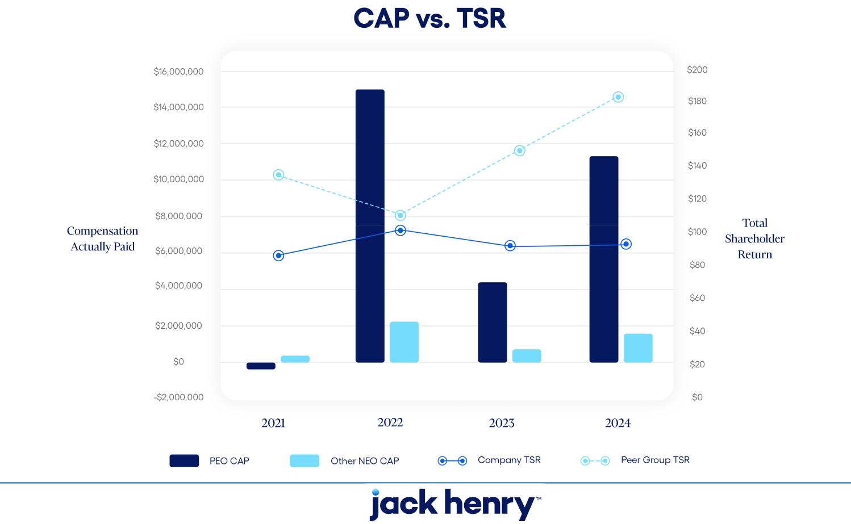

66 2024 Proxy Statement

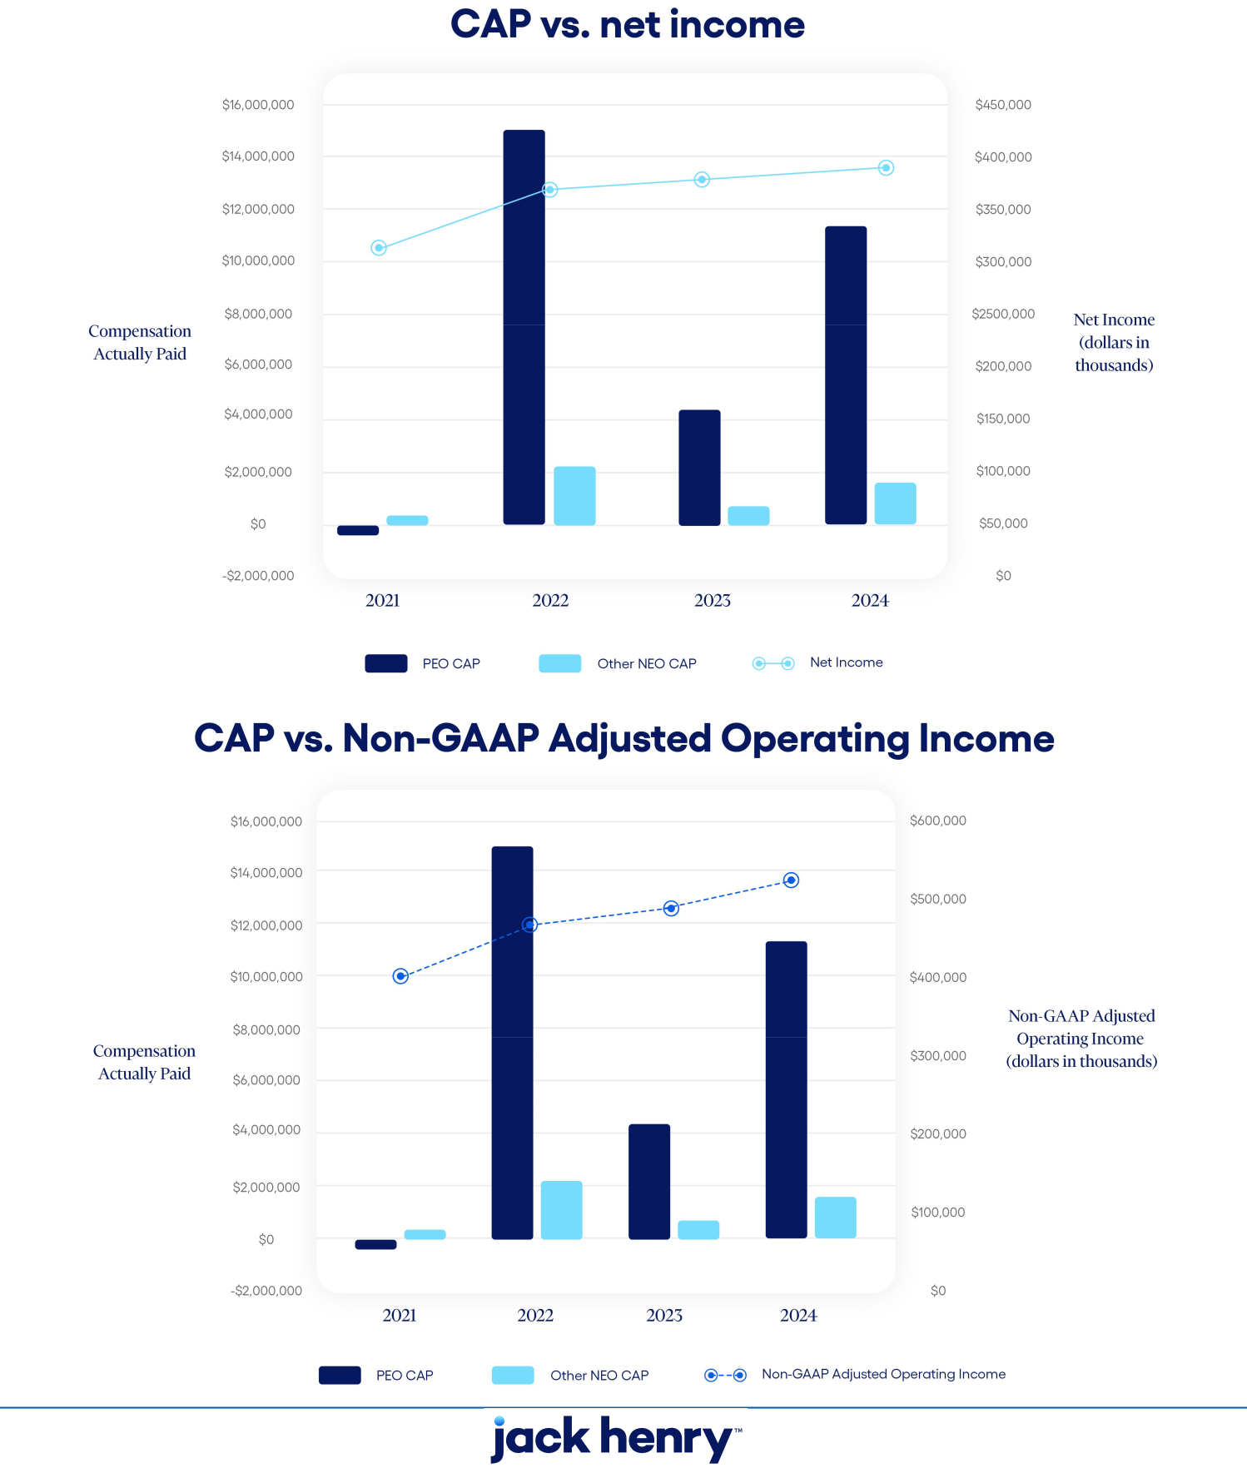

2024 Proxy Statement 67

PROPOSAL 2

ADVISORY VOTE ON EXECUTIVE COMPENSATION

The Board recommends that you vote

“For”
the approval of the compensation of our Named

Executives

As required by Section 14A of the Securities Exchange Act, we include in this proxy statement this proposal for a non-binding stockholder vote on compensation of our Named Executives. We currently conduct annual advisory votes on executive compensation. With this year’s “say on pay” proposal you can elect to endorse or not endorse our executive compensation programs and policies and the compensation we paid our Named Executives in fiscal 2024.

The say on pay vote is advisory and not binding on the Company, the Human Capital & Compensation Committee, or the Board. However, the Human Capital & Compensation Committee and the Board value the opinions of our stockholders and will consider the outcome of the vote when making future decisions regarding executive compensation.

As described in the Compensation Discussion and Analysis, the Human Capital & Compensation Committee has designed the executive compensation program to focus the executives on achieving consistent earnings growth, encourage continuation of the Company’s entrepreneurial spirit, attract and retain highly qualified and motivated executives, reward the creation of stockholder value, encourage esprit de corps, and reward outstanding performance. In designing the overall executive compensation program, the Company’s Human Capital & Compensation Committee strives for the interests of management and stockholders to be the same—the maximization of stockholder value.

Our executive compensation package for our Named Executives includes both cash and equity-based compensation, with an emphasis on at-risk and performance-based pay. The Human Capital & Compensation Committee each year reviews and updates our executive compensation program to ensure it achieves the desired goals.

The Board believes that the compensation of the Named Executives is appropriate and effective in achieving the Company’s objectives. Accordingly, the Board recommends that you vote to approve, on an advisory basis, the following resolution:

“RESOLVED, that the compensation paid to the Named Executives, as disclosed in the Company’s Proxy Statement for the 2024 Annual Meeting of Stockholders pursuant to the compensation disclosure rules of the Securities and Exchange Commission, including the Compensation Discussion and Analysis, the compensation tables and related narrative disclosure, is hereby approved.”

THE BOARD RECOMMENDS THAT YOU VOTE “FOR” THE APPROVAL OF THE COMPENSATION OF OUR NAMED
EXECUTIVES. PROXIES RECEIVED BY THE BOARD WILL BE VOTED FOR THE APPROVAL OF THE COMPENSATION OF OUR NAMED EXECUTIVES UNLESS STOCKHOLDERS SPECIFY IN THEIR PROXY A VOTE OF “AGAINST” OR
“ABSTAIN”.

68 2024 Proxy Statement

PROPOSAL 3

Amendment of the Company's Certificate of Incorporation to Reduce Stockholder Voting Thresholds

The Board recommends that you vote

“For”
the approval of an amendment to our certificate of

incorporation to reduce stockholder voting thresholds

Overview of Amendments to the Certificate of Incorporation

The Board has approved and determined that it is in the best interests of the Company and its stockholders to approve, and to submit to the stockholders for consideration and approval, certain amendments (the “Charter Amendments”) to the Company’s Certificate of Incorporation to (1) eliminate super-majority voting requirements to amend the Certificate of Incorporation and Bylaws of the Company and (2) generally adopt a simple majority voting standard for stockholder meetings to the extent permitted under the Delaware General Corporation Law. The Board believes that the Charter Amendments will help support strong corporate governance by enhancing stockholder rights.

Specifically, the Charter Amendments would:

- reduce the required voting threshold to amend or repeal any provision of the Company’s Certificate of Incorporation from two-thirds of the outstanding shares of common stock entitled to vote to a majority of the outstanding shares of common stock entitled to vote;

- reduce the required voting threshold to adopt, alter, amend or repeal the Company’s Bylaws from two-thirds of the outstanding shares of common stock entitled to vote to a majority of the outstanding shares of common stock entitled to vote; and

- reduce the required voting threshold to approve all other matters to be voted on at a meeting of the Company’s stockholders (other than the election or removal of directors) from a majority of the shares present and entitled to vote at the meeting to a majority of votes cast for and against the matter.

The following table provides a comparison of the current voting standard in the Certificate of Incorporation and the changes expected following the approval of the Charter Amendments by the stockholders:

 | Matter to be voted on | Current voting standard | Voting standard after adoption of
 |  |  | proposal
 | Amendments to Certificate of | Two-thirds of outstanding shares | Majority of outstanding shares^{1, 2}
 | Incorporation
 | Amendments to Bylaws | Two-thirds of outstanding shares | Majority of outstanding shares²
 | Director elections (uncontested) | Plurality | Plurality
 |  |  | 2024 Proxy Statement 69

Director elections (contested) | Majority of votes cast for and against | Majority of votes cast for and against
Removal of Directors | Majority of outstanding shares | Majority of outstanding shares^{1, 2}
Other Matters | Majority of shares present and entitled | Majority of votes cast for and against
 | to vote at the meeting

- Minimum vote required by Delaware General Corporation Law.

- Standard based on outstanding shares rather than majority of votes cast for and against.

Text of Amendments

Articles Sixth and Tenth of the Company’s Certificate of Incorporation contain the provisions that will be affected if this proposal is adopted. Appendix A to this proxy statement shows the proposed changes to Articles Sixth and Tenth, with deletions indicated by strikeouts and additions indicated by underlining.

Required Vote and Recommendation

Pursuant to Article Sixth of the Certificate of Incorporation, approval of this proposal requires the affirmative vote of two-thirds of the Company’s outstanding shares of common stock entitled to vote on this proposal. Abstentions and broker non-votes will have the same effect as votes “AGAINST” this proposal. The individuals named as proxies on the enclosed proxy card will vote your proxy “FOR” this proposal unless you instruct otherwise on the proxy.

If this proposal is approved by the Company’s stockholders, the Company will file a certificate of amendment of the Certificate of Incorporation to effect the Charter Amendments as set forth in Appendix A following the Annual Meeting, which amendment will become effective upon acceptance of the filing by the Secretary of State of the State of Delaware. If the proposal does not receive the requisite vote, the amendment will not be implemented and the current Certificate of Incorporation will continue to apply.

THE BOARD UNANIMOUSLY RECOMMENDS THAT YOU VOTE “FOR” THE APPROVAL OF THE CHARTER AMENDMENTS TO REDUCE STOCKHOLDER VOTING THRESHOLDS. PROXIES RECEIVED BY THE BOARD WILL BE
VOTED FOR THE AMENDMENT UNLESS STOCKHOLDERS SPECIFY IN THEIR PROXY A VOTE OF “AGAINST” OR “ABSTAIN.”

70 2024 Proxy Statement

PROPOSAL 4

RATIFICATION OF SELECTION OF

INDEPENDENT REGISTERED PUBLIC ACCOUNTING FIRM


The Board recommends that you vote

“For”
ratification of the selection of
PricewaterhouseCoopers, LLP as our independent

registered accounting firm

PricewaterhouseCoopers LLP, an independent registered public accounting firm, performed an audit of our consolidated financial statements for the fiscal year ended June 30, 2024 and the effectiveness of our internal control over financial reporting as of June 30, 2024. The Audit Committee has selected PricewaterhouseCoopers LLP to serve as our independent registered public accounting firm for the current fiscal year, and the Audit Committee is presenting this selection to stockholders for ratification. Representatives of PricewaterhouseCoopers, LLP are expected to be present at the Annual Meeting with the opportunity to make a statement if they desire to do so and to be available to respond to appropriate questions.

If prior to the Annual Meeting PricewaterhouseCoopers, LLP declines to act as our independent registered public accountant or the Audit Committee decides not to use PricewaterhouseCoopers LLP as our independent registered public accountant, the Audit Committee will appoint another independent registered public accounting firm. The Audit Committee will present any new independent registered public accounting firm for the stockholders to ratify at the Annual Meeting. If the stockholders do not ratify the engagement of PricewaterhouseCoopers LLP at the Annual Meeting, then the Audit Committee will reconsider its selection of PricewaterhouseCoopers LLP. Even if the appointment of PricewaterhouseCoopers LLP is ratified, the Audit Committee in its discretion may direct the appointment of a different independent auditor at any time during the year if it determines that such a change would be in the best interests of the Company and our stockholders.

To ratify the selection of PricewaterhouseCoopers LLP as our independent registered public accounting firm for the fiscal year ending June 30, 2025, a majority of the shares present and entitled to vote must vote to approve. For purposes of determining the vote regarding this proposal, abstentions will have the same impact as a no vote. Unless you specify otherwise in your proxy, the persons you have appointed will vote your shares “For” ratification of the selection of PricewaterhouseCoopers LLP as our independent registered public accounting firm for the fiscal year ending June 30, 2025.

Audit and Non-Audit Fees

The following table presents fees for professional audit services rendered by PricewaterhouseCoopers LLP for the audit of the Company’s annual consolidated financial statements for the fiscal years ended June 30, 2024 and 2023, and reviews of the financial statements included in the Company’s Forms 10-Q for those fiscal years, the audit of the Company’s assessment and effectiveness of internal control over financial reporting under Section 404 of the Sarbanes-Oxley Act of 2002, and fees for other services rendered during those periods.

2024 Proxy Statement 71

 | 2024 |  |  | 2023
Audit Fees |  | 2,289,250 |  | 2,189,750
Audit-Related Fees (1) | 2,478,249 |  |  | 1,825,400
Tax Fees (2) | 27,500 |  |  | 22,000
All Other Fees | 4,000 |  |  | 900
Total Fees | $4,798,999 |  |  | $4,038,050

- Performed in accordance with system and organization controls reports (SOC 1 and SOC 2) and the review of other SEC filings. SOC 1 and SOC 2 reviews are conducted to evaluate the effectiveness of operational controls in various regulated business operations of the Company, including our data processing service bureaus.

- Tax fees for fiscal 2024 and fiscal 2023 relate to U.S. federal, state and local tax planning and compliance.

In making its decision to continue to retain PricewaterhouseCoopers LLP as the Company’s independent registered public accounting firm for the next fiscal year, the Audit Committee has considered the above information to ensure that the provision of non-audit services will not negatively impact the maintenance of the firm’s independence.

The Audit Committee has in its Charter expressed its policy governing the engagement of the Company’s independent registered public accounting firm for audit and non-audit services. Under the terms of the Charter, the Audit Committee is required to pre-approve all audit, audit-related, and non-audit services performed by the Company’s independent registered public accounting firm. All non-audit services for fiscal 2024 were pre-approved by the Audit Committee.

At the beginning of each fiscal year, the Audit Committee reviews with management and the independent registered public accounting firm the types of services that are likely to be required throughout the year. Those services are comprised of four categories: audit services, audit-related services, tax services, and all other permissible services. The independent registered public accounting firm provides documentation for each proposed specific service to be provided. At that time, the Audit Committee pre-approves a list of specific services that may be provided within each of these categories and sets fee limits for each specific service or project. Management is then authorized to engage the independent registered public accounting firm to perform the pre-approved services as needed throughout the year, subject to providing the Audit Committee with regular updates. The Audit Committee reviews all billings submitted by the independent registered public accounting firm on a regular basis to ensure that their services do not exceed pre-defined limits. The Audit Committee or its Chair reviews and approves in advance, on a case-by-case basis, all other projects, services and fees to be performed by or paid to the independent registered public accounting firm. The Audit Committee also approves in advance any fees for pre-approved services that exceed the pre-established limits, as described above.


THE BOARD RECOMMENDS THAT YOU VOTE “FOR” RATIFICATION OF THE SELECTION OF PRICEWATERHOUSECOOPERS LLP AS OUR INDEPENDENT REGISTERED ACCOUNTING FIRM. PROXIES RECEIVED BY THE BOARD WILL BE VOTED FOR THE RATIFICATION UNLESS STOCKHOLDERS SPECIFY IN THEIR PROXY A VOTE OF “AGAINST” OR “ABSTAIN”.

72 2024 Proxy Statement

STOCK OWNERSHIP OF CERTAIN BENEFICIAL OWNERS

The following table sets forth information concerning the beneficial ownership of shares of the Company’s common stock of (a) those individuals who are known to be the beneficial owners, as defined in Rule 13d-3 of the Exchange Act, of 5% or more of the Company’s common stock, (b) each director and director nominee, (c) the executive officers named in the Summary Compensation Table and (d) all of our current directors and executive officers as a group. The mailing address of each director, director nominee, and executive officer shown in the table below is c/o Jack Henry & Associates, Inc., 663 Highway 60, Monett, Missouri 65708.

 |  |  | Percentage of
Beneficial Owner | Number of Shares Beneficially |  | Shares
Beneficial Owner | Owned (1) |  | Outstanding (1)
The Vanguard Group | 8,648,967 | (2) | 11.9%
BlackRock Inc. | 6,201,647 | (3) | 8.5%
APG Asset Management US Inc. | 4,053,278 | (4) | 5.6%
Kayne Anderson Rudnick Investment | 3,742,198 | (5) | 5.1%
Management, LLC | 3,742,198 | (5) | 5.1%
David B. Foss | 170,514 | (6) | *
Wesley A. Brown | 92,590 | (7) | *
Matthew C. Flanigan | 45,135 | (7) | *
Thomas A. Wimsett | 39,106 | (7) | *
Jacque R. Fiegel | 21,414 | (7) | *
Thomas H. Wilson, Jr. | 15,493 | (7)(8) | *
Gregory R. Adelson | 15,088 | (9) | *
Shruti S. Miyashiro | 13,128 | (7) | *
Craig K. Morgan | 12,902 | (10) | *
Stacey E. Zengel | 5,875 | (11) | *
Mimi L. Carsley | 2,695 |  | *
Curtis A. Campbell | 2,642 | (7)(12) | *
Shanon G. McLachlan | 927 | (13) | *
Tammy S. LoCascio | 365 | (14) | *
Lisa M. Nelson | 365 | (14) | *
All current directors and executive | 446,703 | (15) | *
officers as a group (15 persons) | 446,703 | (15) | *
  - Less than 1%

- Except as otherwise noted in the footnotes, information is set forth as of September 16, 2024. The persons named in the table have sole voting and investment power with respect to all shares of common stock shown as beneficially owned by them, except as noted below. With respect to shares held in the Company’s Retirement Plan, a participant has the right to direct the disposition of shares allocated to their account and a participant is allowed to vote the shares held in their individual account. Calculation of percentage of beneficial ownership includes the assumed exercise of options to purchase common stock by only the respective named stockholder that are vested or that will vest within 60 days of September 16, 2024 and any restricted stock units owned by such person that will vest within 60 days of September 16, 2024.

- According to a Schedule 13G/A filed February 13, 2024, The Vanguard Group has shared dispositive power with respect to 309,197 shares, sole dispositive power with respect to 8,339,770 shares,

2024 Proxy Statement 73

shared voting power with respect to 92,664 shares, and sole voting power with respect to 0 shares. The address for The Vanguard Group is 100 Vanguard Blvd., Malvern, PA 19355.

- According to a Schedule 13G/A filed January 25, 2024, BlackRock Inc. has sole voting power with respect to 5,587,616 shares and sole dispositive power with respect to 6,201,647 shares. The address for BlackRock Inc. is 55 East 52nd St., New York, NY 10055.

- According to a Schedule 13G/A filed February 7, 2024, APG Asset Management US Inc. (“APG US”) has shared voting power and shared dispositive power with respect to 4,053,278 shares. As reported on such Schedule 13G, APG Asset Management, N.V. (“APG NL”) is wholly-owned by APG Groep, N.C. (“APG Groep”) and is the investment manager with respect to the securities to which the Schedule 13G relates. Pursuant to an Investment Management Agreement, APG NL has delegated its investment and voting power with respect to such securities to APG US, which is its wholly-owned subsidiary. Stichting Pensioenfonds ABP is the majority owner of APG Groep. The address for APG US is 666 3rd Ave., 2nd Floor, New York, NY 10017.

- According to a Schedule 13G filed February 13, 2024, Kayne Anderson Rudnick Investment Management, LLC has shared voting power with respect to 584,846 shares, sole voting power with respect to 2,963,907 shares, shared dispositive power with regards to 584,846 shares, and sole dispositive power with respect to 3,157,352 shares. The address for Kayne Anderson Rudnick Investment Management, LLC is 2000 Avenue of the Stars, Suite 1110, Los Angeles, CA 90067.

- Includes 11,685 shares that are currently acquirable by exercise of outstanding stock options and 4,887 shares held in the Retirement Plan for Mr. Foss’ account.

- Includes 1,173 restricted stock units for Mses. Fiegel, and Miyashiro, and Messrs. Flanigan, Wilson, Wimsett, Brown, and Campbell, that will vest on the earlier of (i) the day before the Company’s Annual Meeting or (ii) November 18, 2024.

- Mr. Wilson has elected to defer receipt of 9,982 restricted stock units, which have fully vested and will become payable, in cash or common stock at the Company’s option, upon Mr. Wilson’s termination of service as a director of the Company pursuant to Mr. Wilson’s deferral elections. Each restricted stock unit is the economic equivalent of one share of common stock. These deferred restricted stock units have been excluded from the amounts set forth in this table.

- Mr. Adelson has elected to defer receipt of 3,561 performance shares, which have fully vested and will become payable, in cash or common stock, at the Company’s option, upon Mr. Adelson’s termination of service with the Company pursuant to Mr. Adelson’s deferral elections. Each performance share is the economic equivalent of one share of common stock. These deferred performance shares have been excluded from the amounts set forth in this table.

- Includes 1,184 shares held in the Retirement Plan for Mr. Morgan’s account.

- Includes 154 shares held in the Retirement Plan for Mr. Zengel’s account.

- Mr. Campbell has elected to defer receipt of 983 restricted stock units, which have fully vested and will become payable, in cash or common stock at the Company’s option, upon Mr. Campbell’s termination of service as a director of the Company pursuant to Mr. Campbell's deferral elections. Each restricted stock unit is the economic equivalent of one share of common stock. These deferred restricted stock units have been excluded from the amounts set forth in this table.

- Mr. McLachlan has elected to defer receipt of 269 performance shares, which have fully vested and will become payable, in cash or common stock at the Company’s option, upon Mr. McLachlan’s termination of service as a director of the Company pursuant to Mr. McLachlan's deferral elections. Each restricted stock unit is the economic equivalent of one share of common stock. These deferred restricted stock units have been excluded from the amounts set forth in this table.

- Includes 365 restricted stock units for Mses. LoCascio and Nelson, each non-employee directors, that will vest on the earlier of

(i) the day before the Company’s Annual Meeting or (ii) November 18, 2024.

74 2024 Proxy Statement

- Includes 14,339 shares beneficially owned by other executive officers. Mr. Zengel retired effective June 30, 2024, and is not included in the group total.

STOCKHOLDER PROPOSALS AND NOMINATIONS

Stockholders who intend to present proposals for inclusion in the proxy statement and form of proxy for the 2025 Annual Meeting of Stockholders must submit their proposals to the Company’s Secretary on or before June 6, 2025. A stockholder who wishes to present a proposal at the 2025 Annual Meeting, but who does not request inclusion in the proxy statement, must submit the proposal to the Company’s Secretary by August 14, 2025. The Company’s Bylaws specify requirements for the content of the notice that stockholders must provide.

In addition, any stockholder who intends to nominate a candidate for election to the Board at the Company’s 2025 Annual Meeting pursuant to the advance notice provisions of the Bylaws, must give notice to the Company’s Secretary on or before August 14, 2025. Notice of proxy access director nominees by stockholders who meet the eligibility requirements in the Company’s Bylaws must be received by the Company’s Secretary no earlier than the close of business on May 7, 2025 and no later than the close of business on June 6, 2025. In each case, the notice must include information specified in the Company’s Bylaws, including information concerning the nominee and information about the stockholder’s ownership of, and agreements related to, the Company’s common stock.

In addition to satisfying the foregoing advance notice requirements under our Bylaws, to comply with the universal proxy rules under the Exchange Act, stockholders who intend to solicit proxies in support of director nominees other than our nominees must provide notice that sets forth the information required by Rule 14a-19 under the Exchange Act no later than September 14, 2025.

The Company will not entertain any proposals or nominations at the 2025 Annual Meeting that do not meet the requirements set forth in the Company’s Bylaws. If the stockholder does not also comply with the requirements of Rule 14a-4(c)(2) under the Exchange Act, as amended, the Company may exercise discretionary voting authority under proxies that it solicits to vote in accordance with the Company’s best judgment on any such stockholder proposal or nomination. The Bylaws are posted on our web site at https://ir.jackhenry.com/corporate-governance/overview. To make a submission or to request a copy of our Bylaws, stockholders should contact the Company’s Secretary. We strongly encourage stockholders to seek advice from knowledgeable counsel before submitting a proposal or a nomination.

FINANCIAL STATEMENTS

Consolidated financial statements of the Company are contained in the 2024 Annual Report to Stockholders which accompanies this Proxy Statement.

OTHER MATTERS

Why am I receiving these materials?

You have received these materials because the Board is soliciting your proxy to vote your shares at the Annual Meeting. This Proxy Statement includes information that the Company is required to provide you under the SEC rules and is designed to assist you in voting your shares.

What matters will be voted on at the Annual Meeting?

At the Annual Meeting, stockholders will consider and vote upon the following matters:

2024 Proxy Statement 75

Proposal |  | Board Recommendation | Page
(1) | The election of nine directors to serve until the 2025 Annual Meeting of | FOR each nominee | 4
 | Stockholders; | FOR each nominee
(2) | Approval, on an advisory basis, of the compensation of our named executive | FOR | 68
 | officers; | FOR | 68
(3) | Approval of an amendment to the Company’s certificate of incorporation to | FOR | 69
 | reduce stockholder voting thresholds. | FOR
(4) | To ratify the selection of PricewaterhouseCoopers LLP as the Company’s | FOR | 71
 | independent registered public accounting firm for the fiscal year ending June 30, | FOR | 71
 | 2025.

In addition, the stockholders will consider and vote upon such other business as may properly come before the Annual Meeting and any adjournments thereof.

When and Where is the Annual Meeting?

The Annual Meeting will be held at the Company’s Headquarters, 663 Highway 60, Monett, Missouri, on Tuesday, November 12, 2024, 11:00 a.m., Central Time. The Annual Meeting will be in the Company’s Executive Conference Center in the lower level (Building J-7).

Who can attend and vote at the Annual Meeting?

Only stockholders of record at the close of business on September 16, 2024, the record date set by the Board for the Annual Meeting, are entitled to notice of and to vote at such meeting. A list of these stockholders will be available during the ten days prior to the meeting at the Company’s headquarters at 663 Highway 60, Monett, Missouri.

The Company’s authorized capital stock currently consists of 250,000,000 shares of common stock, par value $.01 per share, and 500,000 shares of preferred stock, par value $1.00 per share. As of September 16, 2024, there were 72,917,394 shares of common stock outstanding and no shares of preferred stock outstanding. At such date, our executive officers and directors were entitled to vote, or to direct the voting of, shares of Common Stock representing less than 1% of the shares entitled to vote at the Annual Meeting. Each share of our common stock outstanding on the record date will be entitled to one vote on each matter.

How will the Annual Meeting be conducted?

Stockholders and guests may attend the Annual Meeting in person. The Company will hold a question and answer session with management immediately following the conclusion of the business to be conducted at the Annual Meeting. To help ensure that the Annual Meeting is productive and efficient, and in fairness to all stockholders in attendance, the Company requests that meeting participants limit participation to one question or comment and that remarks are respectful of fellow stockholders and meeting participants. Questions may be ruled as out of order if they are, among other things: irrelevant to our business; related to legal matters, ongoing negotiations or potential transactions, or other matters upon which the Company does not comment on; disorderly; repetitious of statements already made; or in furtherance of the speaker’s own personal, political, or business interests. The Company reserves the right to eject participants or cut off speaking privileges for failure to comply with reasonable requests or the rules of conduct for the meeting.

76 2024 Proxy Statement

How can I vote?

Stockholders may submit their votes in the following ways:

- At the Annual Meeting. Stockholders of record may vote in person at the Annual Meeting; or

- By Proxy. There are three ways to vote by proxy:

  - by internet, following the instructions on the enclosed Proxy Card;

  - by mail, using the enclosed Proxy Card and return envelope; or

  - by telephone, using the telephone number and instructions on the enclosed Proxy Card.

Even if a stockholder expects to attend the Annual Meeting, it is advisable to vote by proxy to ensure such stockholder’s vote is represented.

What is the voting requirement to approve the proposals?

In an uncontested election, a director nominee must be elected by a majority of the votes cast, in person or by proxy, regarding the election of that director nominee. A “majority of the votes cast” for the purposes of director elections means that the number of votes cast “For” a director nominee’s election exceeds the number of votes cast as “Withhold” for that director nominee. If an incumbent director is not re-elected in an uncontested election and no successor is elected at the same meeting, the Company’s Corporate Governance Guidelines require that such director must offer to tender his or her resignation to the Board.

In a contested election, which occurs when the number of director nominees exceeds the number of open seats on the Board, director nominees will be elected by a plurality of the shares represented in person or by proxy at the meeting. A “plurality” means that the open seats on the Board will be filled by those director nominees who received the most affirmative votes, regardless of whether those director nominees received a majority of the votes cast with respect to their election.

At the Annual Meeting, the election of directors is considered to be uncontested because we have not been notified of any other nominees as required by our Bylaws. To be elected, each director nominee must receive a majority of votes cast regarding that nominee.

The approval of Proposal 3 requires the approval of at least two-thirds of the outstanding shares of Common Stock.

The approval of all other matters to be voted on at the Annual Meeting will require the affirmative vote of a majority of the shares of common stock present at the Annual Meeting in person or by proxy and entitled to vote.

Abstentions and broker non-votes will have no effect on the election of directors. For the purpose of determining whether the stockholders have approved other matters, abstentions are treated as shares present or represented and voting, so abstaining has the same effect as a negative vote. Shares held by brokers that do not have discretionary authority to vote on a particular matter and that have not received voting instructions from their clients are not counted or deemed to be present or represented for the purpose of determining whether stockholders have approved that matter, but they are counted as present for the purpose of determining the existence of a quorum at the Annual Meeting. Please note that banks and brokers that have not received voting instructions from their clients cannot vote on their clients’ behalf on “non-routine” proposals. The election of directors (Proposal 1), the advisory votes on the compensation of our named executive

2024 Proxy Statement 77

officers (Proposal 2), and the amendment to our Certificate of Incorporation (Proposal 3) are considered to be “non-routine” proposals.

How are Proxy Materials being distributed?

We are furnishing proxy materials to our stockholders primarily via “Notice and Access” delivery. On or about October 4, 2024, we mailed to our stockholders (other than those who previously requested email or paper delivery) a Notice of Internet Availability containing instructions on how to access the proxy materials via the Internet. If you receive the Notice of Internet Availability by mail, you will not receive a printed copy of the proxy materials in the mail. Instead, the Notice of Internet Availability instructs you on how to access the proxy materials and vote by going to a secure website.

If you received the Notice of Internet Availability by mail and would like to receive paper copies of the proxy materials in the mail on a one-time or ongoing basis, follow the instructions in the Notice of Internet Availability for making this request. If you would like to receive an electronic copy of the proxy materials by email on a one-time or ongoing basis, follow the instructions in the Notice of Internet Availability for making this request.

What if I share a household with another Company Stockholder?

If you and other residents at your mailing address own shares in street name, your broker, bank, or other nominee may have sent you a notice that your household will receive only one annual report and proxy statement for each company in which you hold shares through that broker, bank, or nominee. This practice is called “householding.” If you did not respond that you did not want to participate in householding, you are deemed to have consented to that process. If these procedures apply to you, your broker, bank, or other nominee will have sent one copy of our 2024 Annual Report to Stockholders and Proxy Statement to your address. You may revoke your consent to householding at any time by contacting your broker, bank, or other nominee. If you did not receive an individual copy of our 2024 Annual Report to Stockholders and Proxy Statement, we will send copies to you if you contact us at 663 Highway 60, Post Office Box 807, Monett, Missouri, 65708, (417) 235-6652, Attention: Investor Relations. If you and other residents at your address have been receiving multiple copies of our 2024 Annual Report to Stockholders and Proxy Statement and desire to receive only a single copy of these materials, you may contact your broker, bank, or other nominee or contact us at the above address or telephone number.

Who will pay for this solicitation?

Proxy solicitation is being made by mail, although it may also be made by telephone or in person by officers, directors, and employees of the Company not specifically engaged or compensated for that purpose. The Company will bear the entire cost of the Annual Meeting, including the cost of preparing, assembling, printing, and mailing this Proxy Statement, the Proxy Card, Notice of Internet Availability, and any additional materials furnished to stockholders. Copies of the solicitation materials will be furnished to brokerage houses, fiduciaries, and custodians for forwarding to the beneficial owners of shares held of record by them and, upon their request, such persons will be reimbursed for their reasonable expenses incurred in completing the mailing to such beneficial owners.

What happens if I vote by proxy and do not give specific voting instructions?

If a stockholder does not specify how a proxy is to be voted, the shares represented thereby will be voted: (1) FOR the election as directors of the nine persons nominated by the Board; (2) FOR approval of the compensation of our named executive officers; (3) FOR approval of the amendment to our certificate of incorporation to reduce stockholder voting thresholds (4) FOR

78 2024 Proxy Statement

ratification of the selection of the Company’s independent registered public accounting firm; and (5) upon other matters that may properly come before the Annual Meeting, in accordance with the discretion of the persons to whom the proxy is granted.

Can I revoke my proxy or change my vote?

Any stockholder executing a Proxy Card retains the power to revoke it at any time prior to the voting of the proxy. It may be revoked by a stockholder personally appearing at the Annual Meeting and casting a contrary vote, by filing an instrument of revocation with the Secretary of the Company, or by the presentation at the Annual Meeting of a duly executed later-dated Proxy Card.

What happens if additional matters are presented at the Annual Meeting?

The Board knows of no matters that are expected to be presented for consideration at the Annual Meeting which are not described herein. The Company will not entertain any proposals or nominations at the Annual Meeting that do not meet the advance notice requirements set forth in the Company’s Bylaws. However, if other matters properly come before the meeting, it is intended that the persons named in the accompanying Proxy Card will vote thereon in accordance with their best judgment.

How can I vote if I am the beneficial owner and my shares are held by a broker, trustee, or other nominee?

If a stockholder’s shares are held in the name of a bank, broker, or other nominee, that nominee will provide separate instructions on how to vote. Those stockholders may vote at the Annual Meeting if they obtain and bring to the Annual Meeting a legal proxy from the bank, broker, or other nominee holding the shares.

If you are a participant in the Company’s Retirement Plan and you own shares of our common stock through the Retirement Plan, you may vote by proxy or you may receive separate instructions on how to direct the Retirement Plan trustee how to vote those shares on your behalf. If you do not vote by proxy or otherwise provide voting instructions for these shares, then, as permitted by the terms of the Retirement Plan, the Retirement Plan administrator will instruct the trustee to vote your Retirement Plan shares “FOR” all the director nominees named in this Proxy Statement and “FOR” all other proposals.

Other Information

Important Notice Regarding the Availability of Proxy Materials for the Stockholder Meeting to be Held on November 12, 2024: The Proxy Statement, Proxy Card, and the 2024 Annual Report to Stockholders are available at www.envisionreports.com/JKHY.

2024 Proxy Statement 79

APPENDIX A

Proposed Changes to the Company’s Certificate of Incorporation

If approved, the Charter Amendments will result in the following changes to Article Sixth and Article Tenth of the Company’s Certificate of Incorporation. Additions are shown as underlined text and deletions are shown as strikethrough text.

SIXTH: Except as otherwise provided herein or in the bylaws, every decision by a the affirmative vote of the majority of the shares represented at the meeting and entitled to vote on the subject matter votes cast for and against with respect to a matter at any meeting of stockholders shall constitute a valid corporate act.

6.1. The corporation reserves the right to amend or repeal any provisions contained in these articles this certificate of incorporation or any amendments thereto; provided, however, that any proposed amendment shall be approved by vote of the holders of a majority of the corporation’s stock entitled to vote. two-thirds of the corporation’s stock entitled to vote. However, in the event any amendment to these articles of incorporation or amendments thereto are recommended to the shareholders by at least two-thirds of the corporation’s board of directors, then the affirmative vote of two-thirds of the shareholders of the corporation shall not be required to adopt that amendment and only the vote of a simple majority of the corporation’s stock entitled to vote will be required.

6.2. [omitted]

TENTH: The board of directors of the corporation is expressly authorized to make, alter, or repeal the bylaws of the corporation. The bylaws of the corporation may also be adopted, altered, amended or repealed by the affirmative vote of the holders of a majority two-thirds of the corporation’s stock entitled to vote.

80 2024 Proxy Statement



